[GitHub - dataquestio/loan-prediction: Predict which loans will be foreclosed on.](https://github.com/dataquestio/loan-prediction)

[Pearson correlation coefficient - Wikipedia](https://en.wikipedia.org/wiki/Pearson_correlation_coefficient)

## Resources

* [R value](https://en.wikipedia.org/wiki/Pearson_product-moment_correlation_coefficient)
* [pandas.DataFrame.plot()](http://pandas.pydata.org/pandas-docs/stable/generated/pandas.DataFrame.plot.html)
* [Correlation](https://www.mathsisfun.com/data/correlation.html)
* [Guess the Correlation](http://guessthecorrelation.com/)

[RegExr: Learn, Build, & Test RegEx](https://regexr.com/)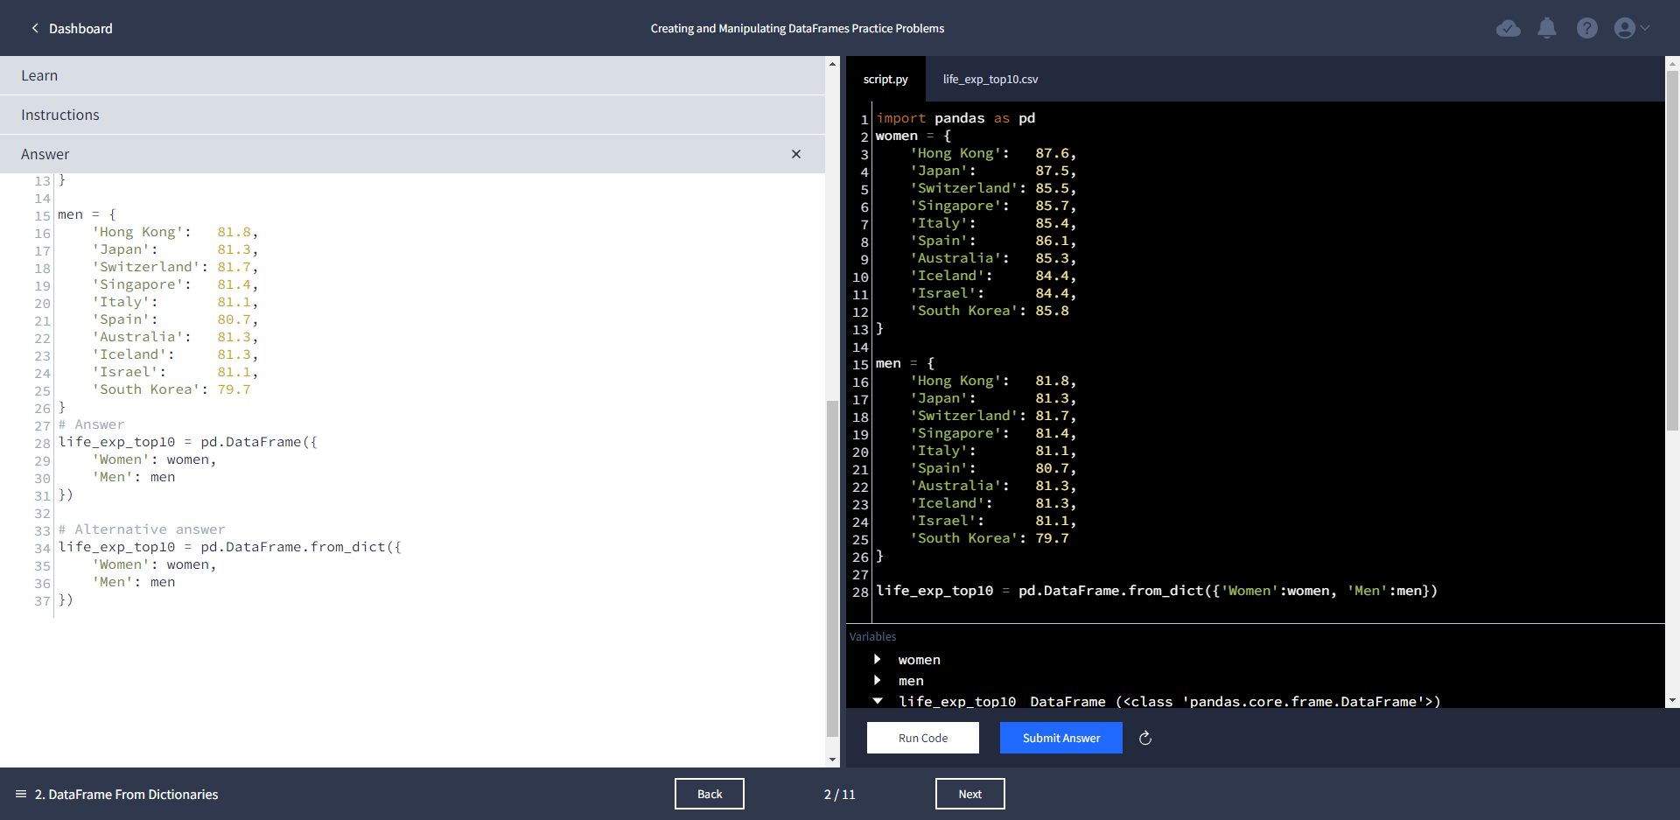

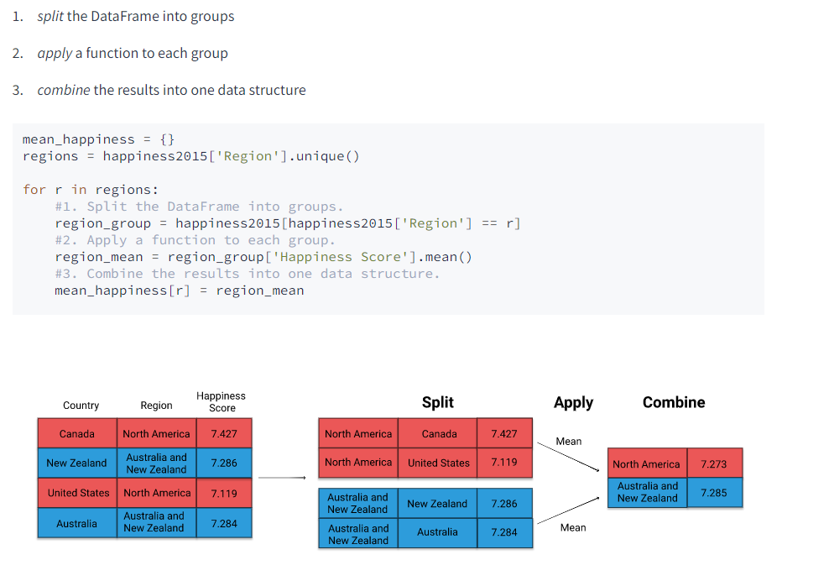

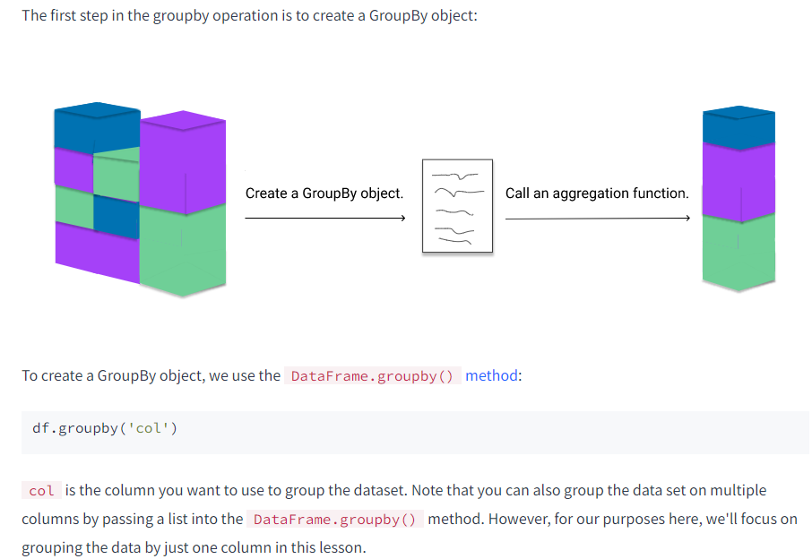

happiness2015['Region'].value_counts()

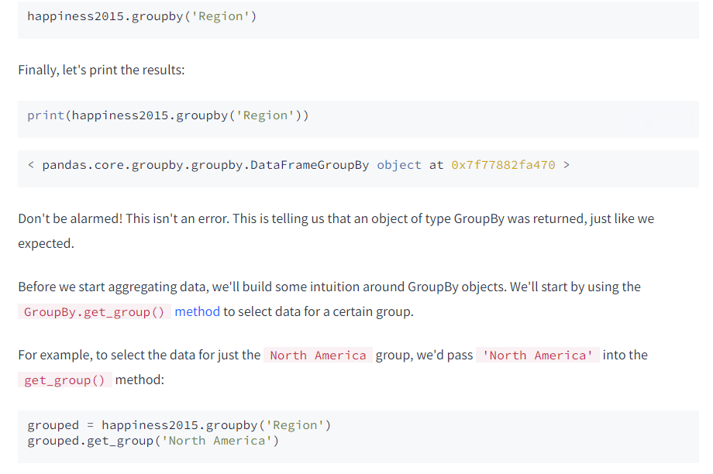

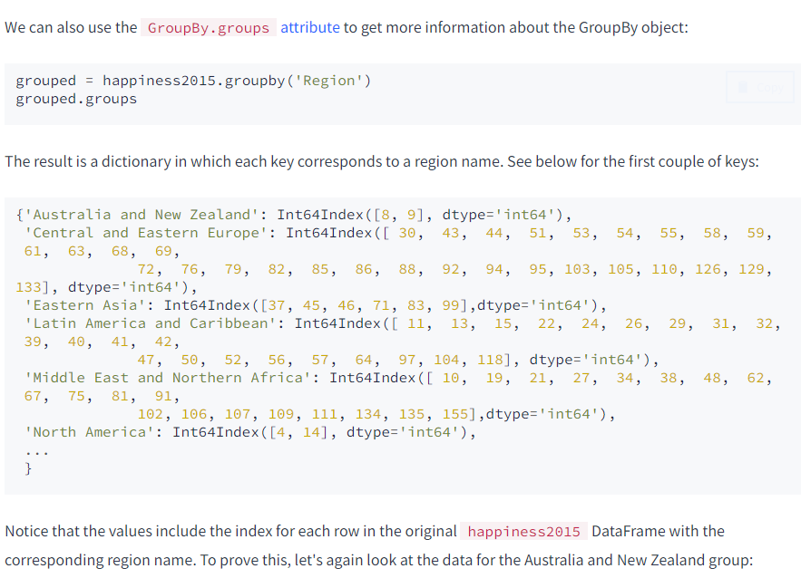

grouped = happiness2015.groupby('Region')

north_america = happiness2015.loc[[4,14]]

na_group = grouped.get_group('North America')

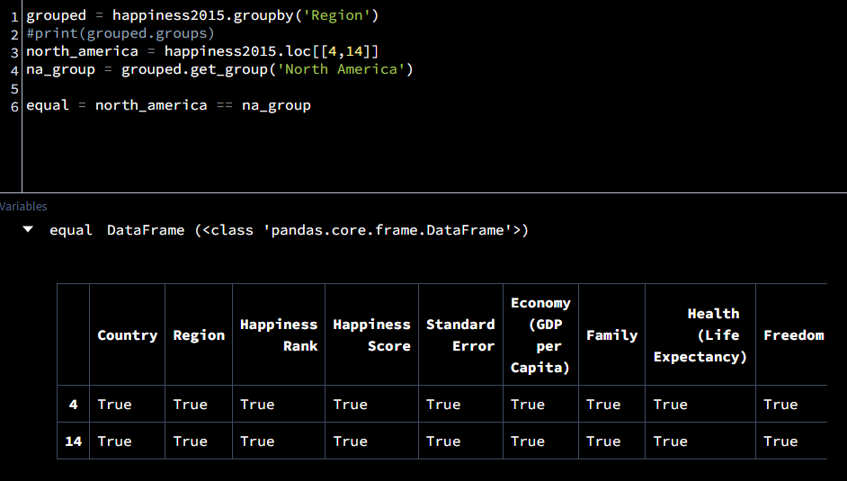

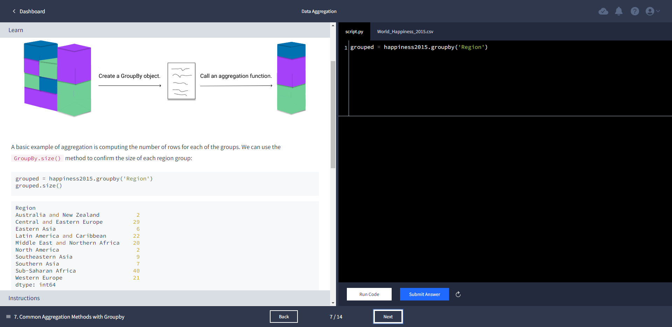

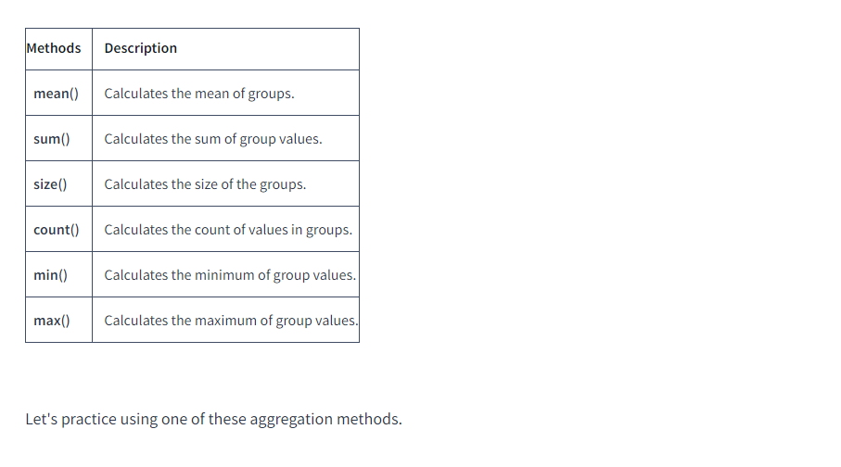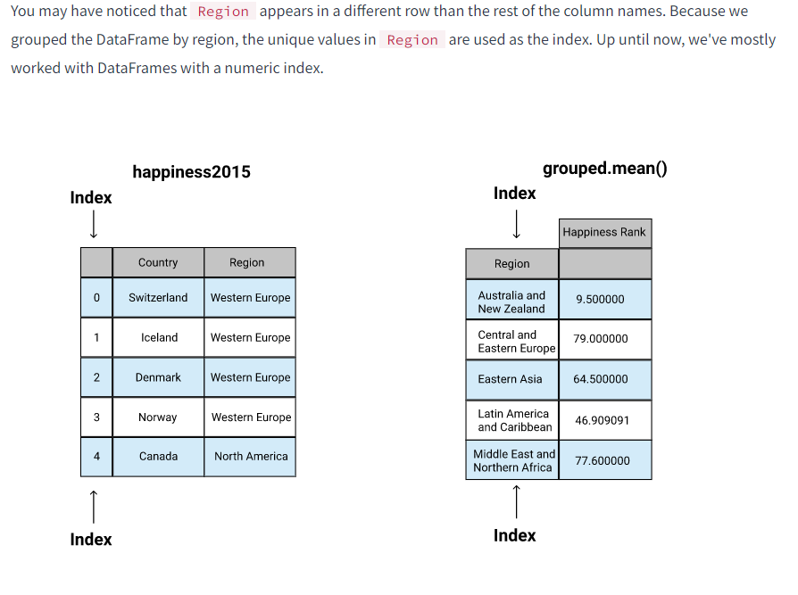

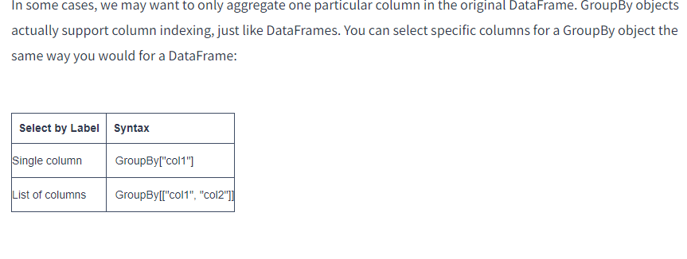

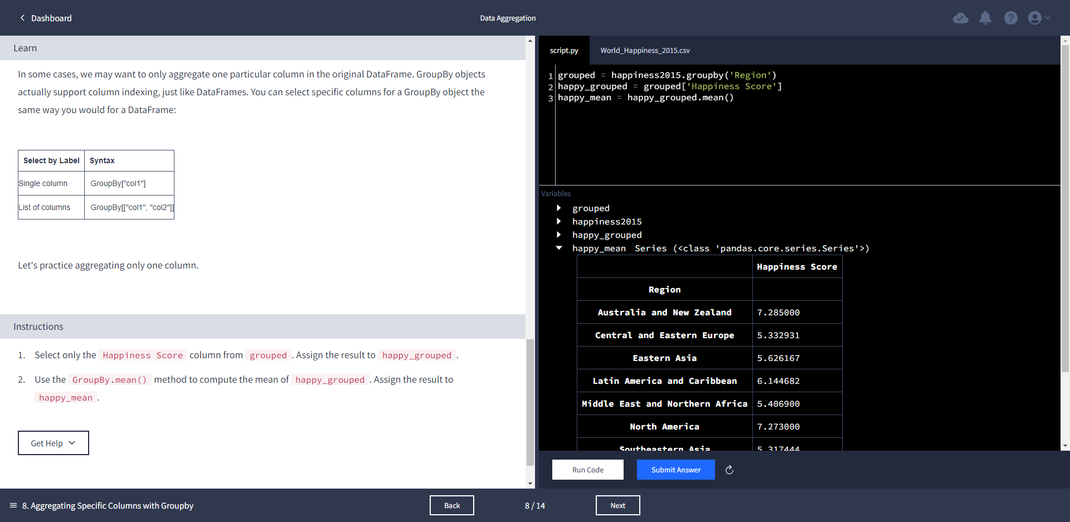

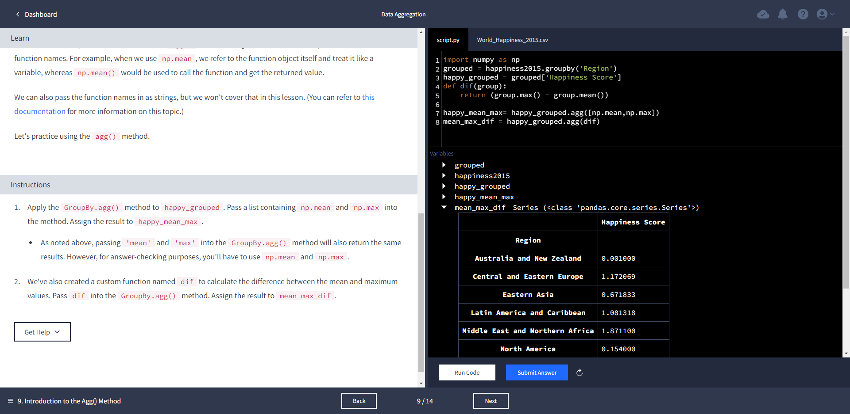

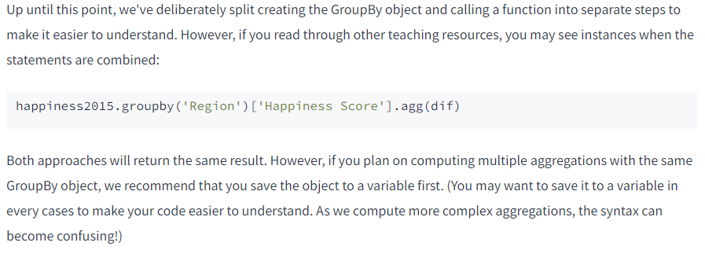

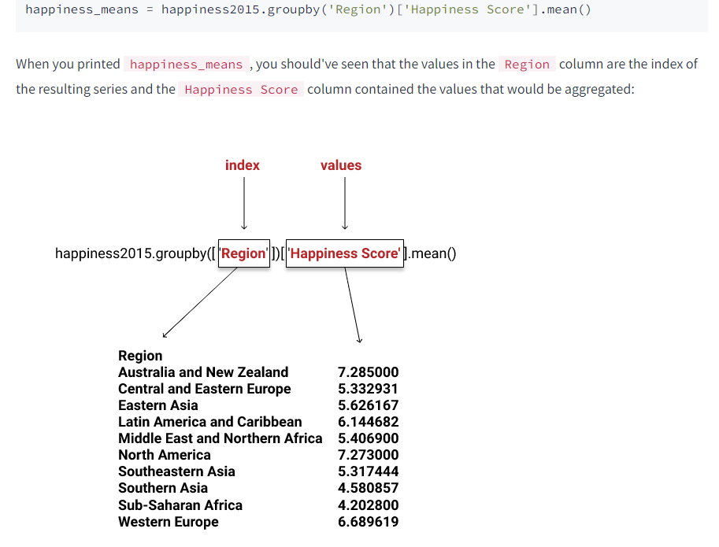

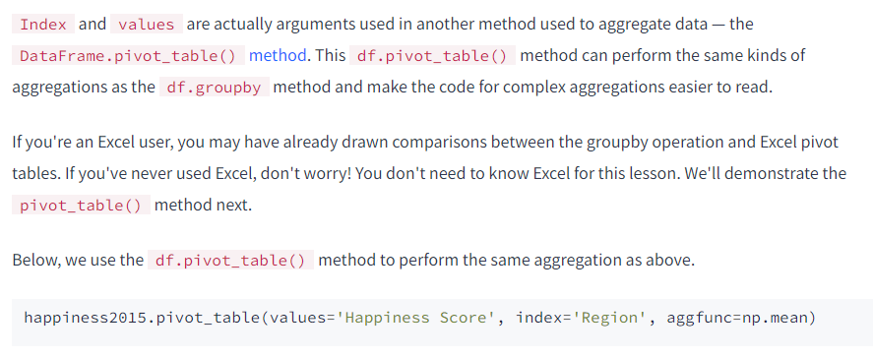

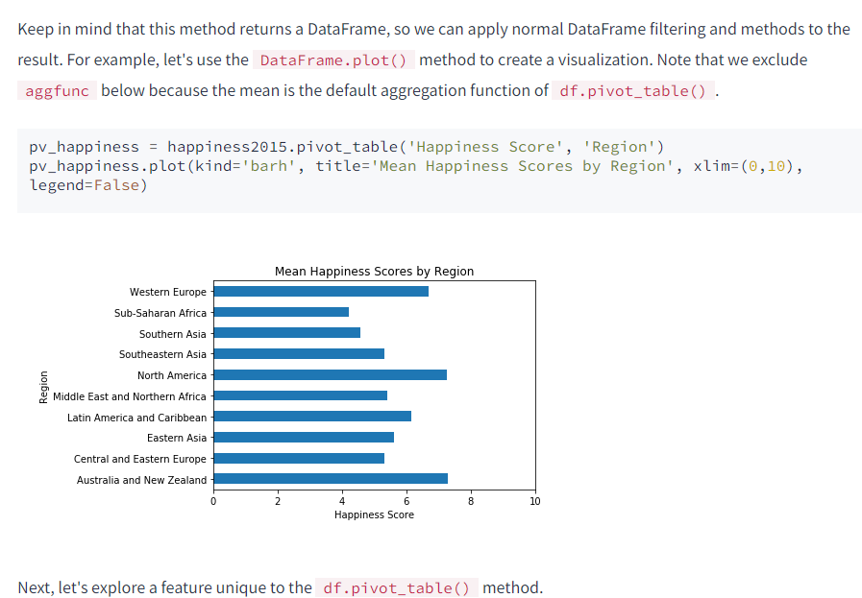

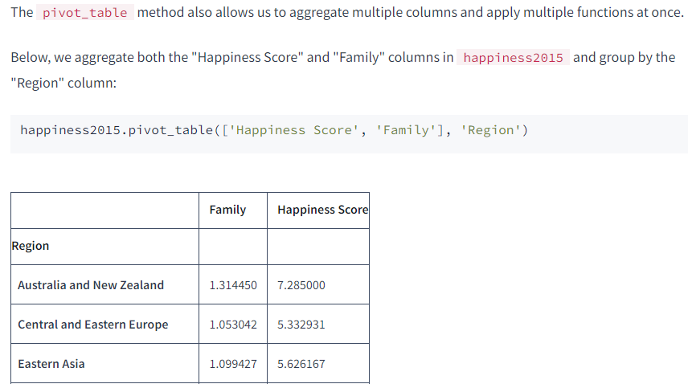

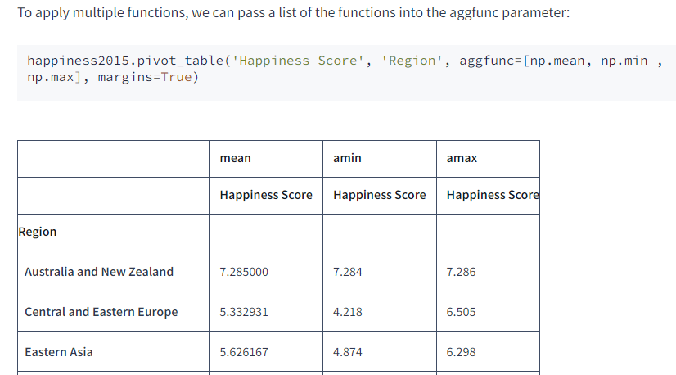

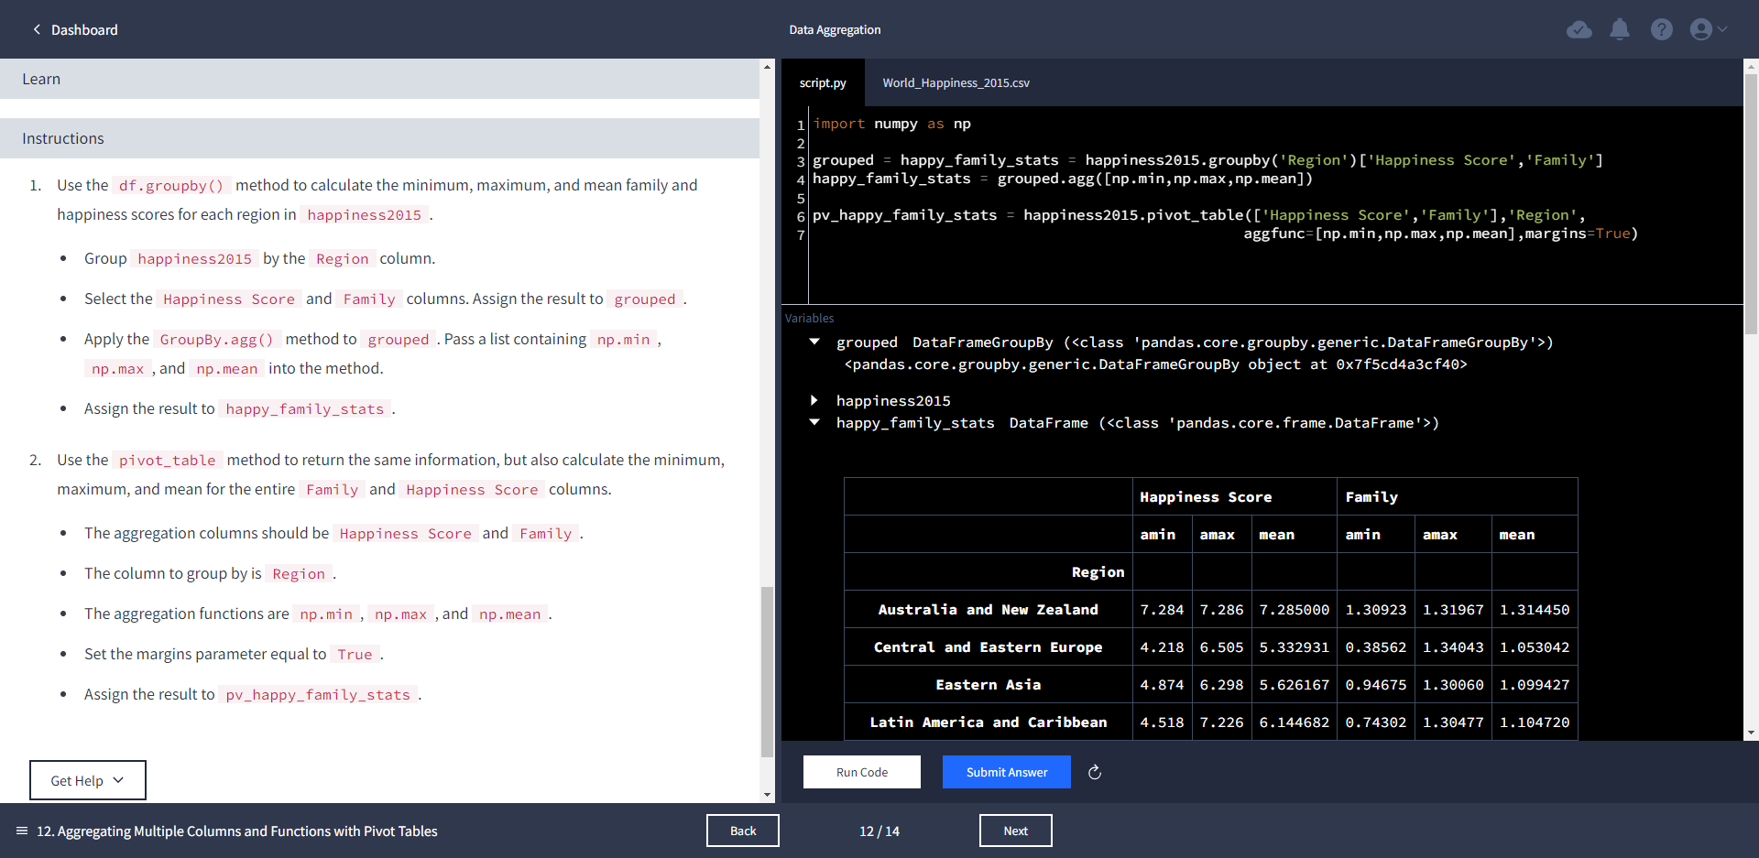

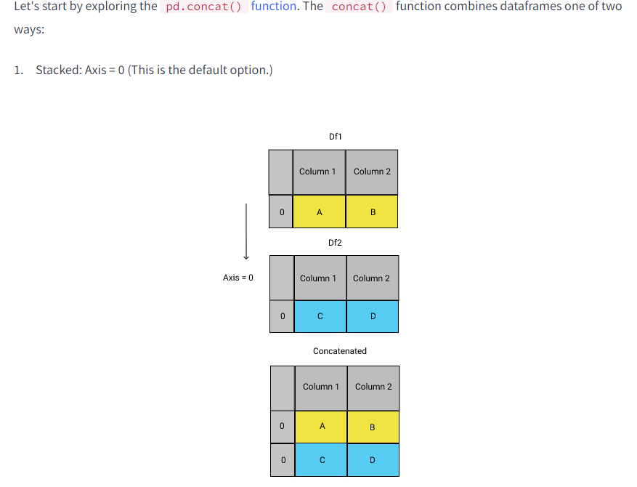

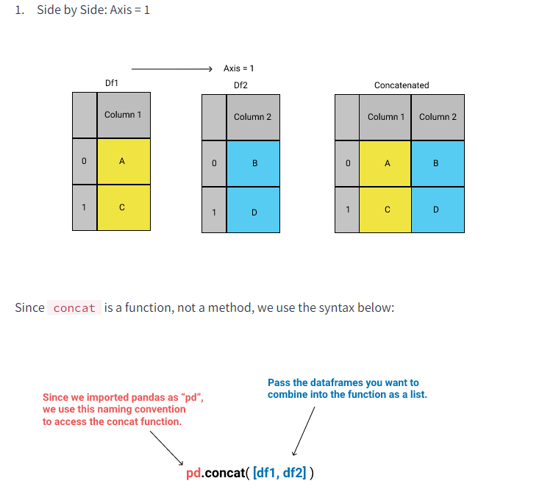

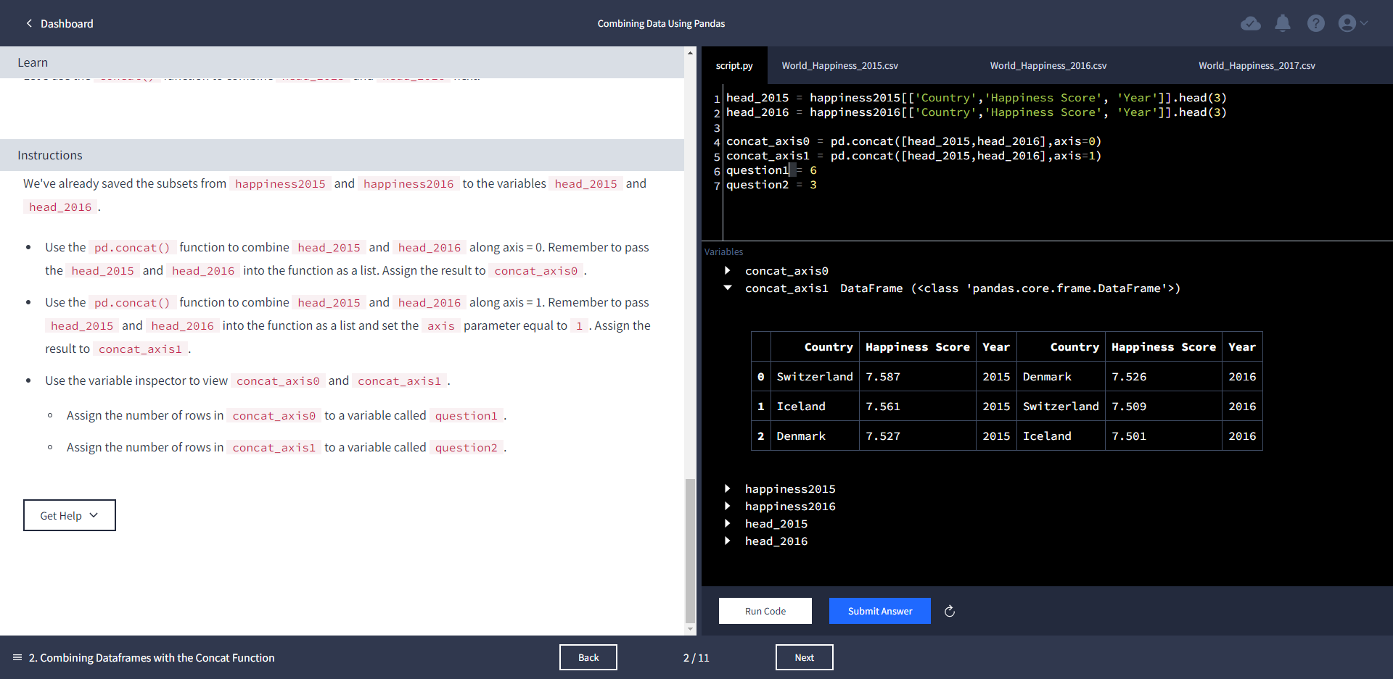

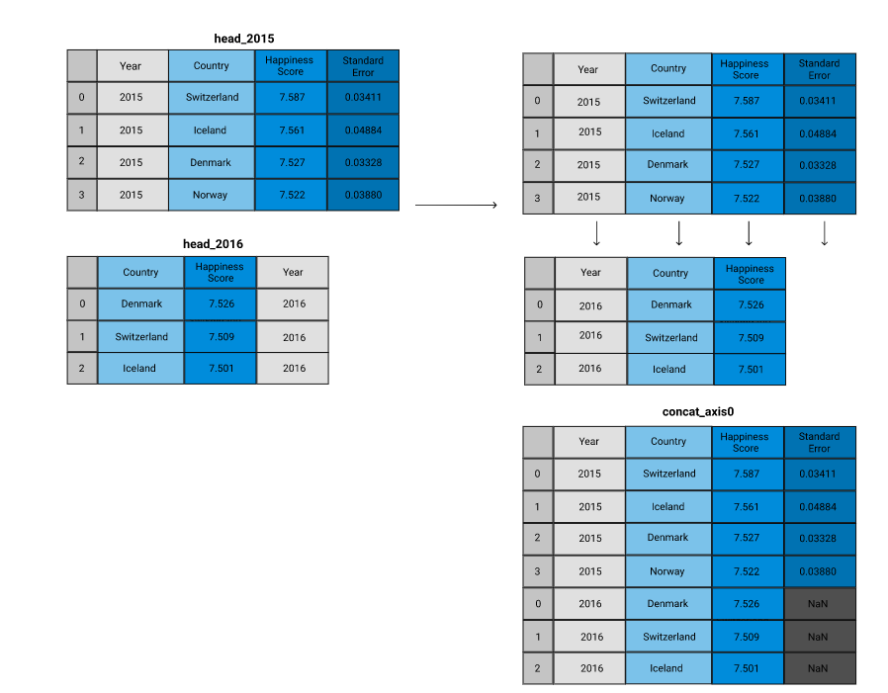

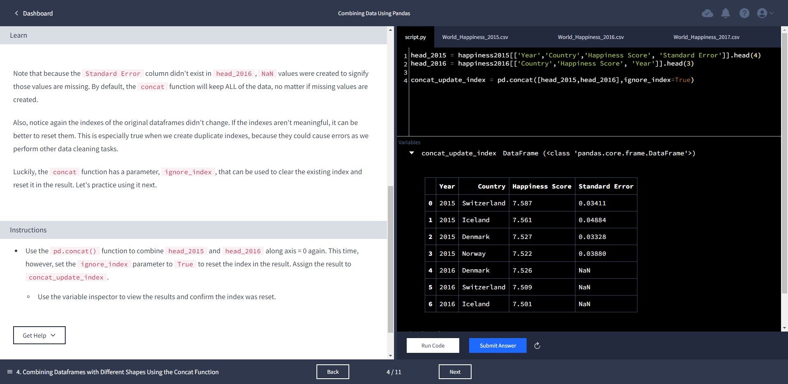

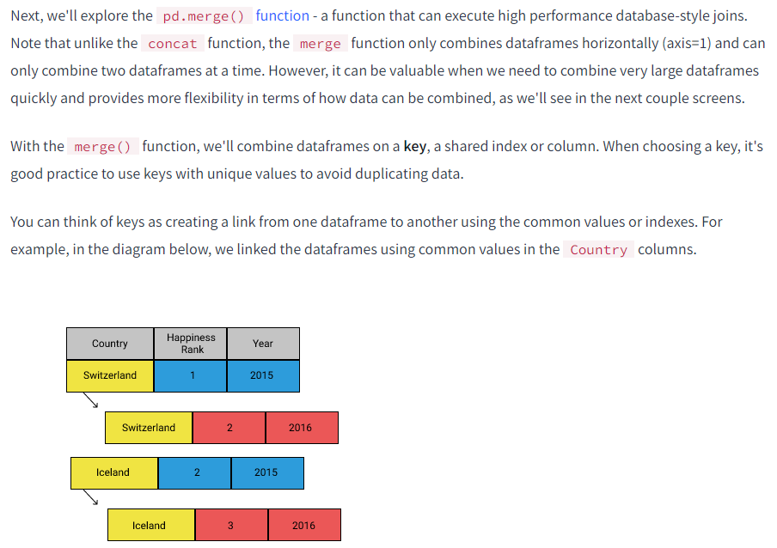

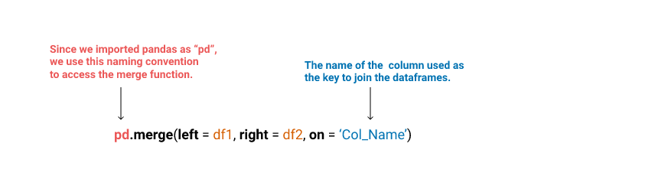

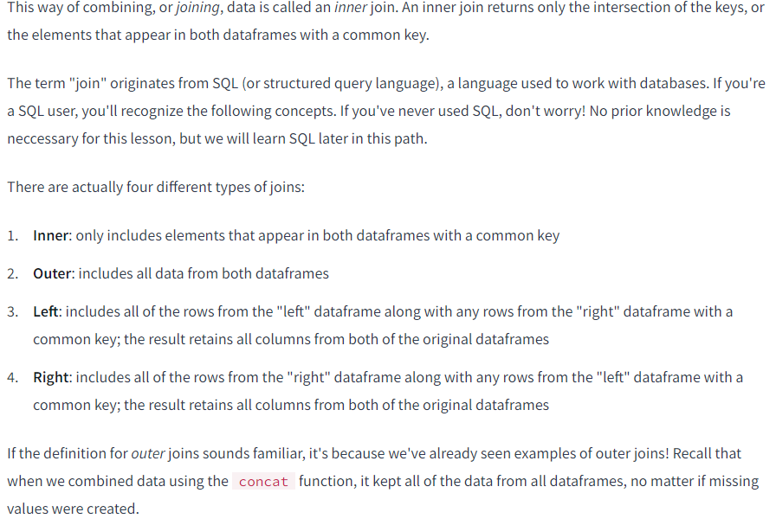

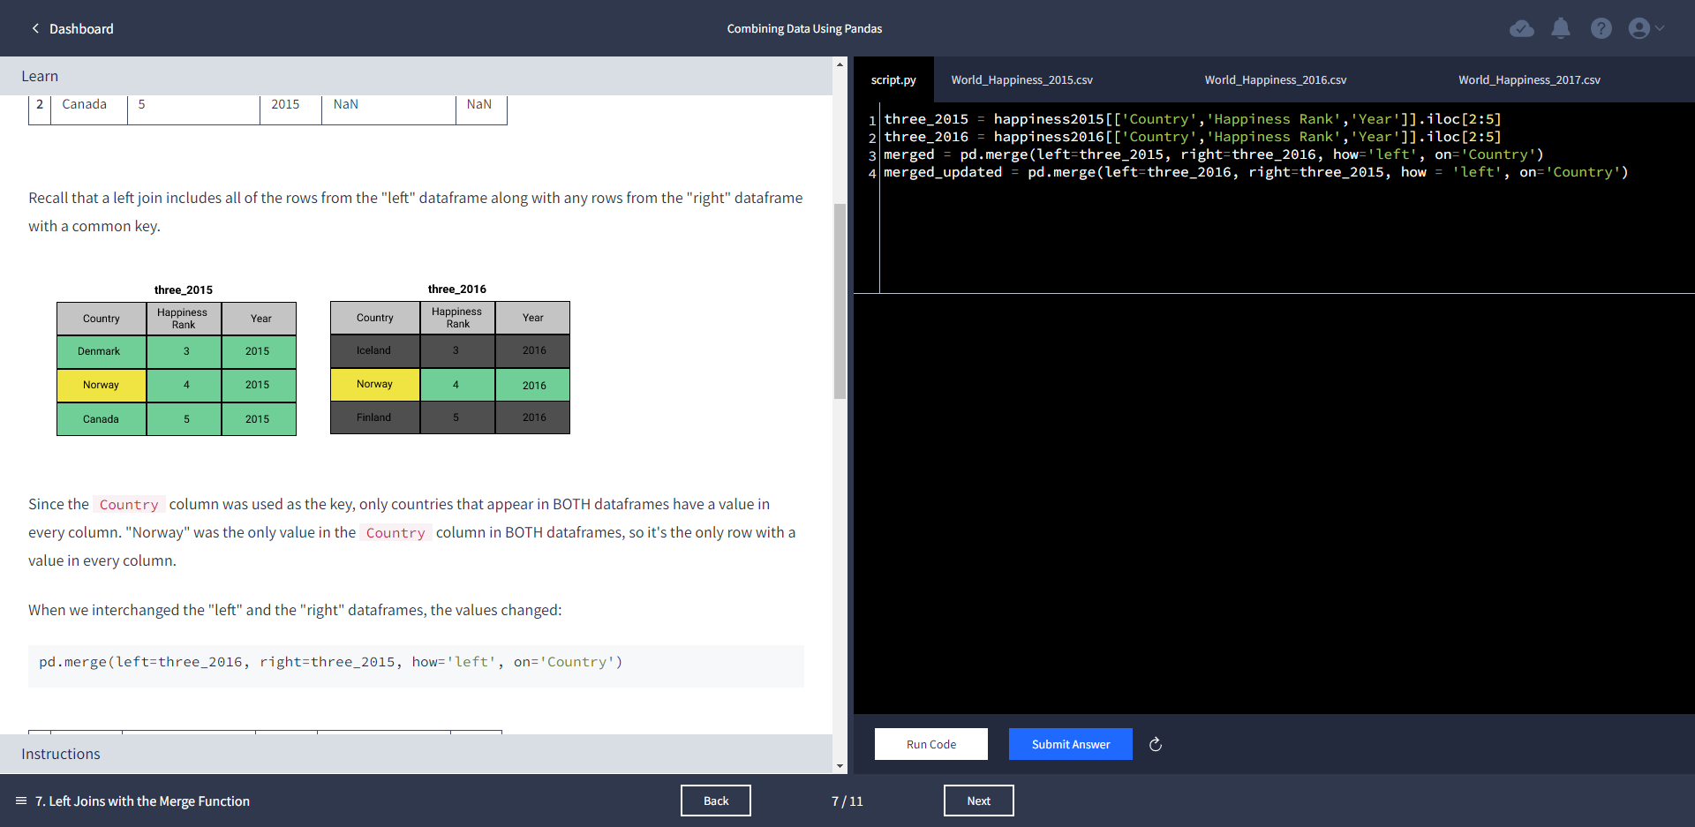

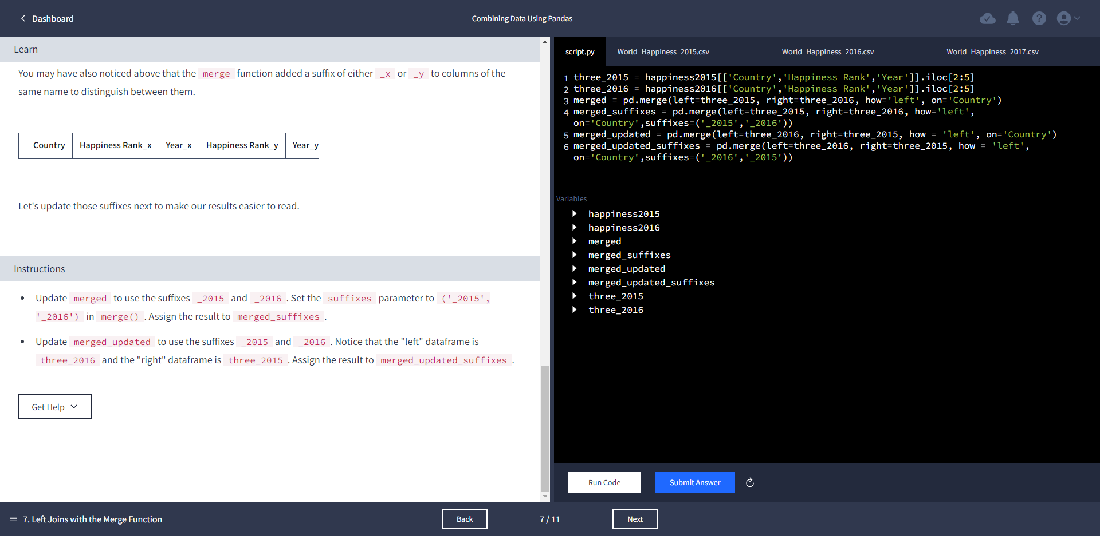

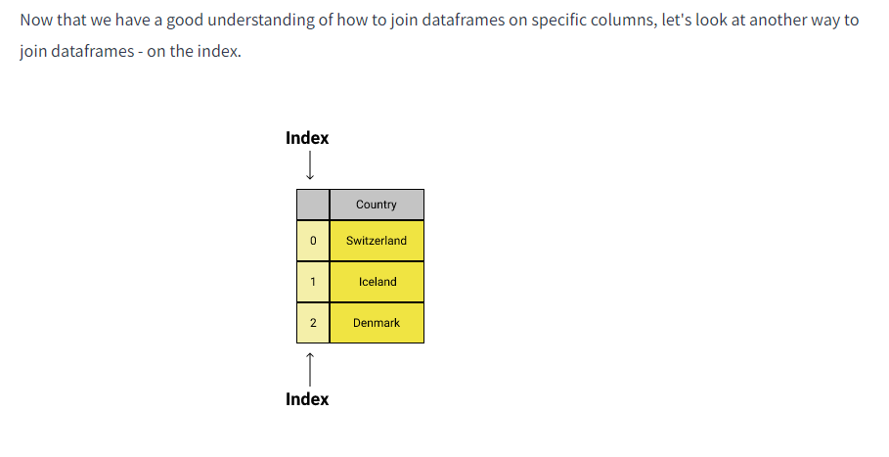

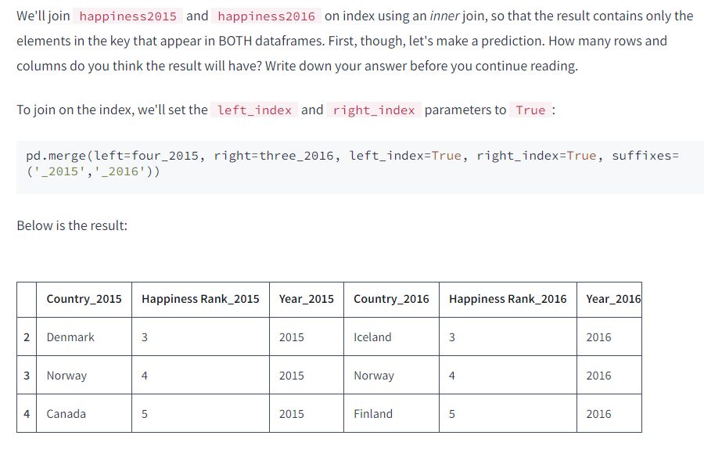

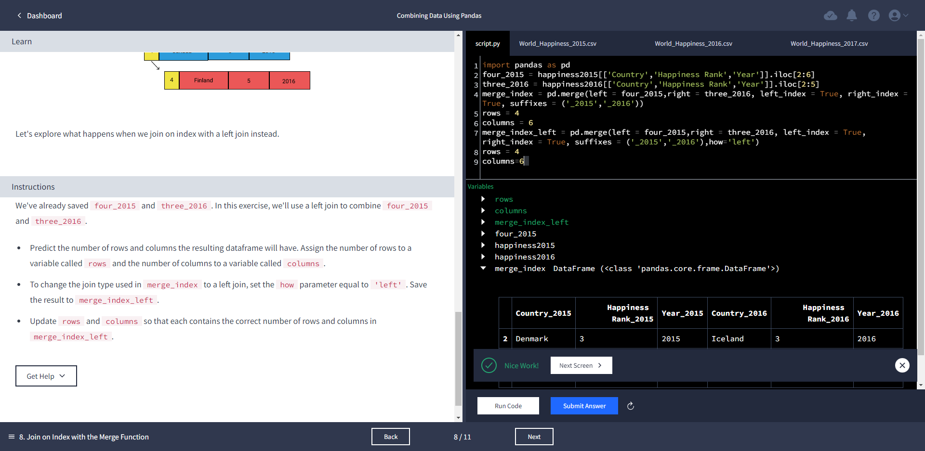

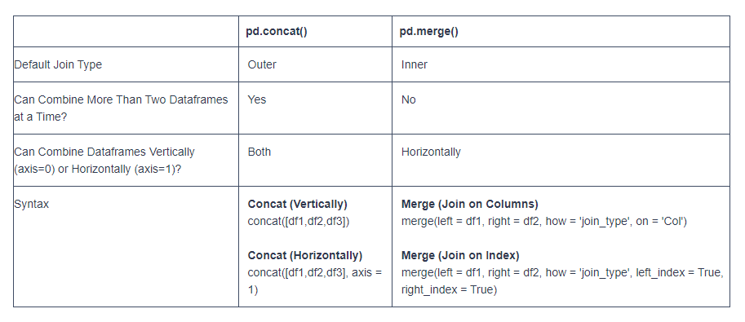

happiness2017.rename(columns={'Happiness.Score': 'Happiness Score'}, inplace=True)

[Merge, join, concatenate and compare — pandas 1.5.1 documentation (pydata.org)](https://pandas.pydata.org/pandas-docs/stable/user_guide/merging.html)

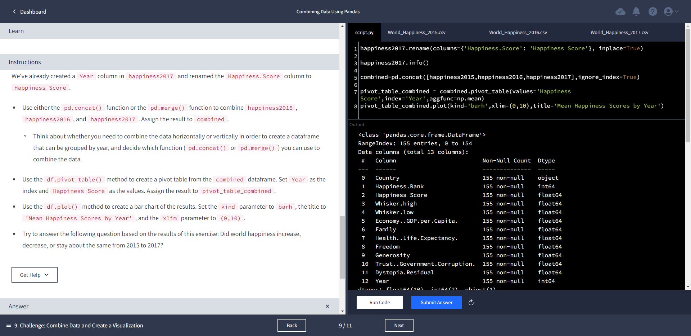

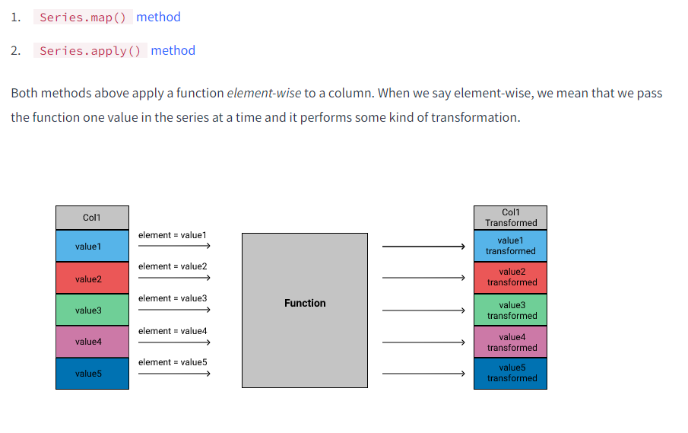

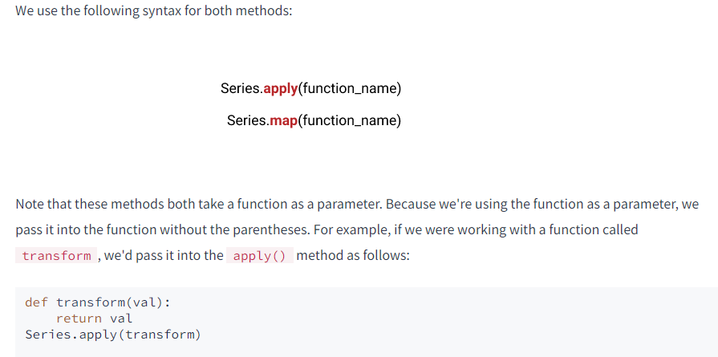

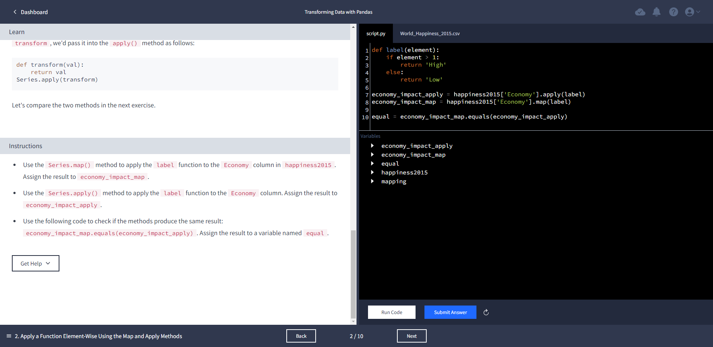

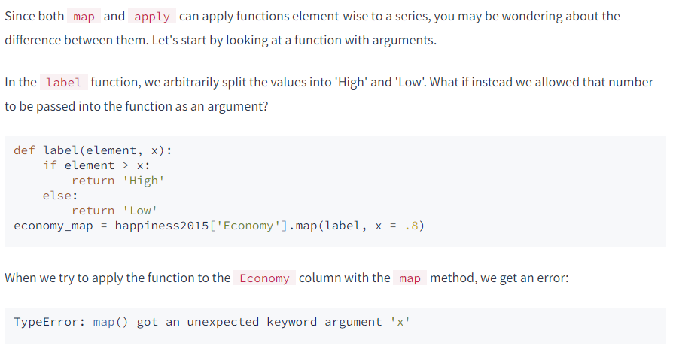

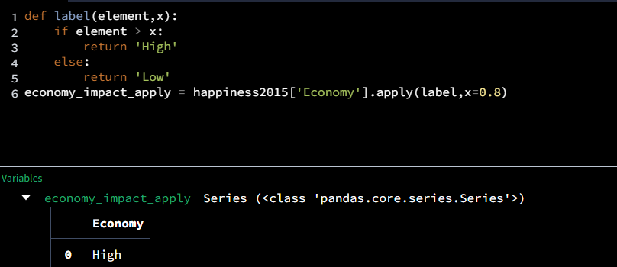

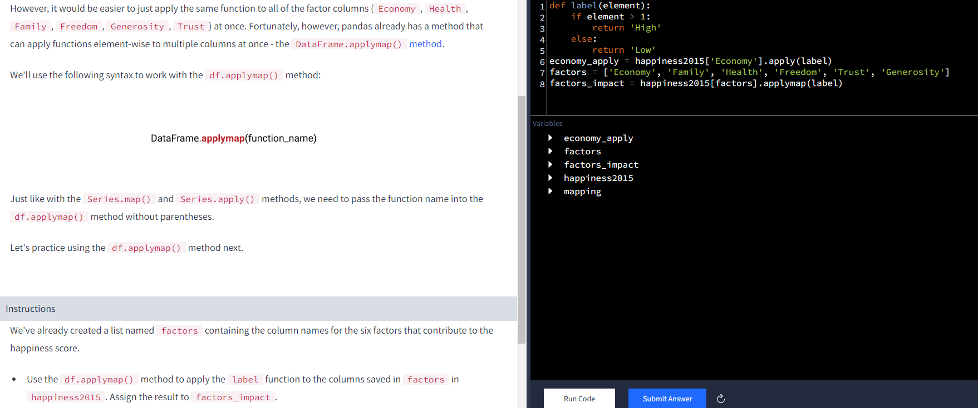

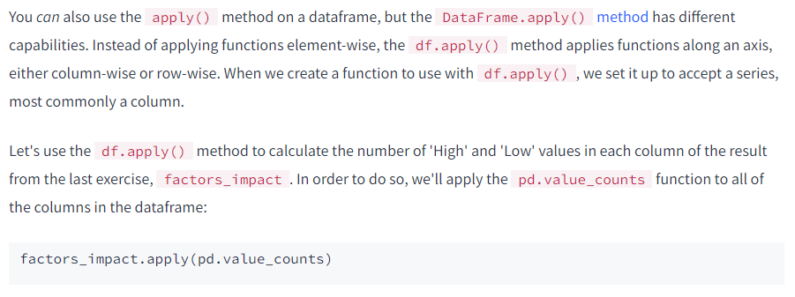

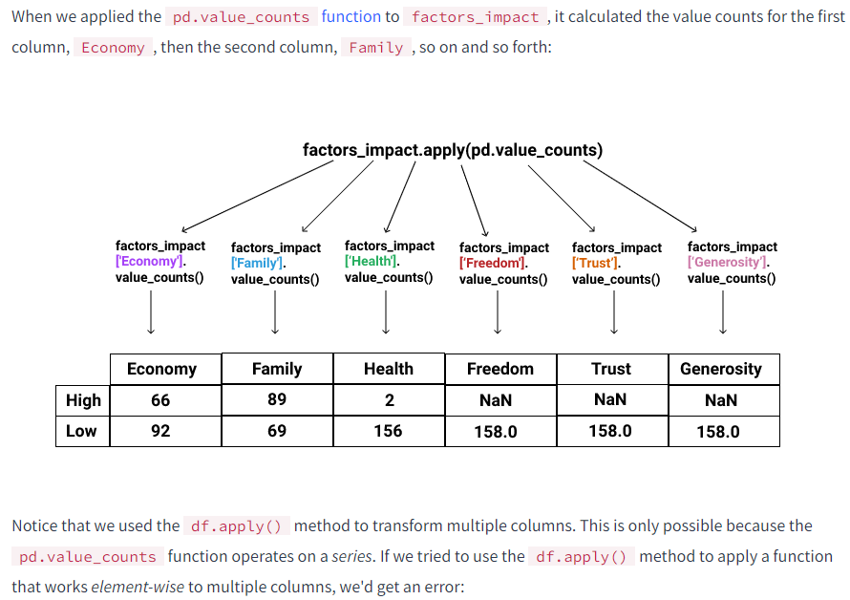

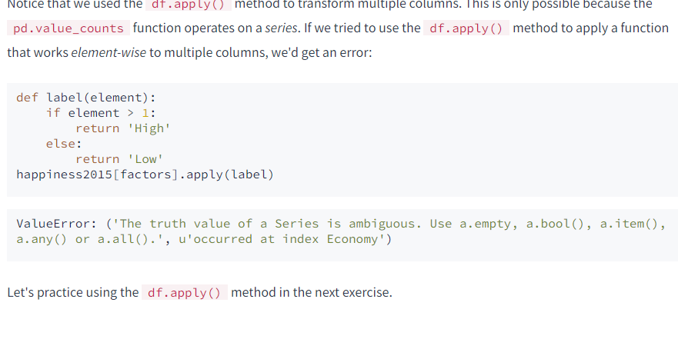

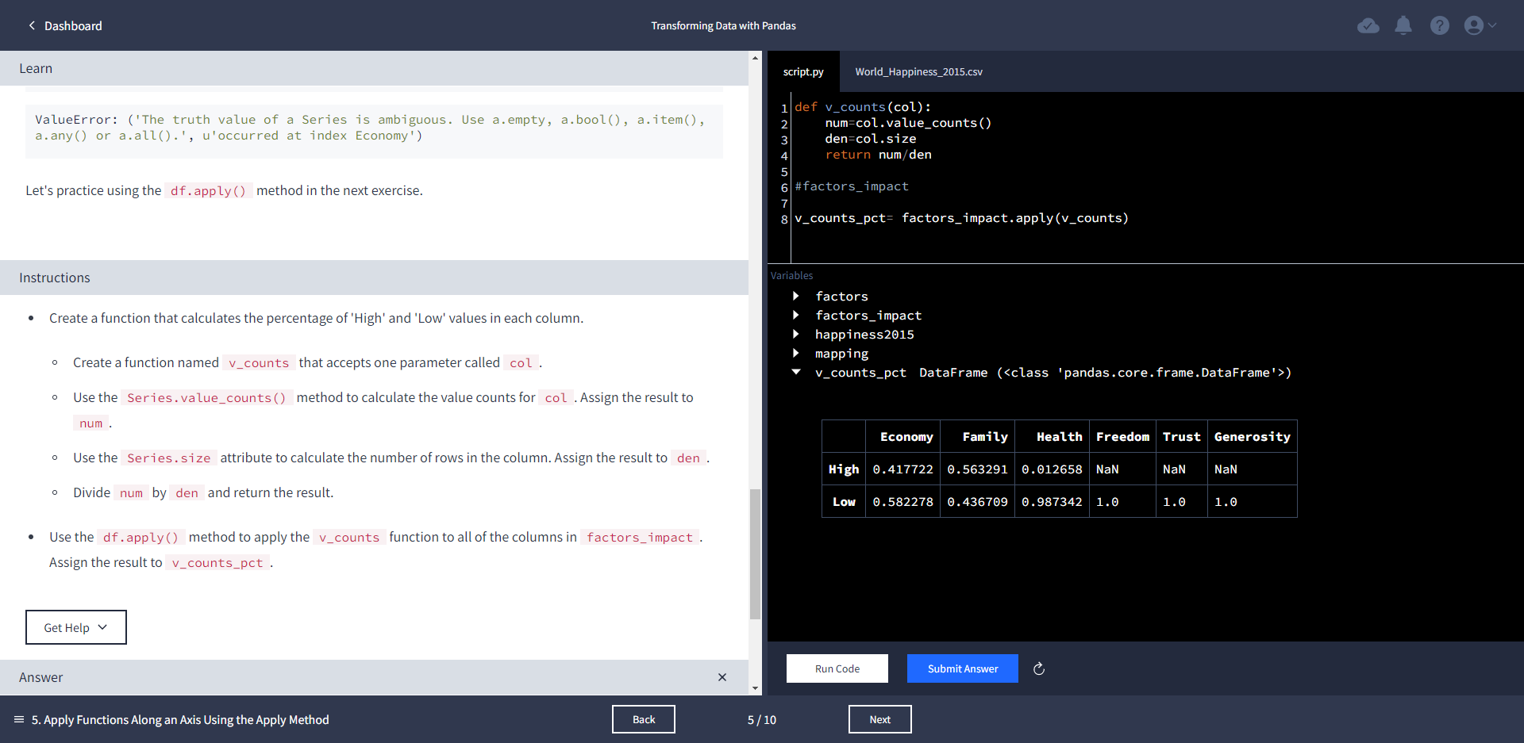

In general, we should only use the apply() method when a vectorized function does not exist. Recall that pandas uses vectorization, the process of applying operations to whole series at once, to optimize performance. When we use the apply() method, we're actually looping through rows, so a vectorized method can perform an equivalent task faster than the apply() method.

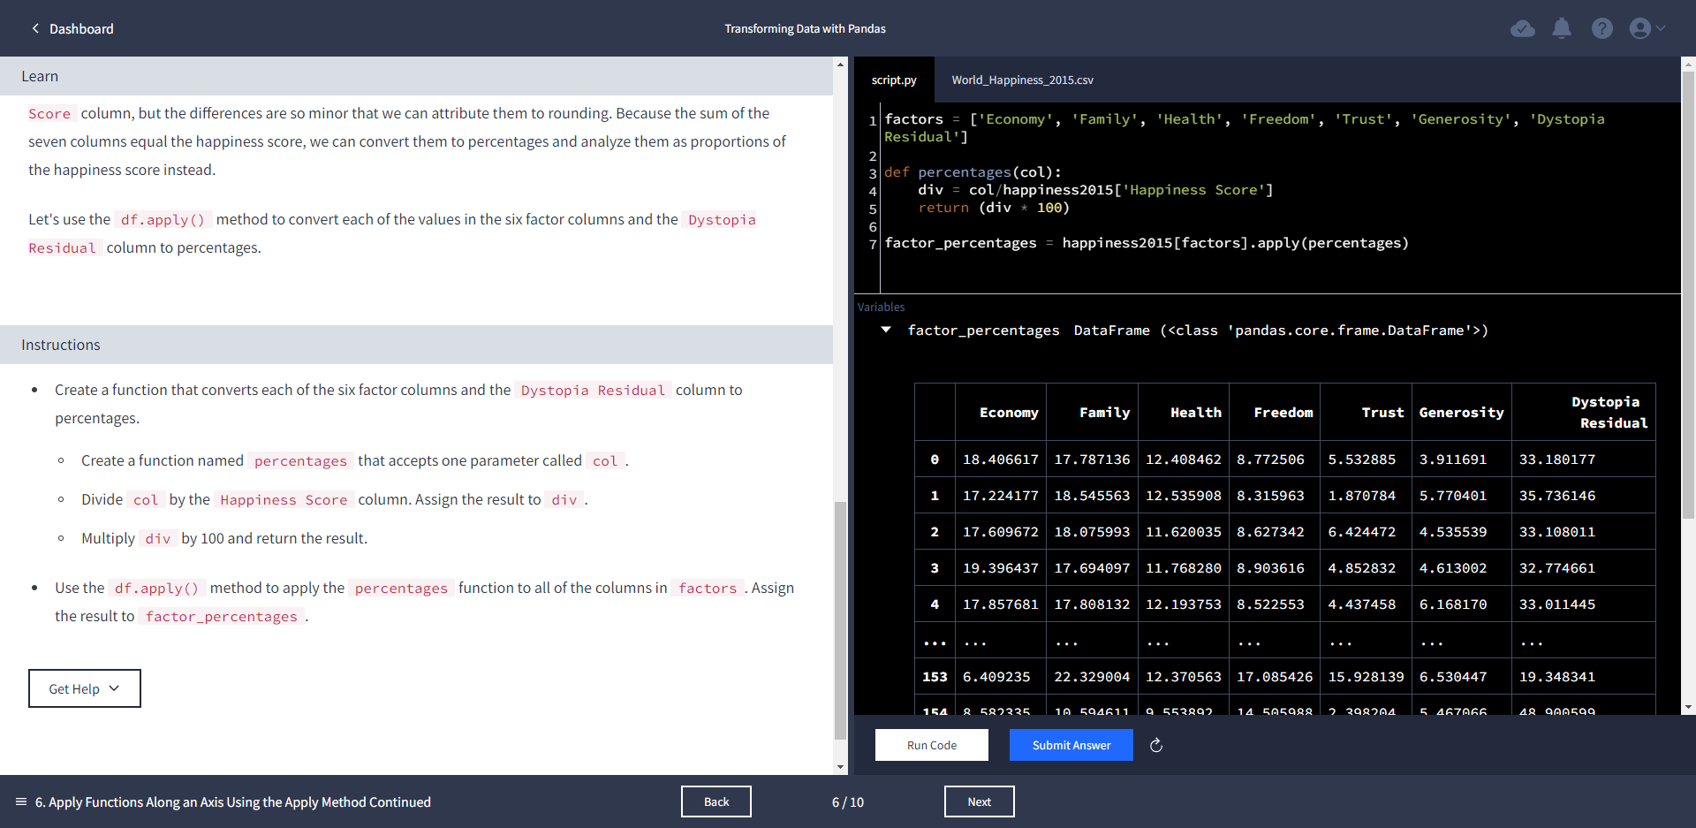

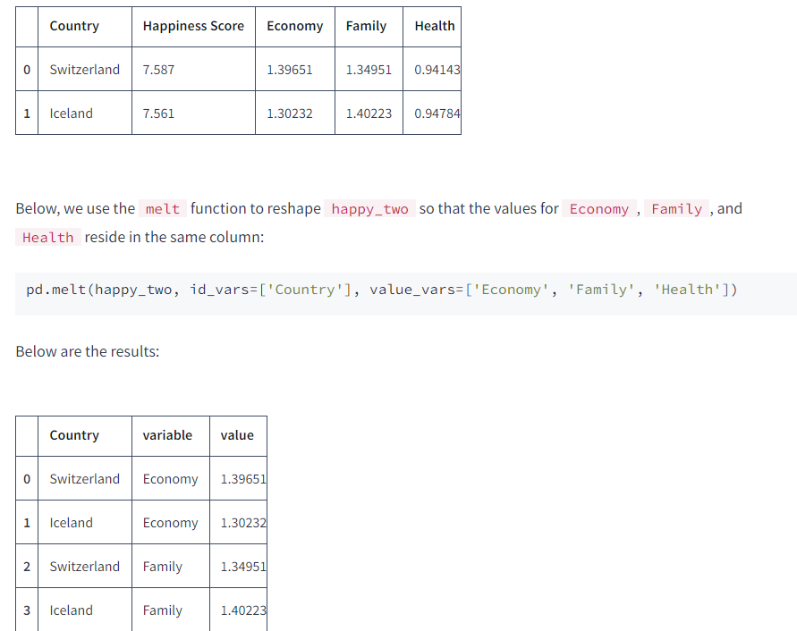

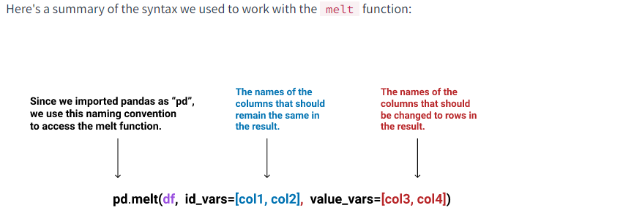

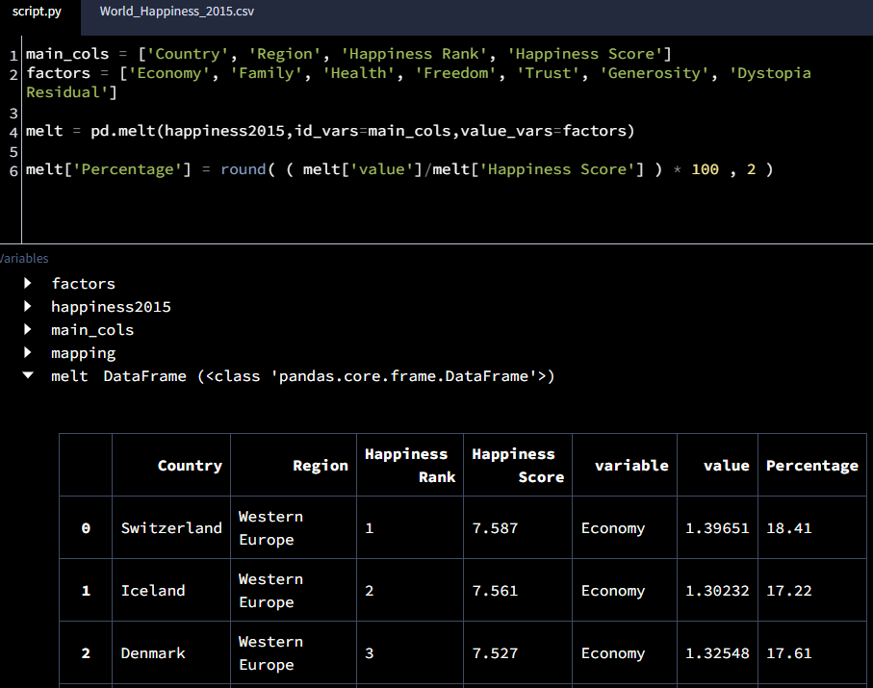

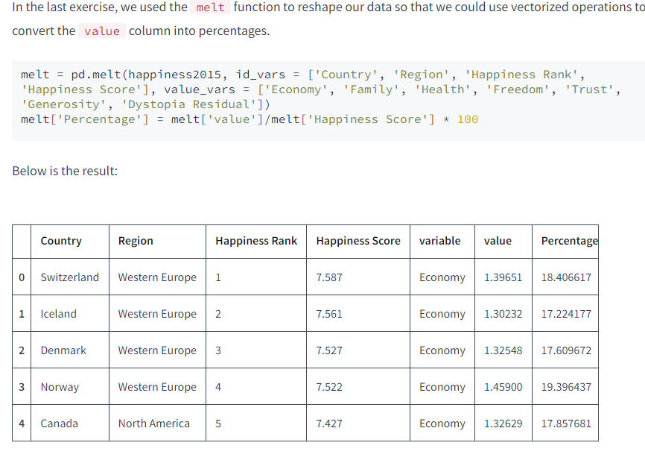

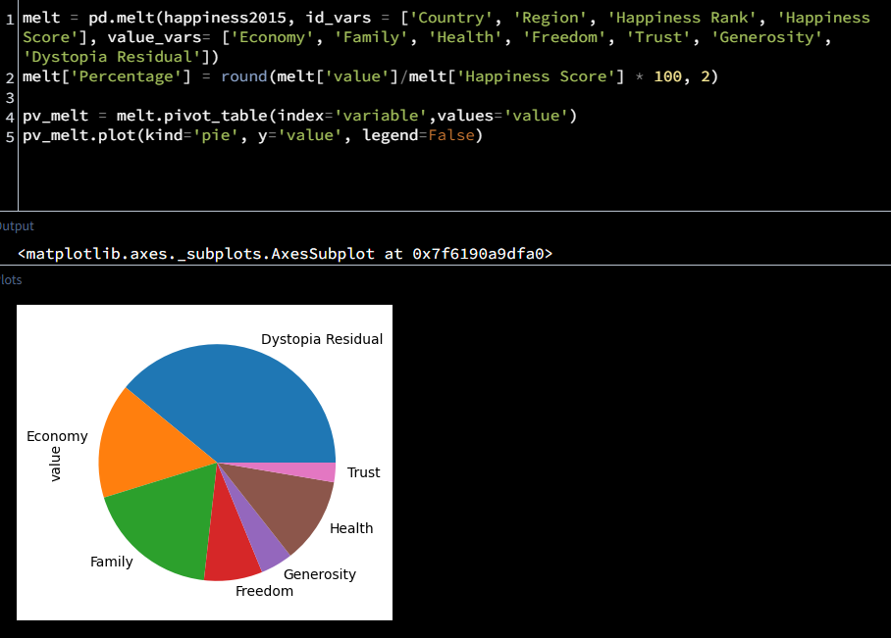

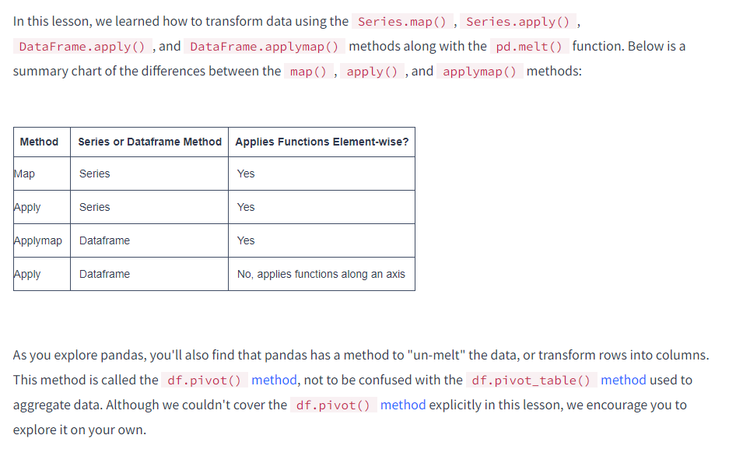

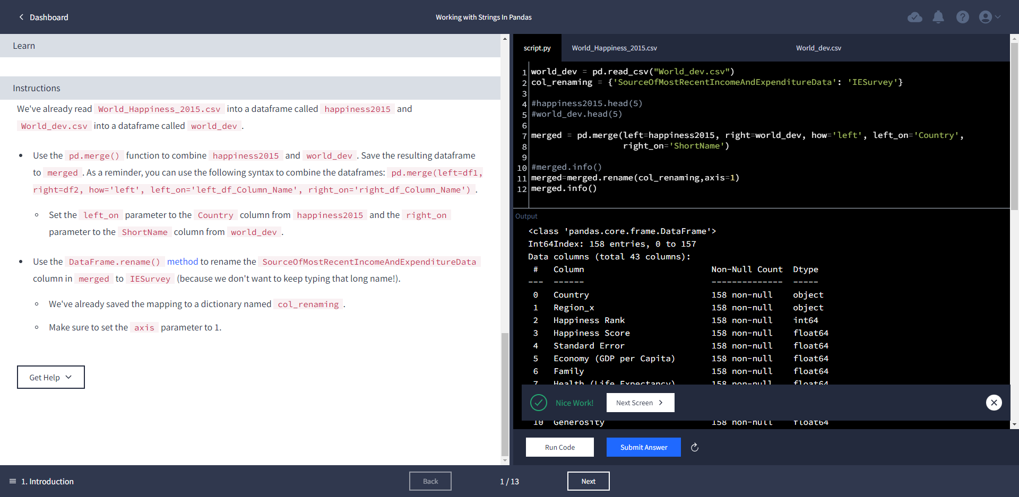

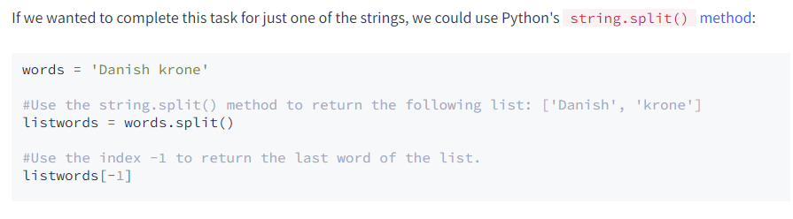

def extract_last_word(element):

return str(element).split()

merged['Currency Apply'] = merged['CurrencyUnit'].apply(extract_last_word)

merged['Currency Apply'].head(5)

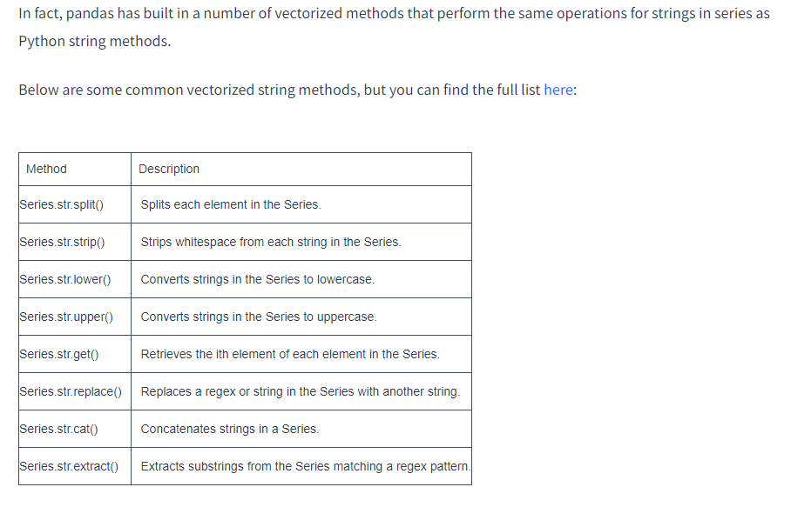

[Working with text data — pandas 1.5.1 documentation (pydata.org)](https://pandas.pydata.org/pandas-docs/stable/user_guide/text.html)

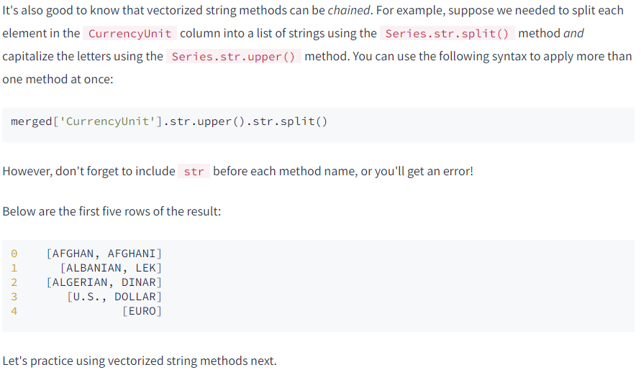

merged['Currency Vectorized'] = merged['CurrencyUnit'].str.split().str.get(-1)

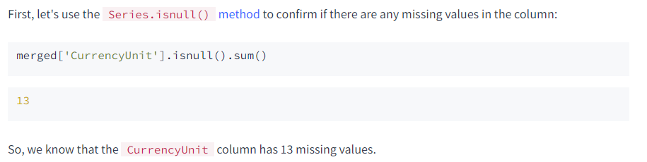

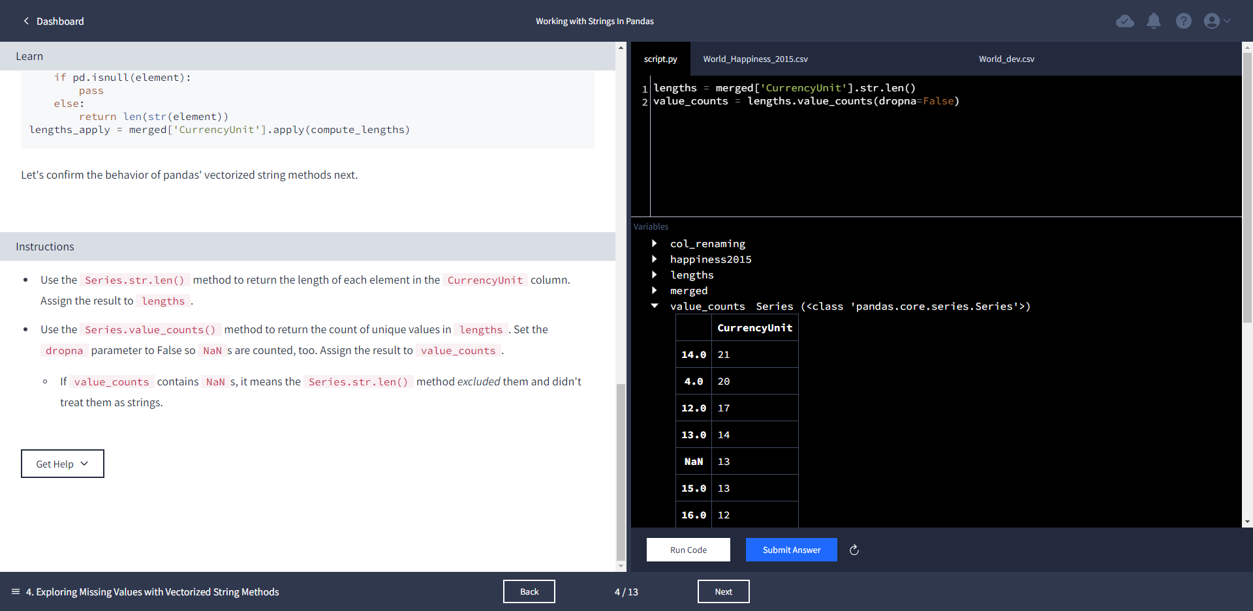

[6.2. re — Regular expression operations — Python 3.4.10 documentation](https://docs.python.org/3.4/library/re.html)

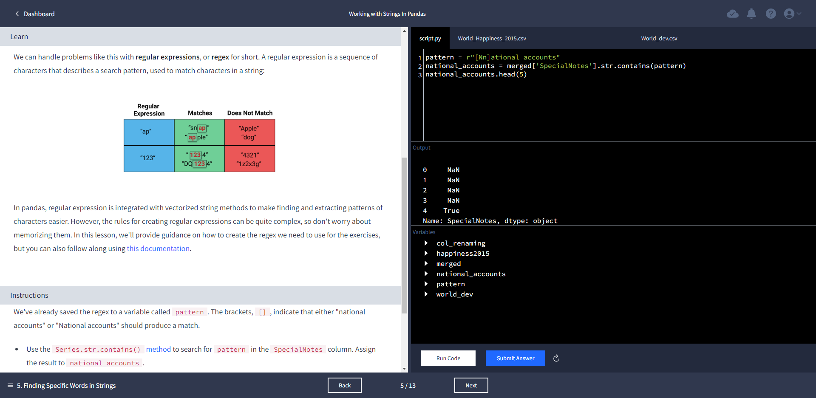

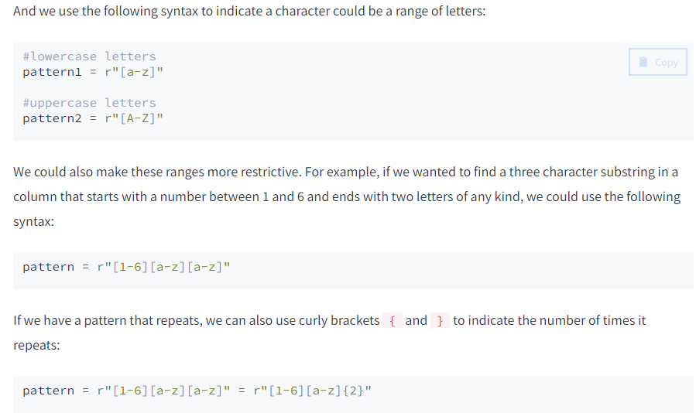

pattern =r"([1-2][0-9]{3})"

years = merged['SpecialNotes'].str.extract(pattern)

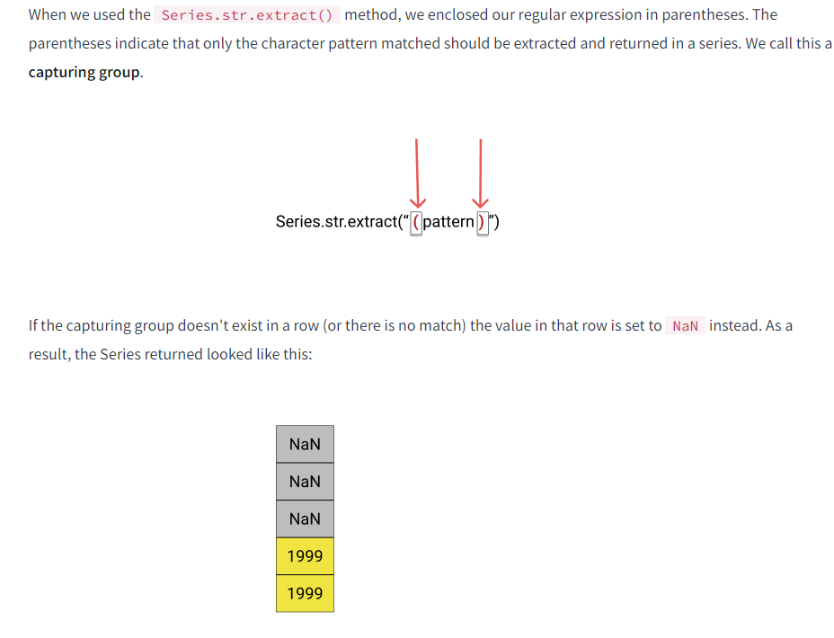

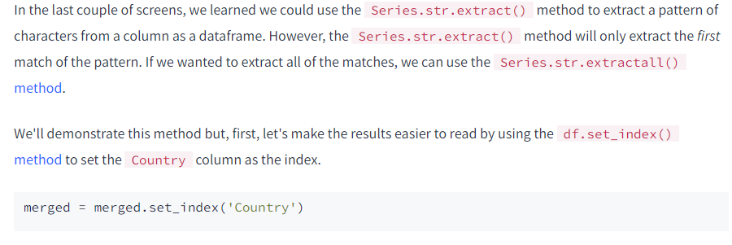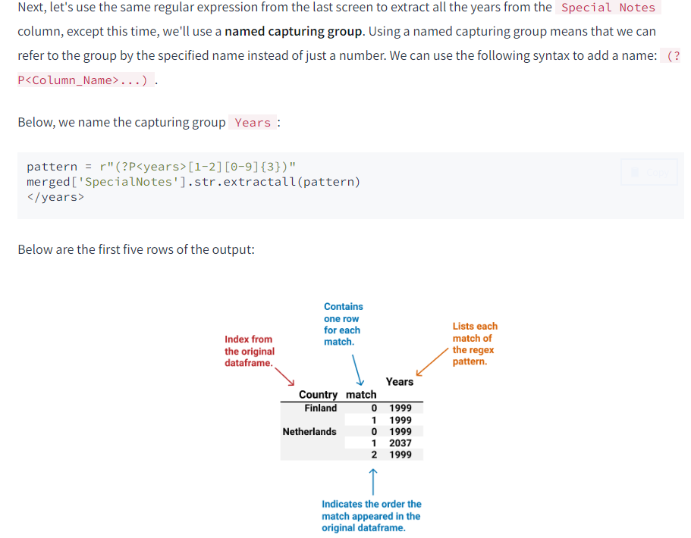

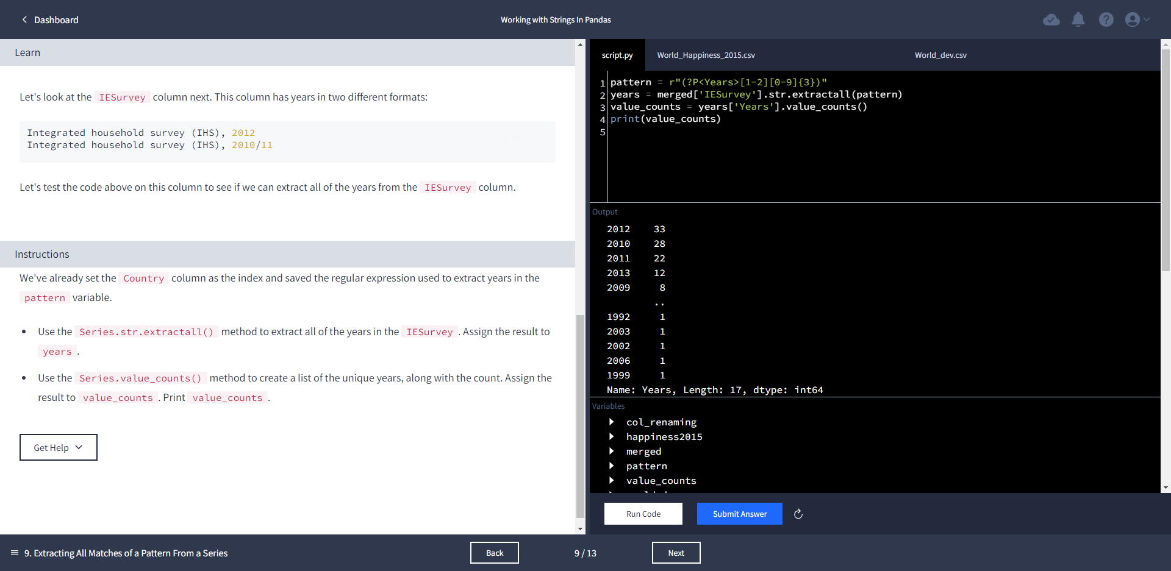



years.sort_values('Second_Year')

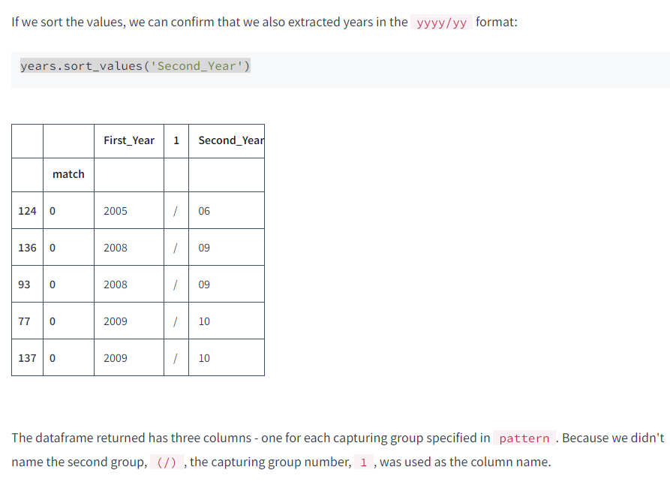

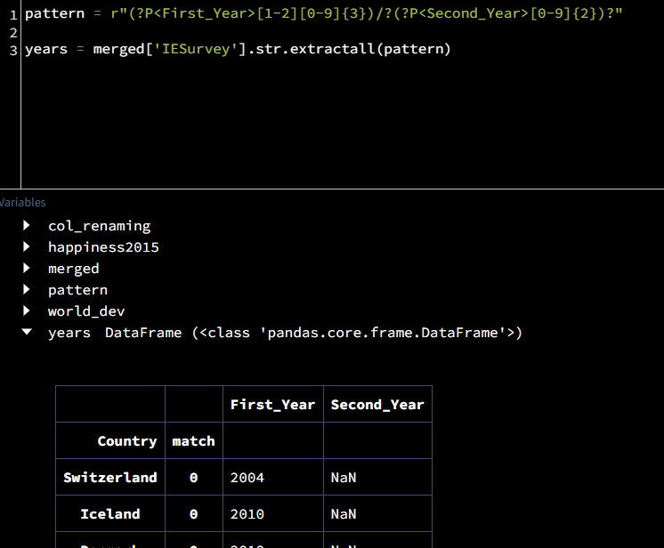

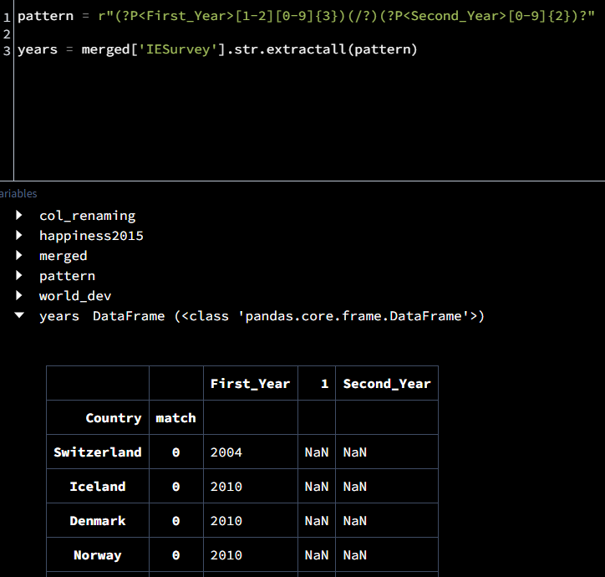

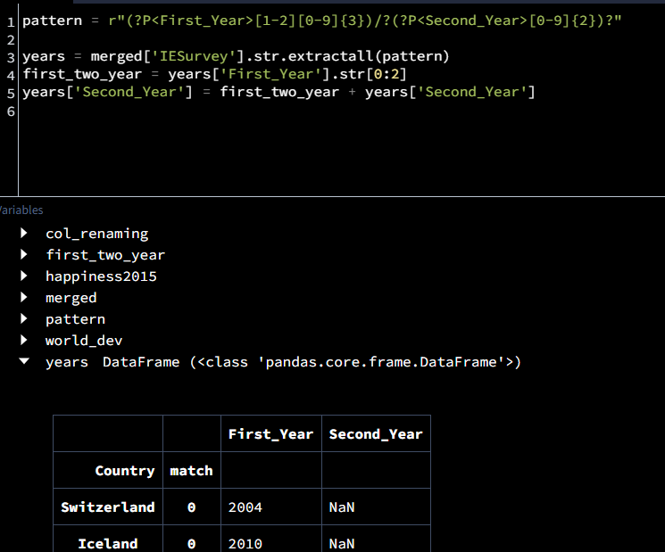

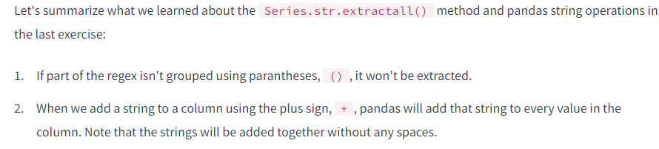

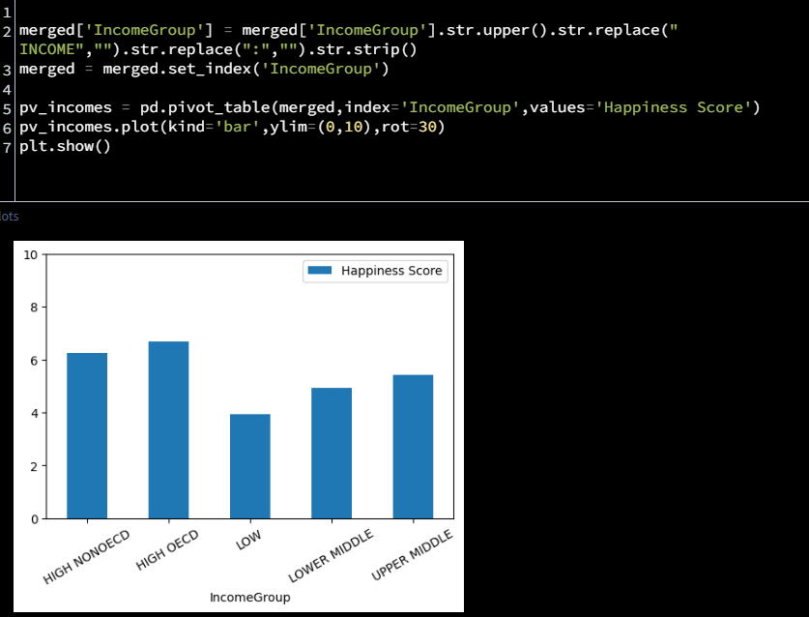

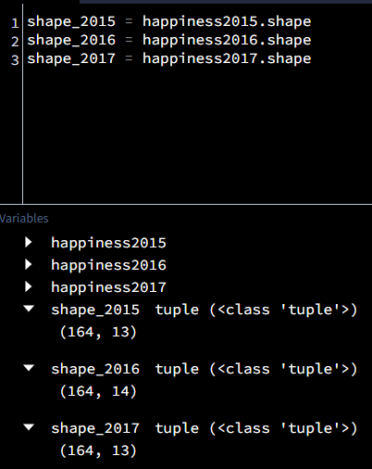

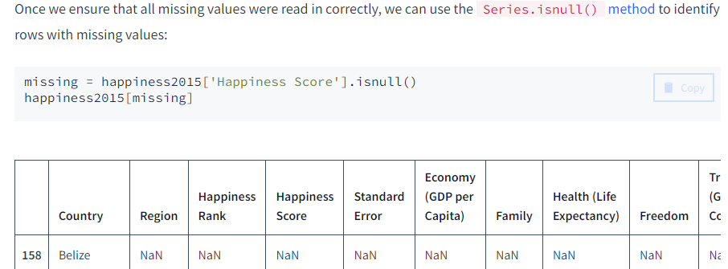

[python - Pandas replace a character in all column names - Stack Overflow](https://stackoverflow.com/questions/39741429/pandas-replace-a-character-in-all-column-names)

happiness2017.columns = happiness2017.columns.str.replace('.', ' ').str.replace('\s+', ' ').str.strip().str.upper()

happiness2016.columns = happiness2016.columns.str.replace('[()]','').str.replace('s+','').str.strip().str.upper()

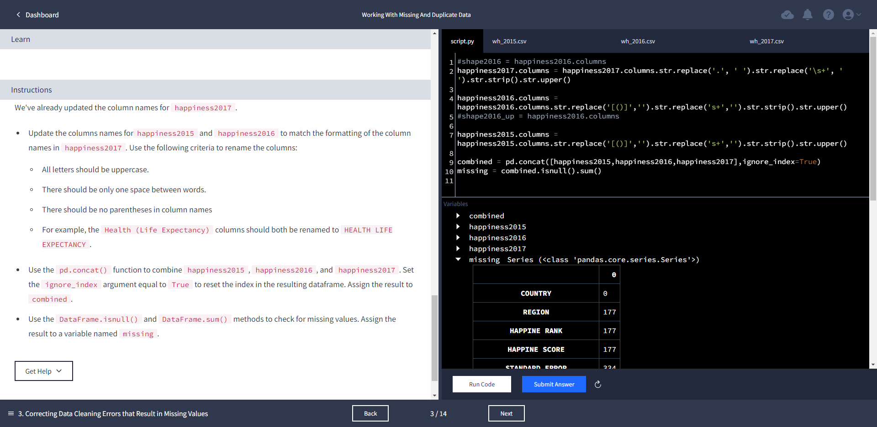

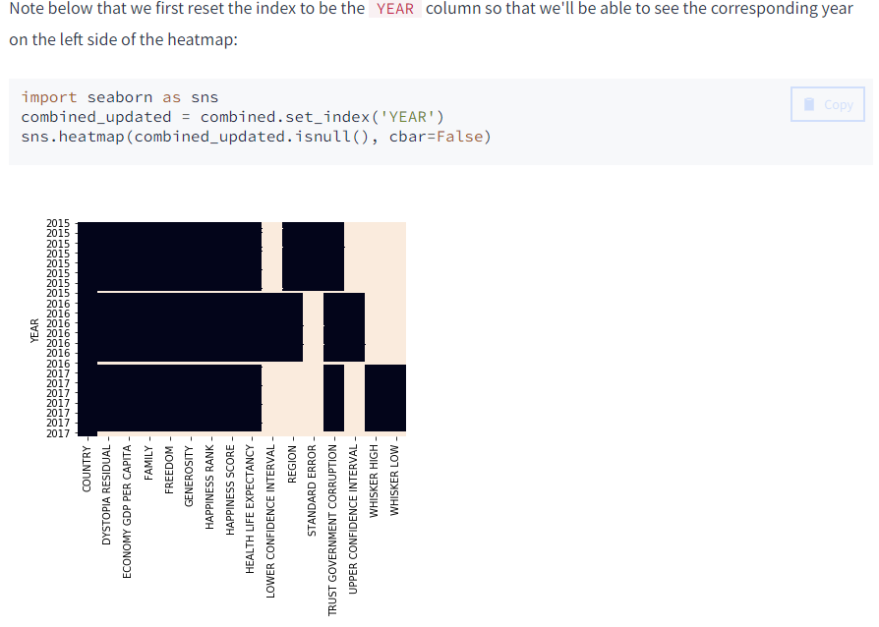

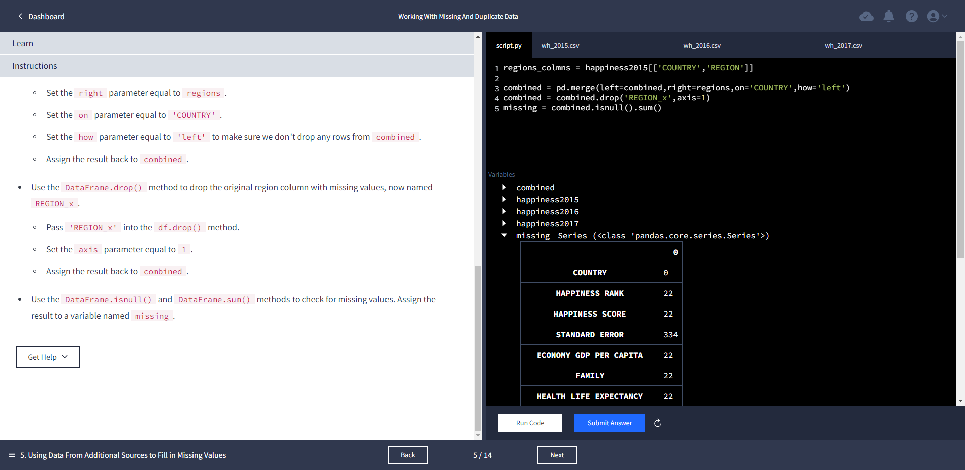

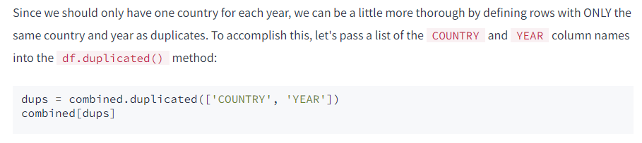

However, one thing to keep in mind is that the df.duplicated() method will only look for exact matches, so if the capitalization for country names isn't exactly the same, they won't be identified as duplicates. To be extra thorough, we can first standardize the capitalization for the COUNTRY column and then check for duplicates again.

combined['COUNTRY'].head(20)

combined['COUNTRY'] = combined['COUNTRY'].str.upper()

combined['COUNTRY'].head(20)

dups = combined.duplicated(['COUNTRY','YEAR'])

combined[dups]

combined[combined['COUNTRY'] == 'SOMALILAND REGION']

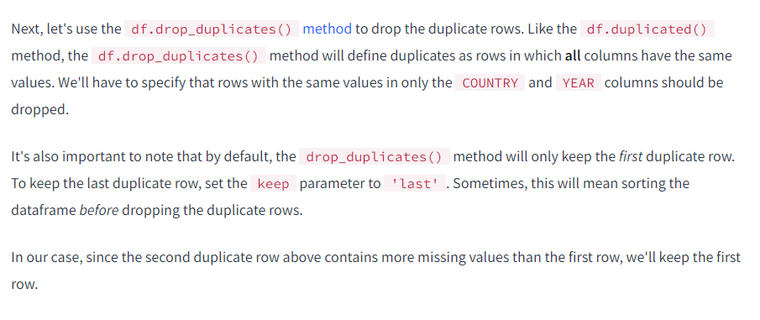

columns_to_drop = ['LOWER CONFIDENCE INTERVAL', 'STANDARD ERROR', 'UPPER CONFIDENCE INTERVAL', 'WHISKER HIGH', 'WHISKER LOW']

combined=combined.drop(columns_to_drop,axis=1)

missing = combined.isnull().sum()

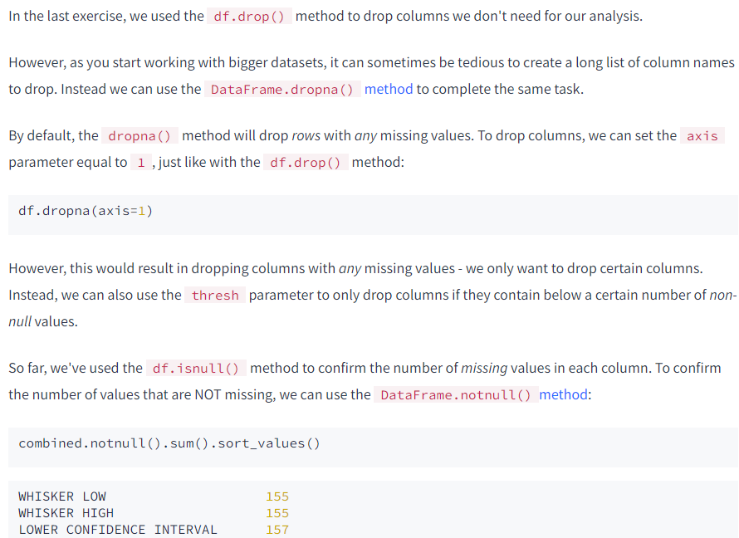

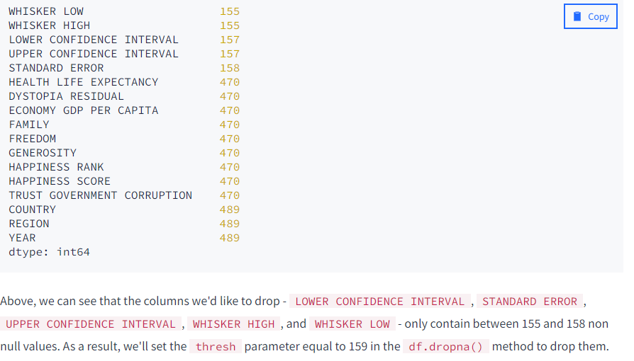

combined= combined.dropna(thresh=159,axis=1)

missing=combined.isnull().sum().sort_values()

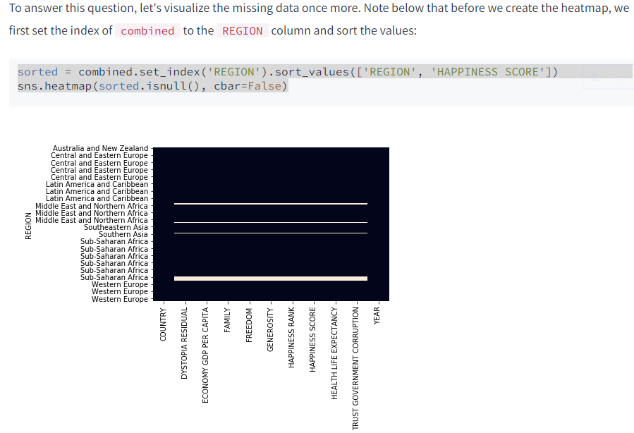

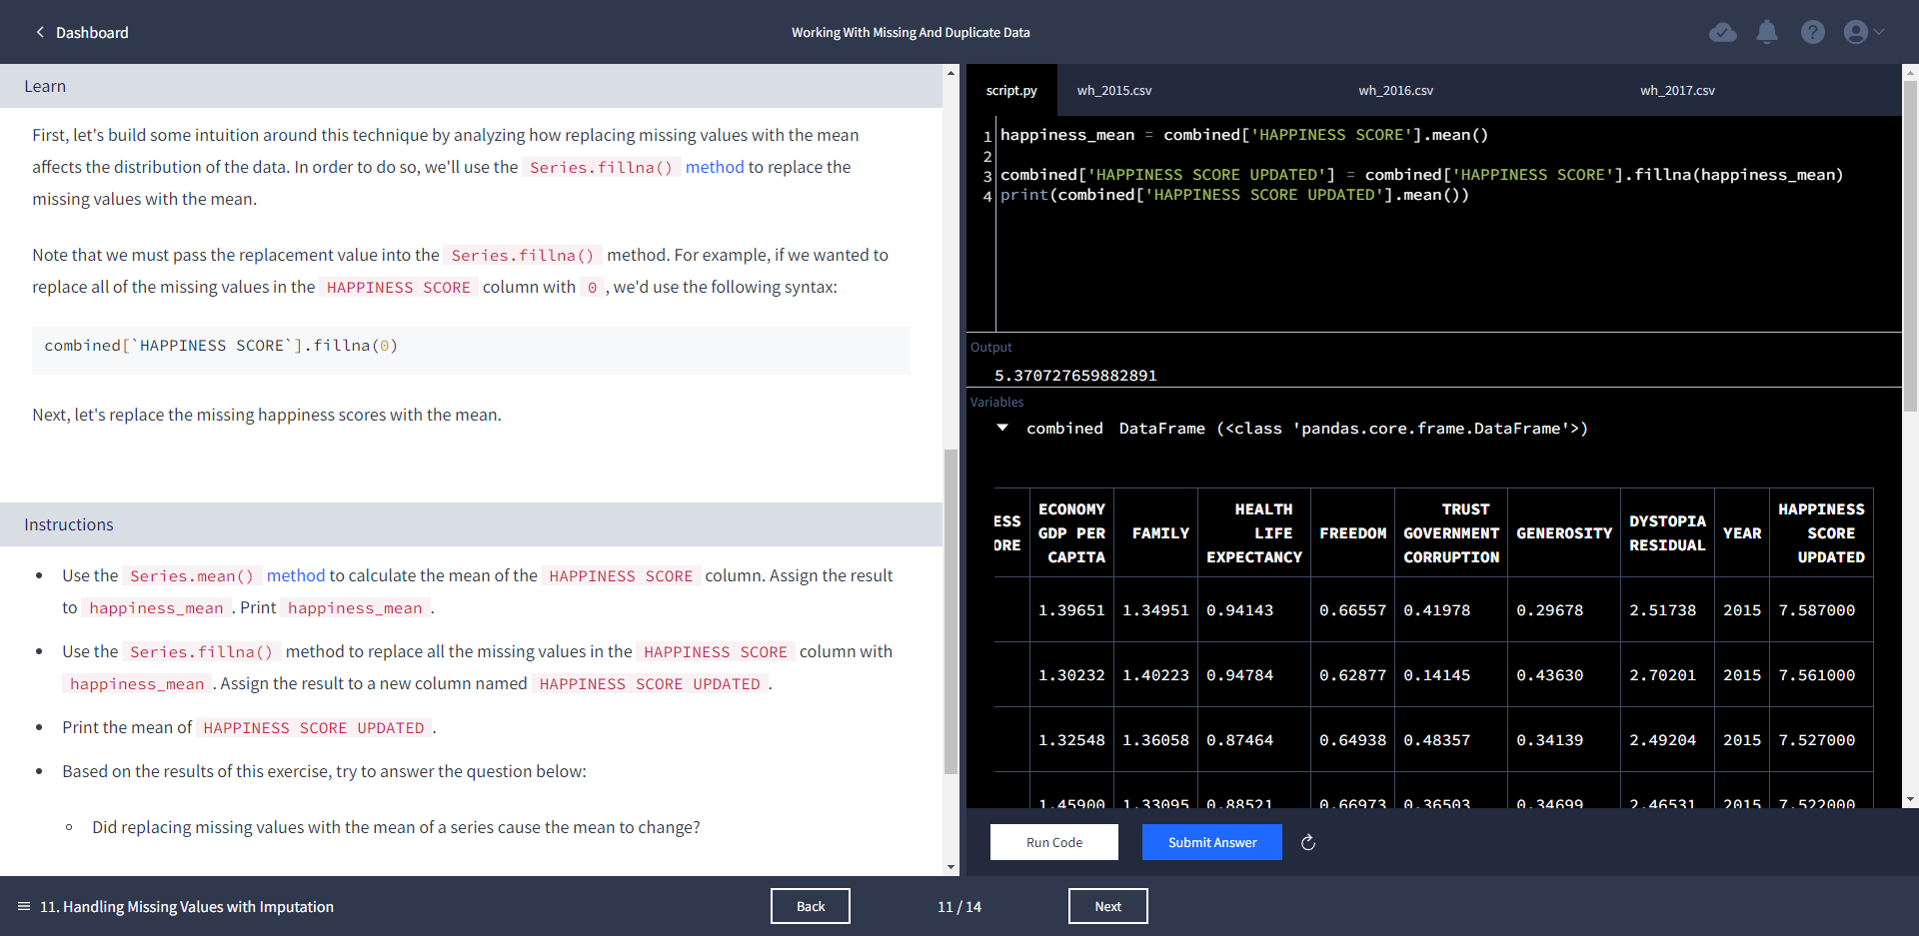

dete_survey_updated = dete_survey_updated[dete_survey_updated['separationtype'].str.contains('Resignation')].copy()

tafe_resignations = tafe_survey_updated[tafe_survey_updated['separationtype'] == 'Resignation'].copy()

mapping = {"Gender. What is your Gender?": "gender","CurrentAge. Current Age":"age" , "LengthofServiceOverall. Overall Length of Service at Institute (in years)" : "institute_service" , \

"LengthofServiceCurrent. Length of Service at current workplace (in years)" : "role_service"}

tafe_survey_updated.rename(mapping,axis=1,inplace=True)

pattern = r'(?P<First>[0-9]{2})/?(?P<Second>[1-2][0-9]{3})'

y = dete_resignations['cease_date'].str.extract(pattern)

dete_resignations['dete_start_date'].value_counts().sort_values()

import plotly.express as px

dete_dates = dete_resignations[['dete_start_date', 'role_start_date', 'cease_date']]

fig = px.box(dete_dates, y=dete_dates.columns, width=500, height=600, template='plotly_white')

fig.update_layout(title='DETE Employees Who Resigned.<br><i>When did they join, when did they leave?')

fig.update_yaxes(dtick=5, color='gray', title='Year', showline=True, mirror=True)

fig.update_xaxes(title='', color='gray', showline=True, mirror=True)

fig.show('png')

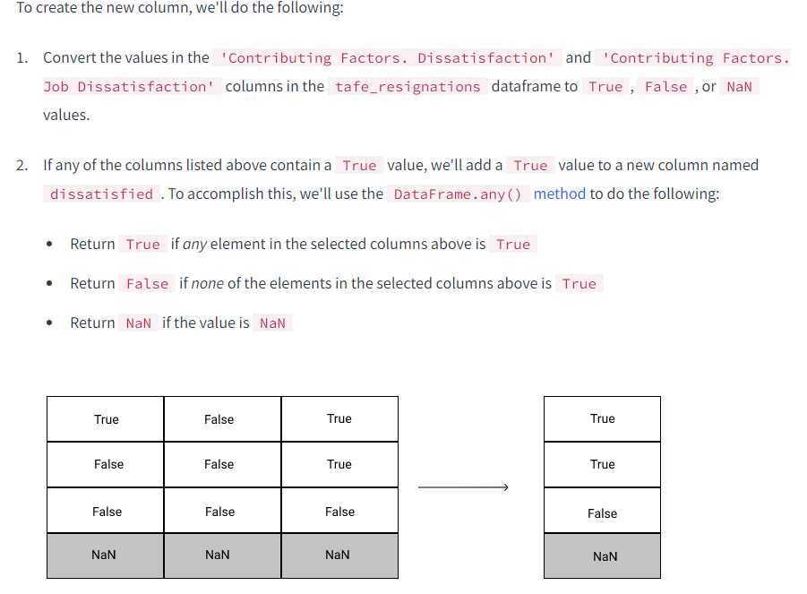

tafe_resignations['dissatisfied'] = tafe_resignations[tafe_col].any(axis=1,skipna=False)

[{"metadata":{"trusted":true},"cell_type":"code","source":"tafe_col = \\\n[\\\n 'Contributing Factors. Dissatisfaction' \\\n ,'Contributing Factors. Job Dissatisfaction']\n\n","execution_count":61,"outputs":[]}]

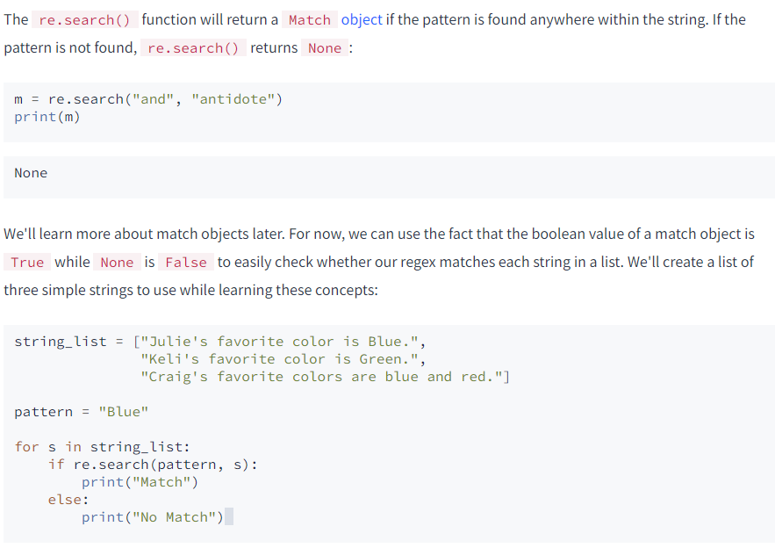

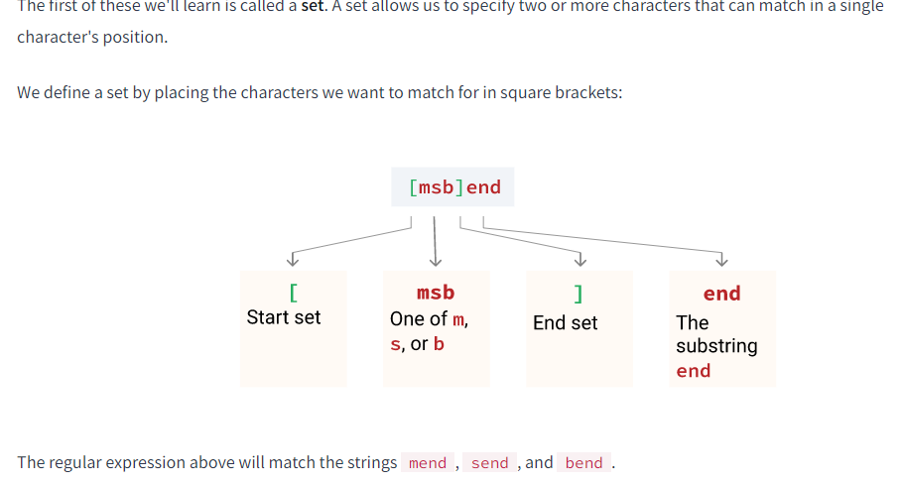

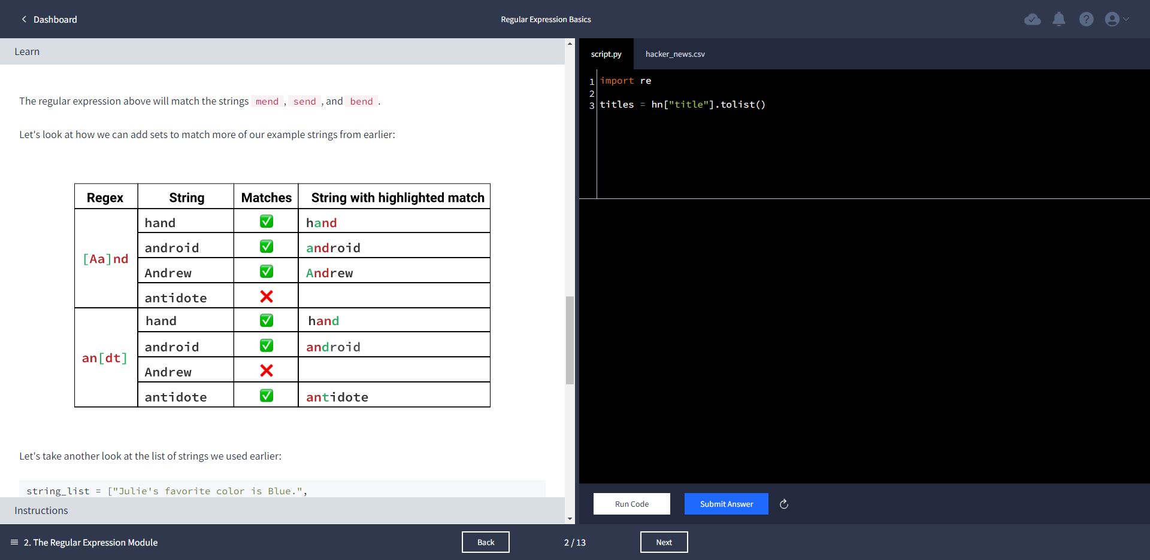

titles = hn["title"].tolist()

import re

titles = hn["title"].tolist()

python_mentions = 0

pattern = '[Pp]ython'

for s in titles:

if (re.search(pattern,s)):

python_mentions += 1

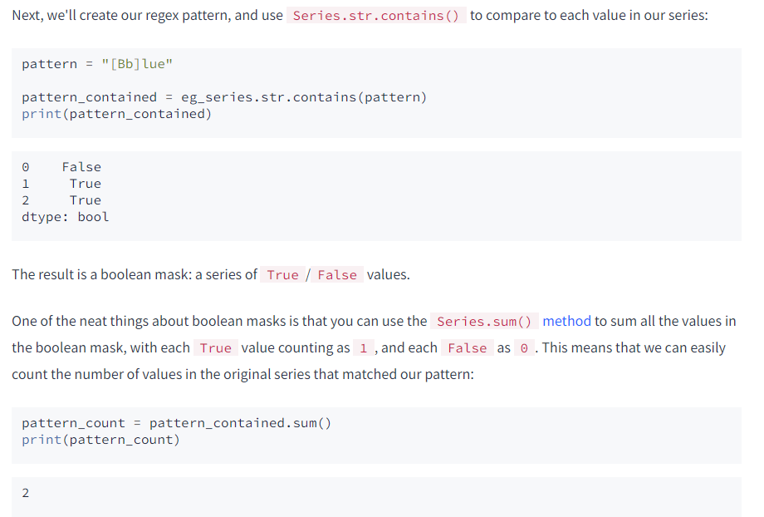

pattern_count = eg_series.str.contains(pattern).sum()

print(pattern_count)

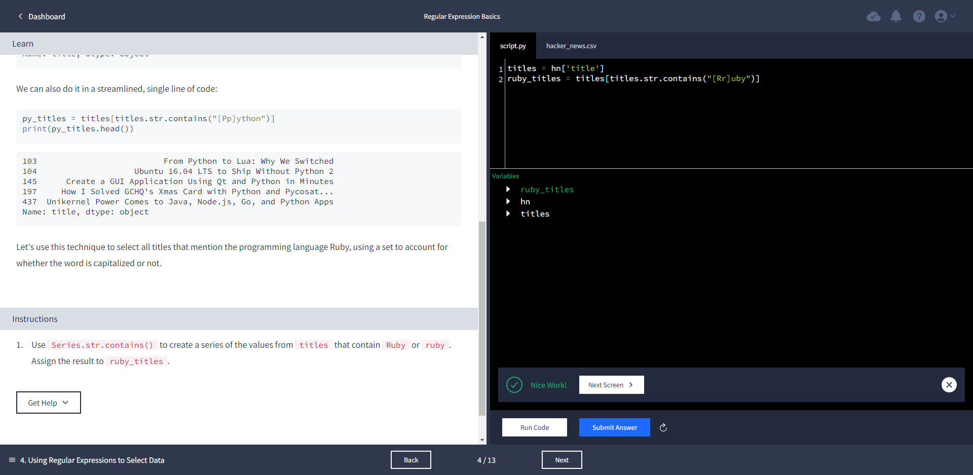

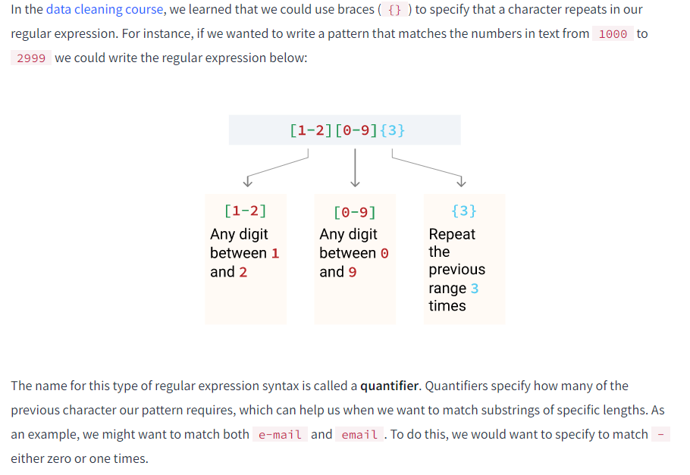

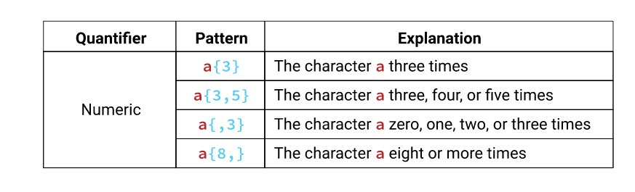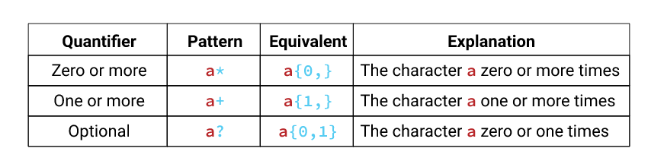

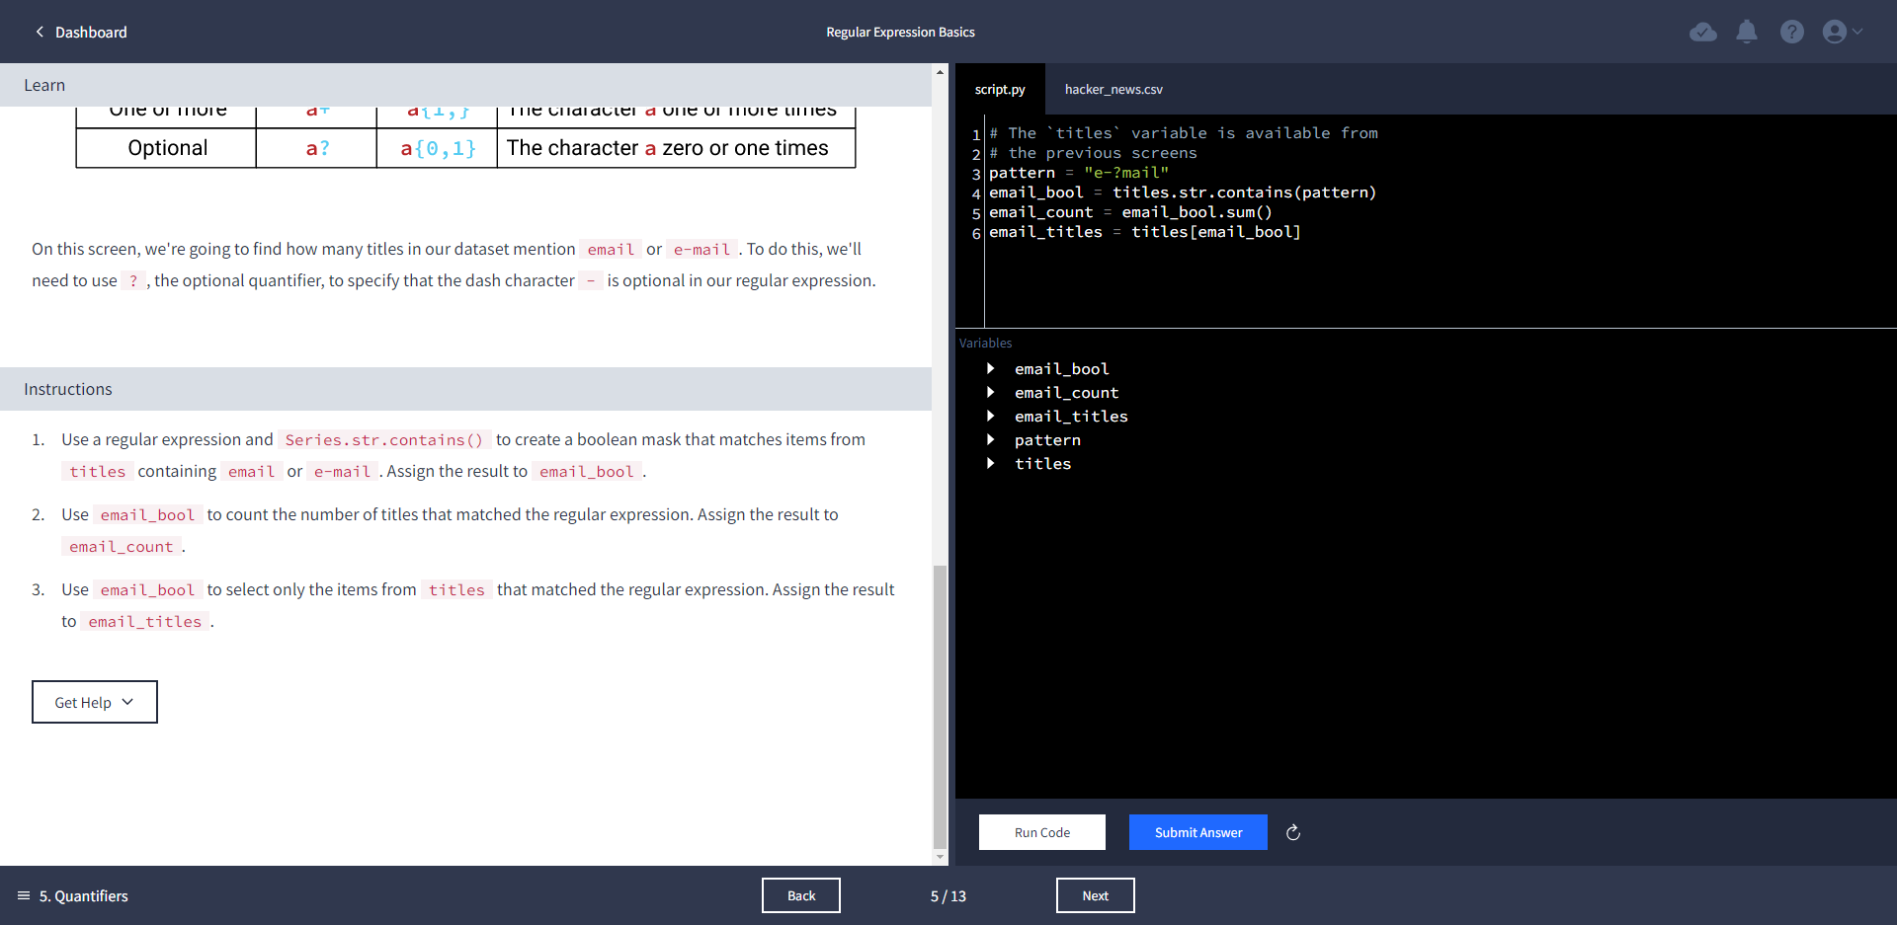

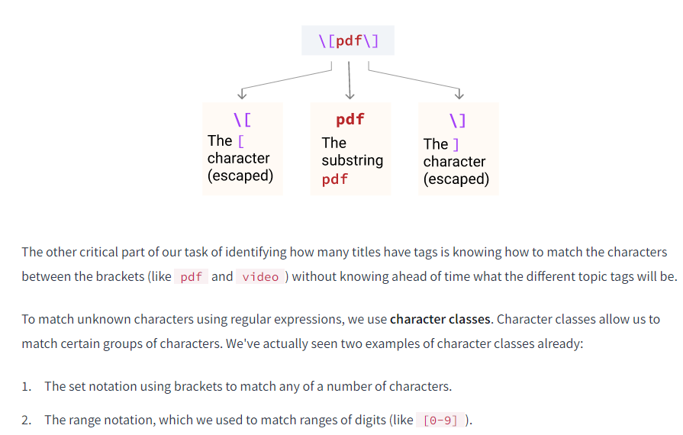

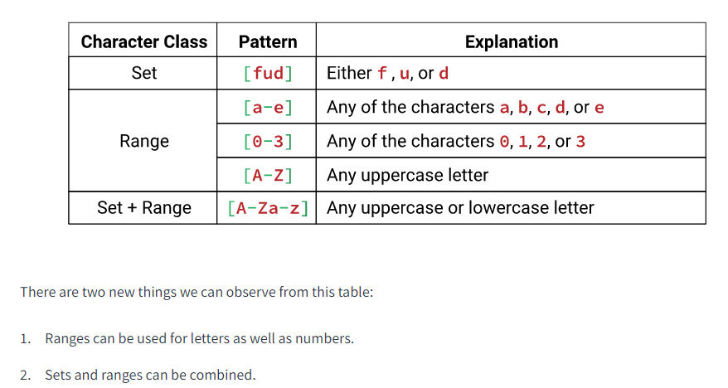

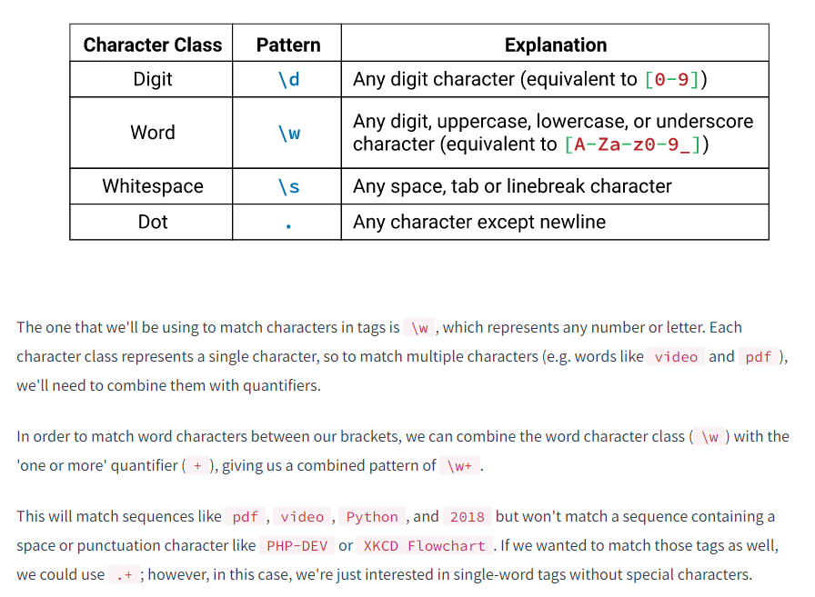

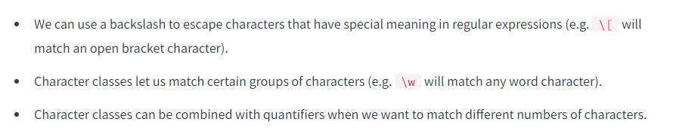

pattern = "\[\w+\]"

tag_titles = titles.str.contains(pattern)

sample = titles[tag_titles]

tag_count = tag_titles.sum()

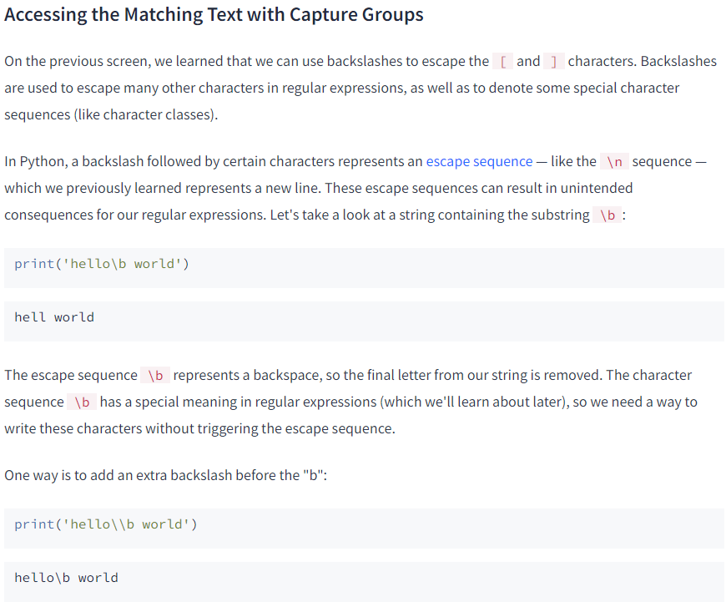

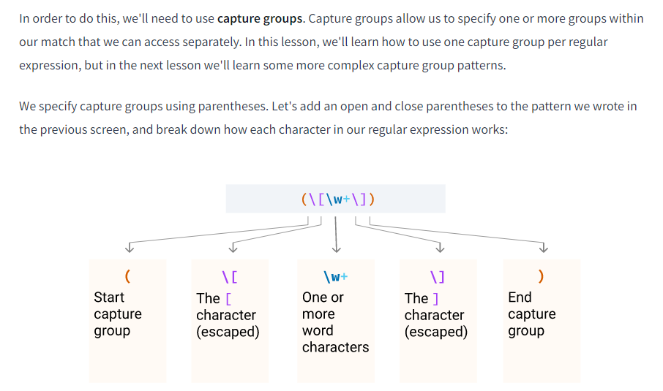

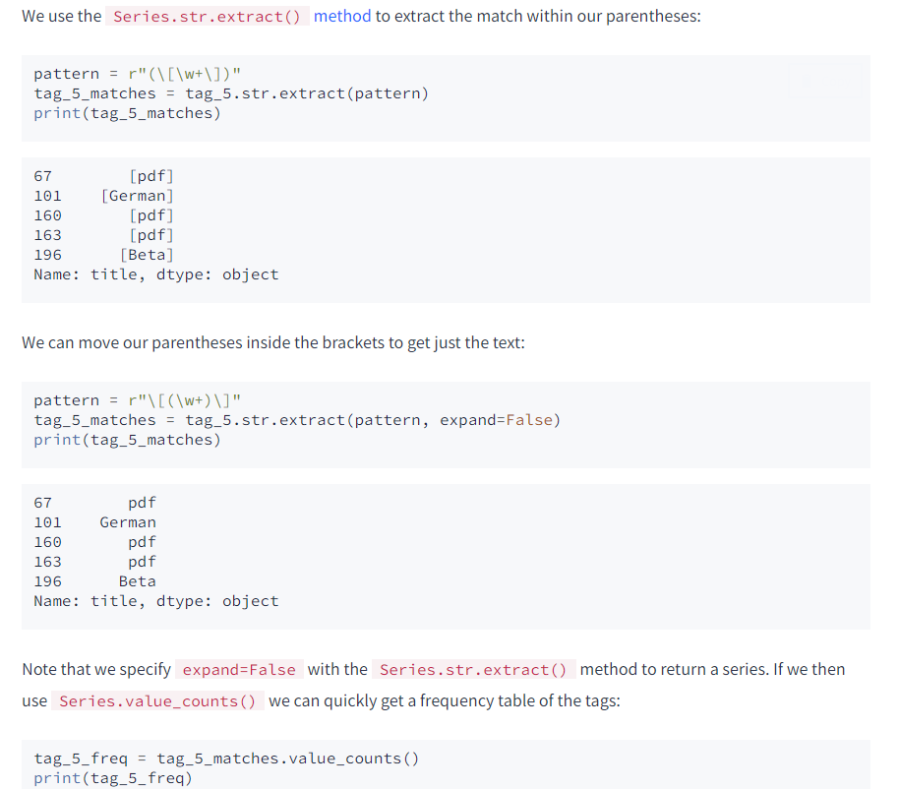

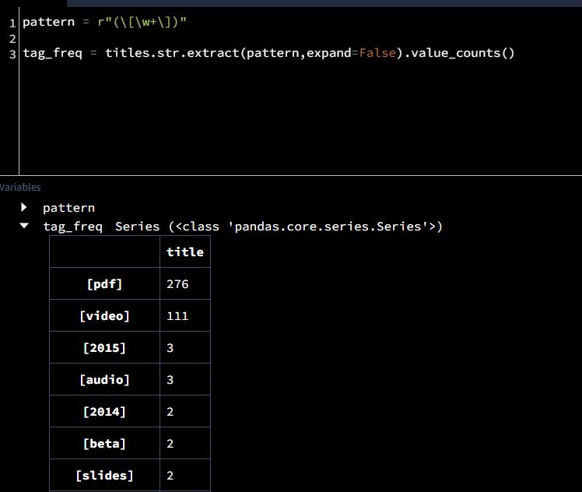

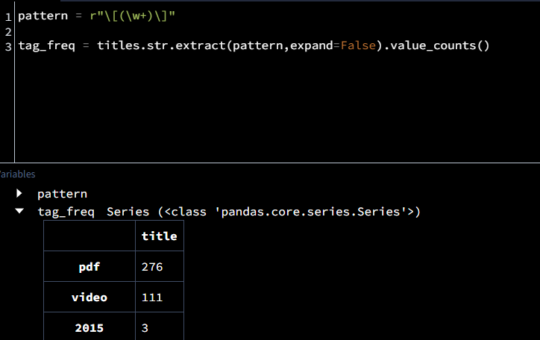

[RegExr: Learn, Build, & Test RegEx](https://regexr.com/)

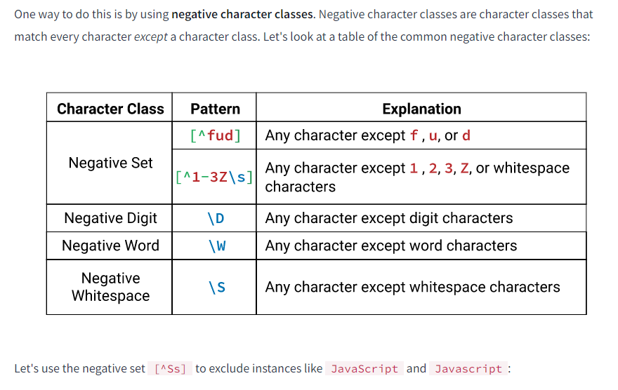

first_10_matches(r"[Jj]ava[^Ss]")

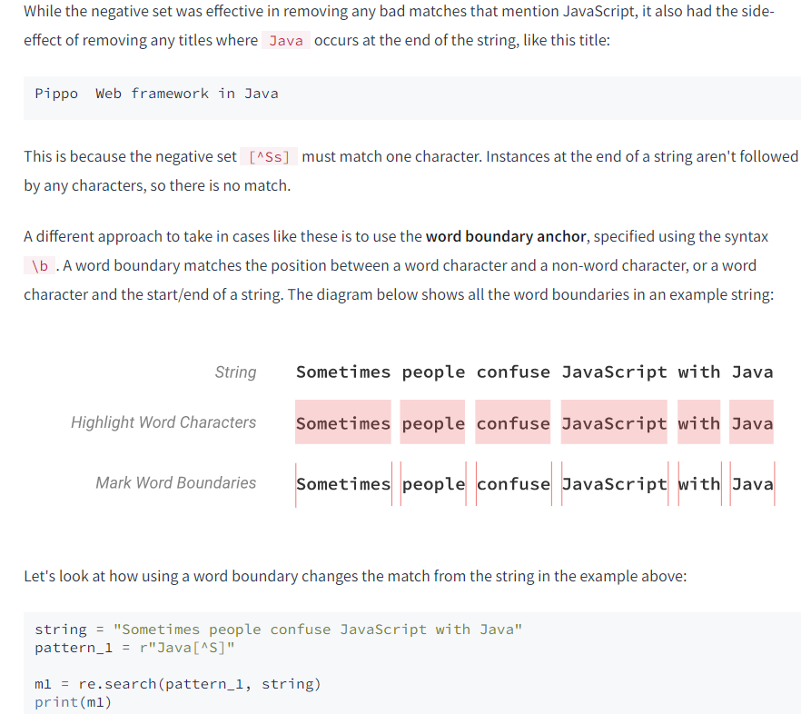



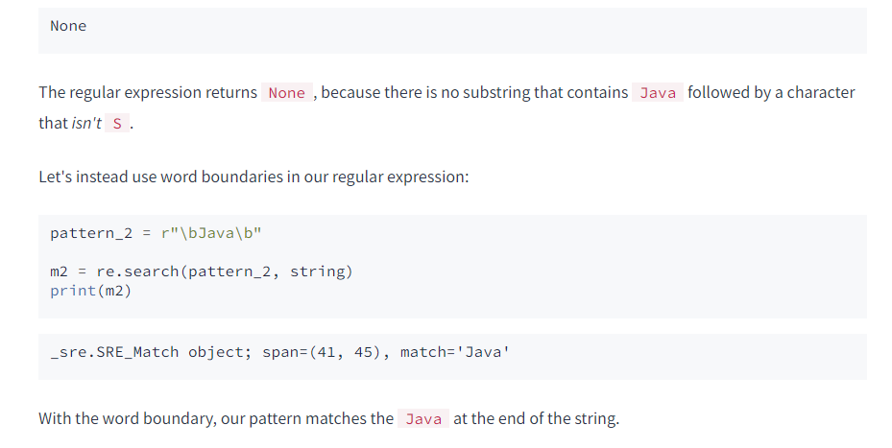

pattern = r"(\b[Jj]ava\b)"

java_titles = titles[titles.str.contains(pattern)]

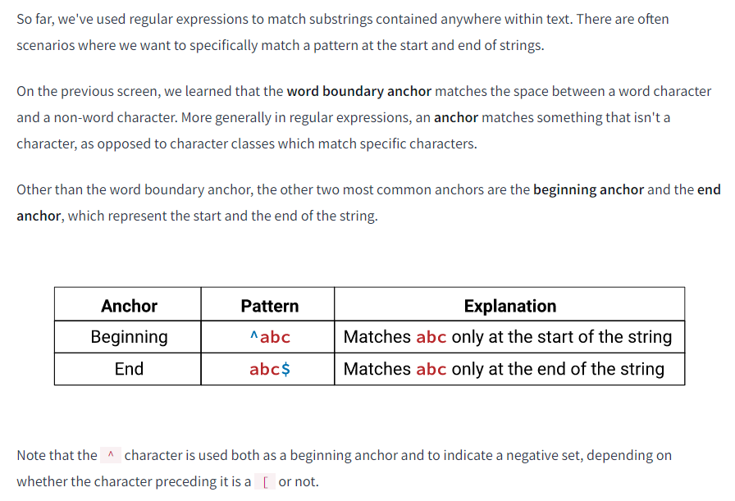

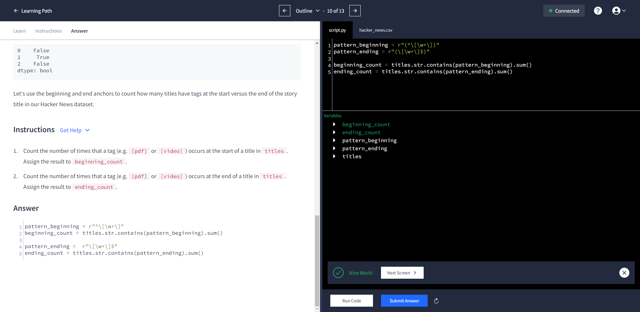

[re — Regular expression operations — Python 3.10.8 documentation](https://docs.python.org/3/library/re.html#re.A)

* Don't forget to use the ignorecase flag.
* You will need to use a word boundary so that your pattern does not capture words like "late mail" or "emailing"
* You will need to use the optional (?) quantifier to match cases where there both is and isn't a separator between "e" and "mail."
* There are two different separators - one is a - and one is a whitespace character.
* You'll need to use a set to combine the separators, and then a quantifier to make them optional.

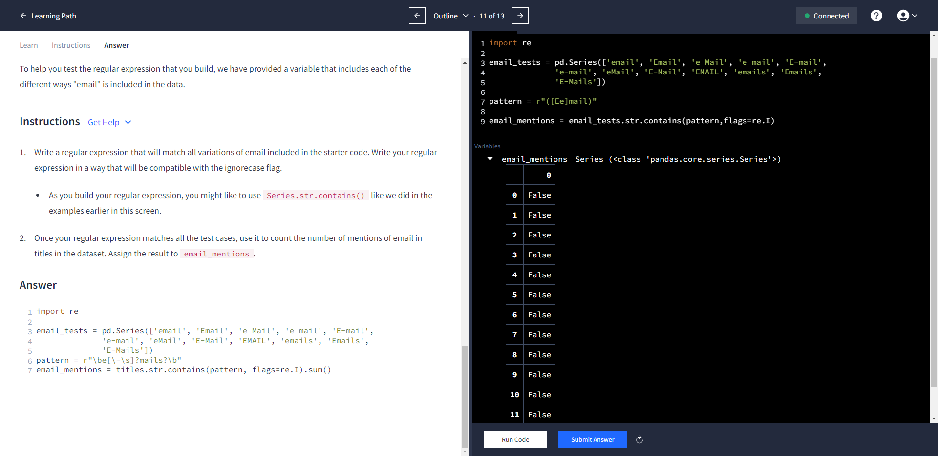

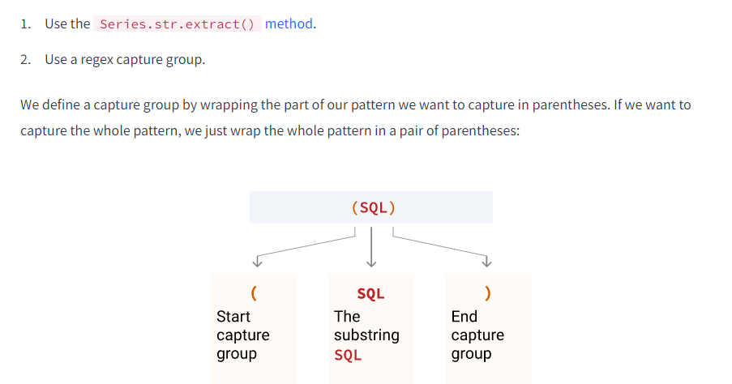

Recall that we specify expand=False with the Series.str.extract() method to return a series.

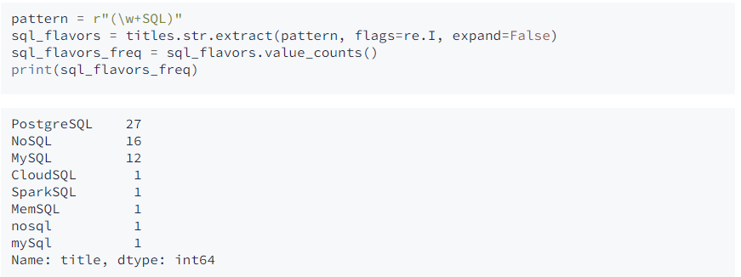

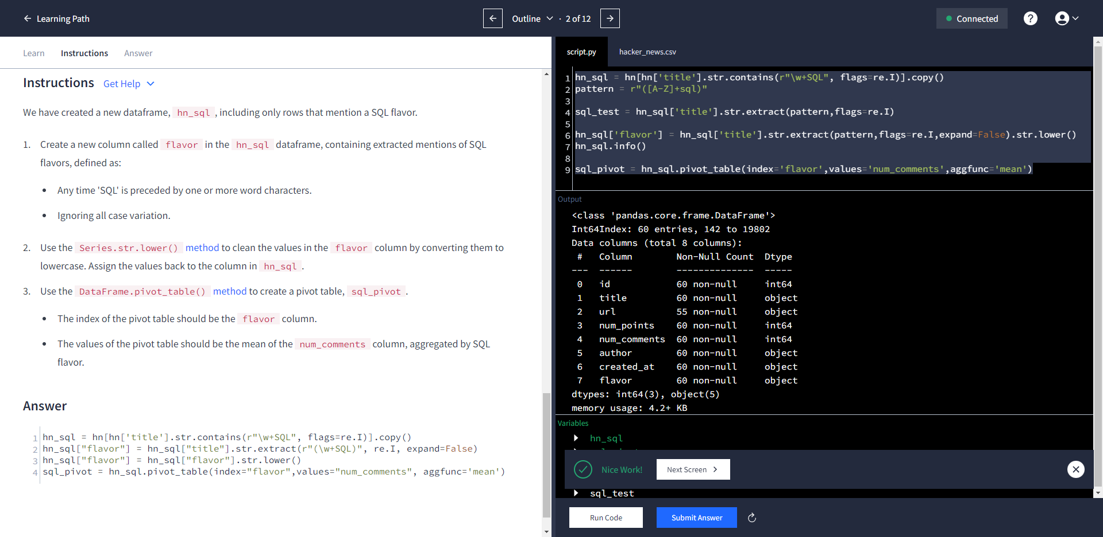

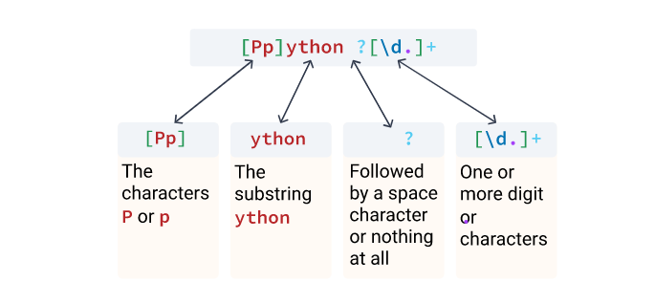

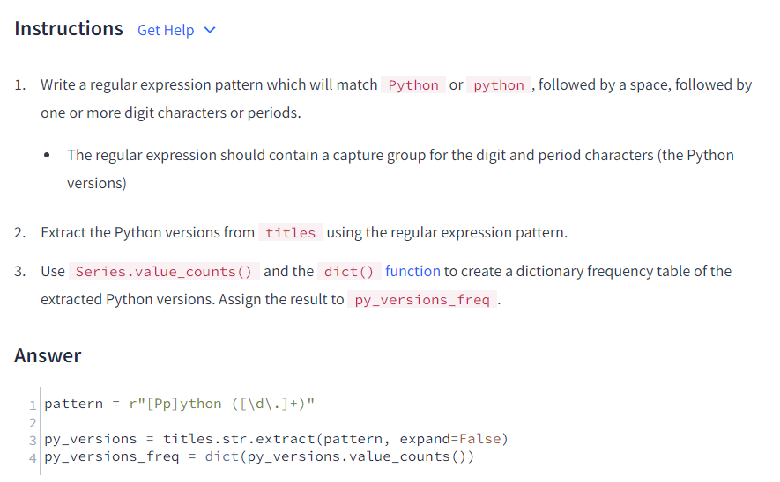



pattern = r"\b[Cc]\b[^+.]"

1. Uncomment the line of code. Add a negative set to the end of the regular expression that excludes:
   * The period character .
   * The plus character +.

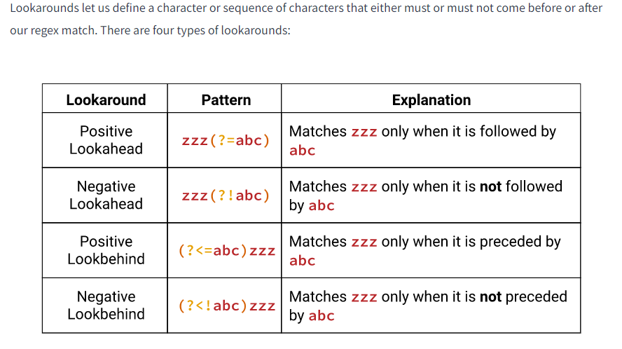

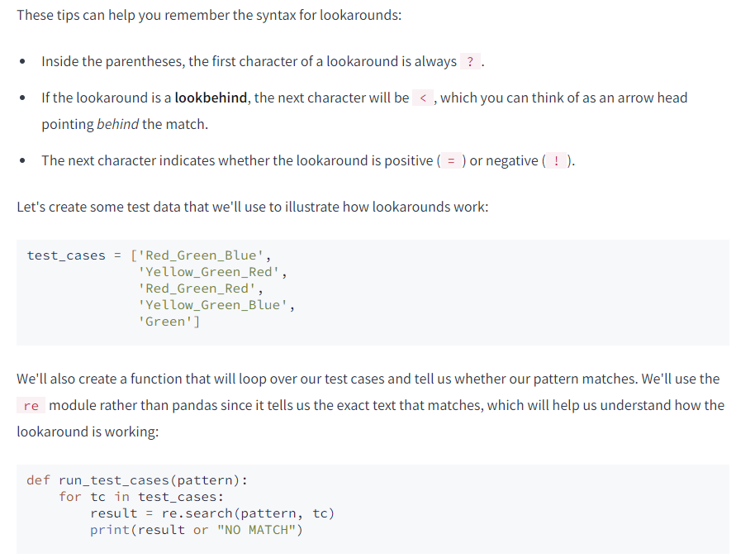

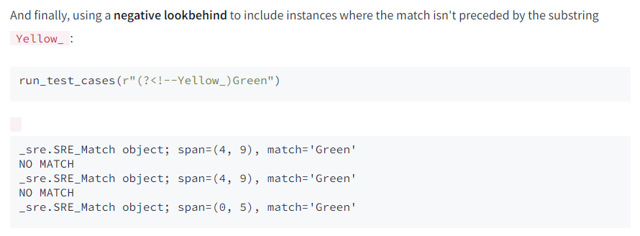

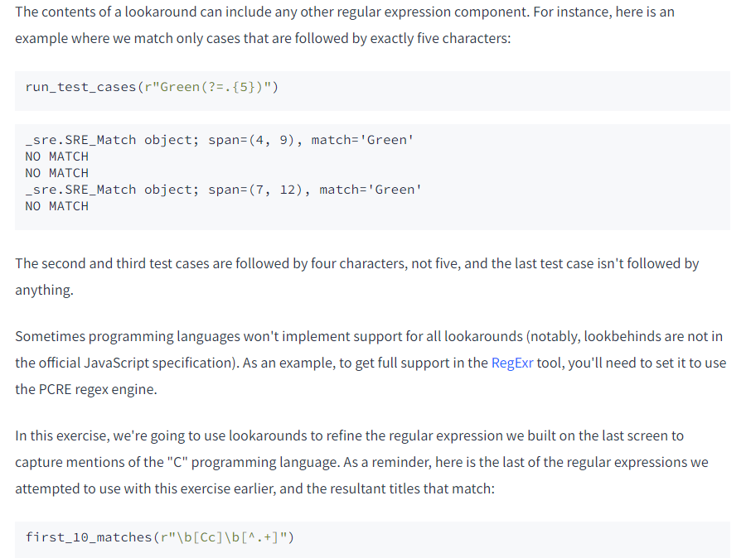

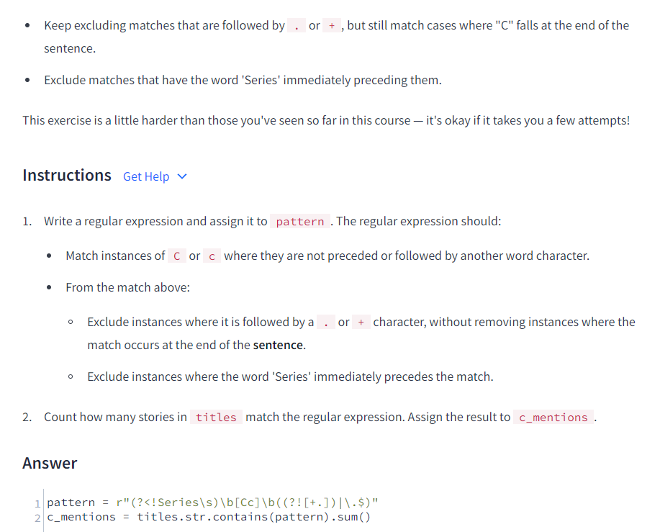

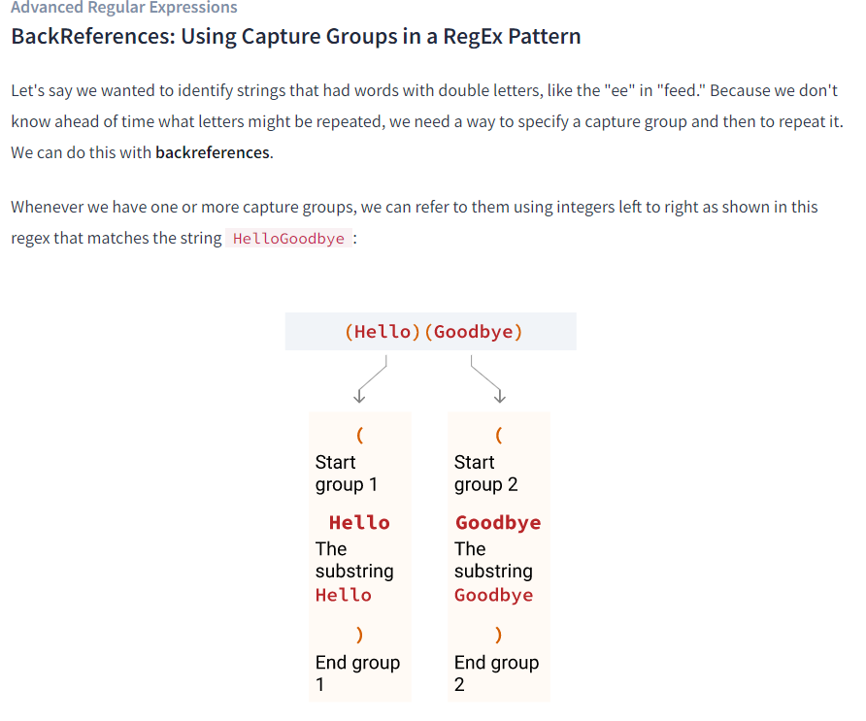

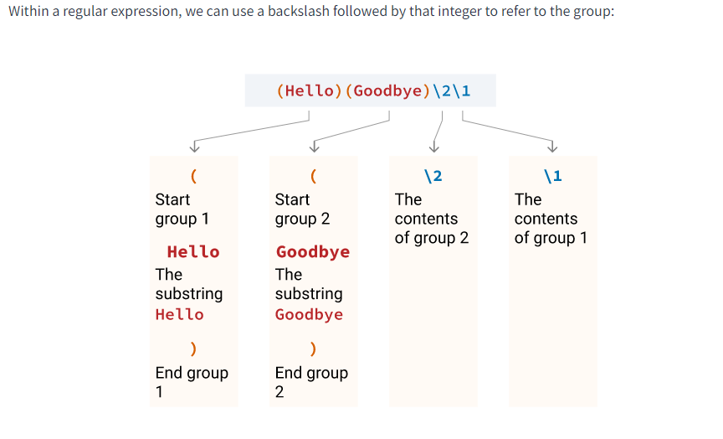

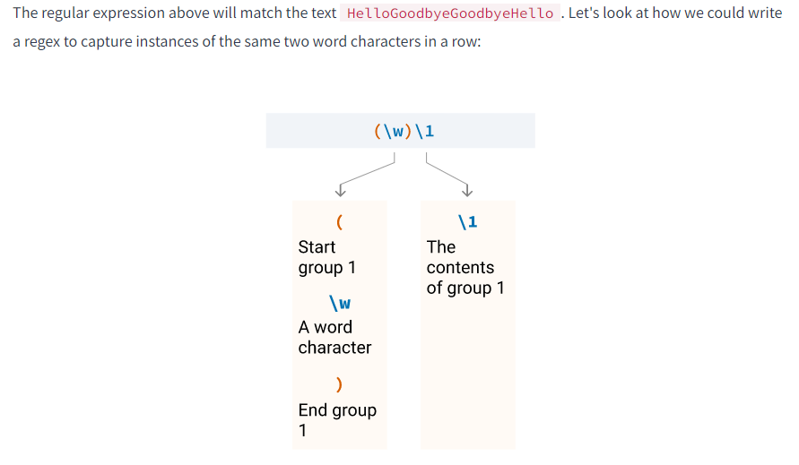

test_cases = [

"I'm going to read a book.",

"Green is my favorite color.",

"My name is Aaron.",

"No doubles here.",

"I have a pet eel."

]

for tc in test_cases:

print(re.search(r"(\w)\1", tc))

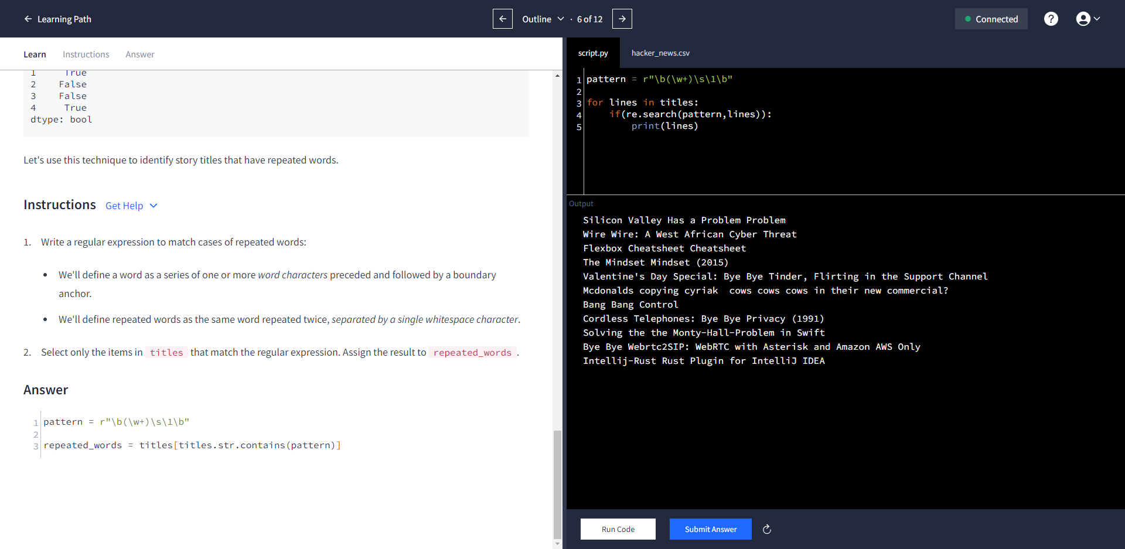

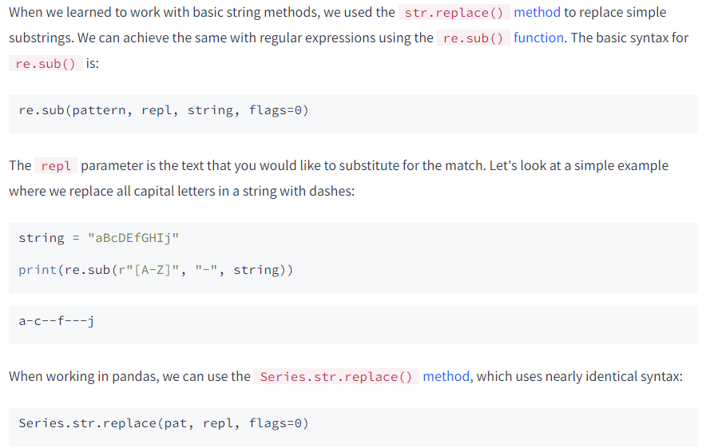

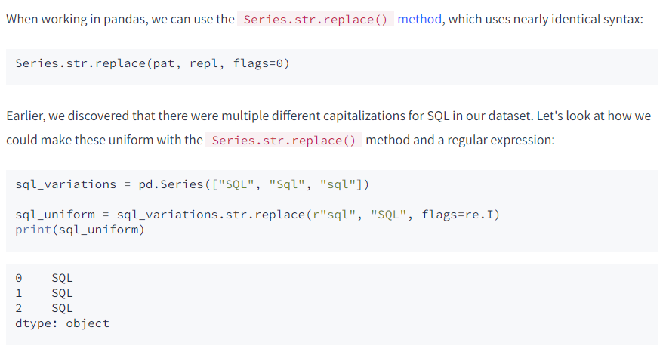

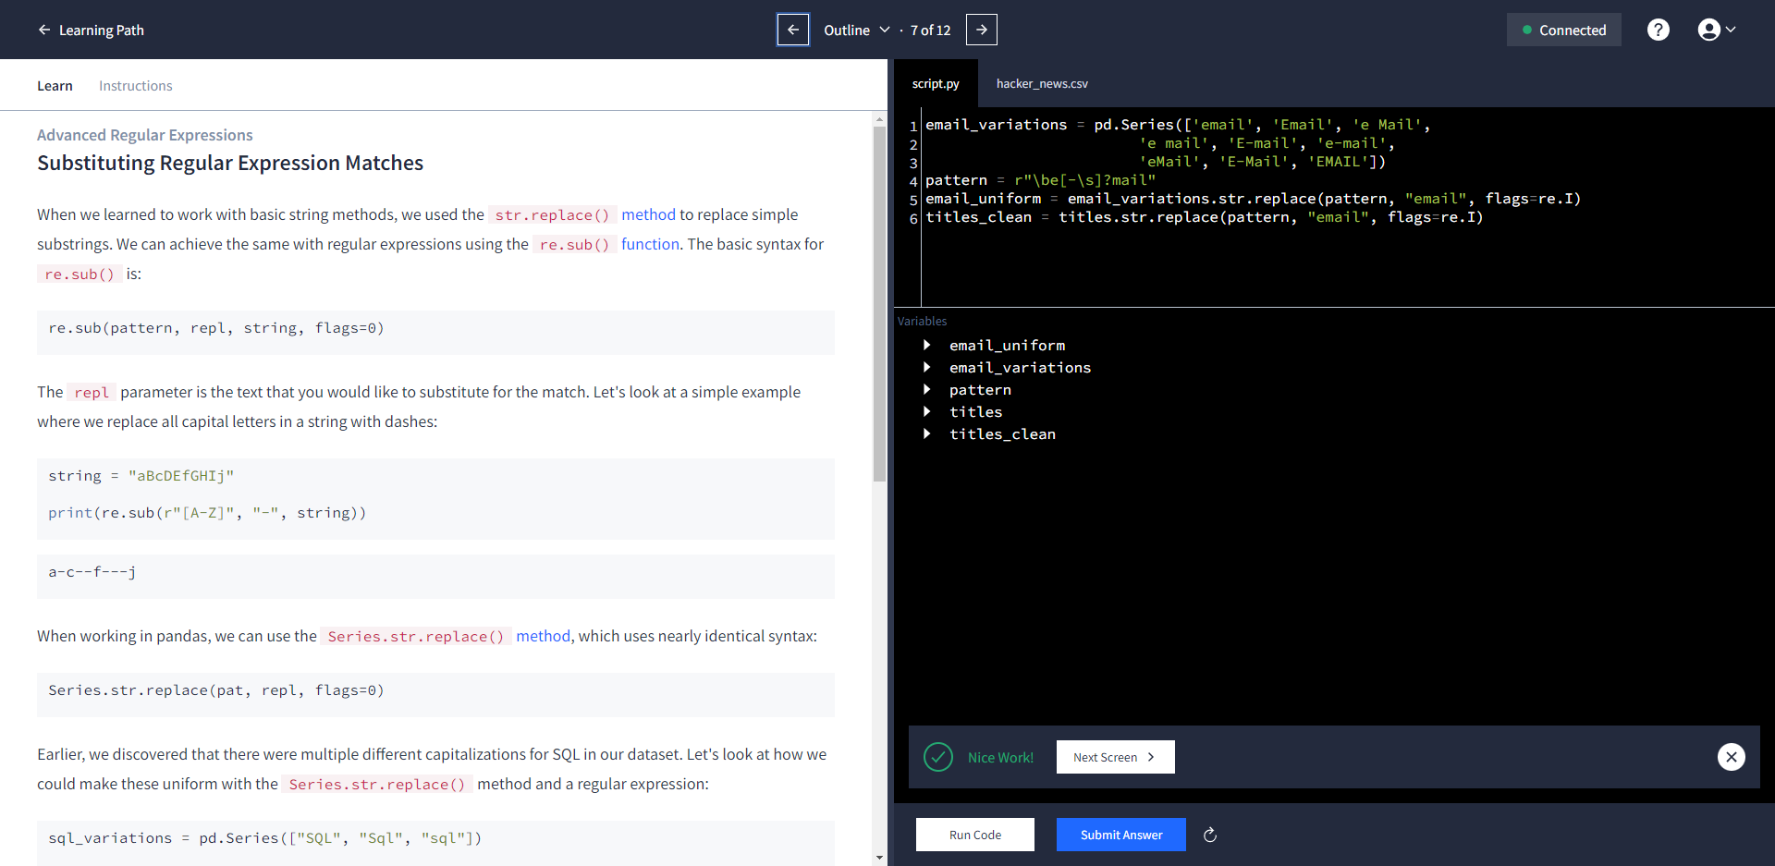

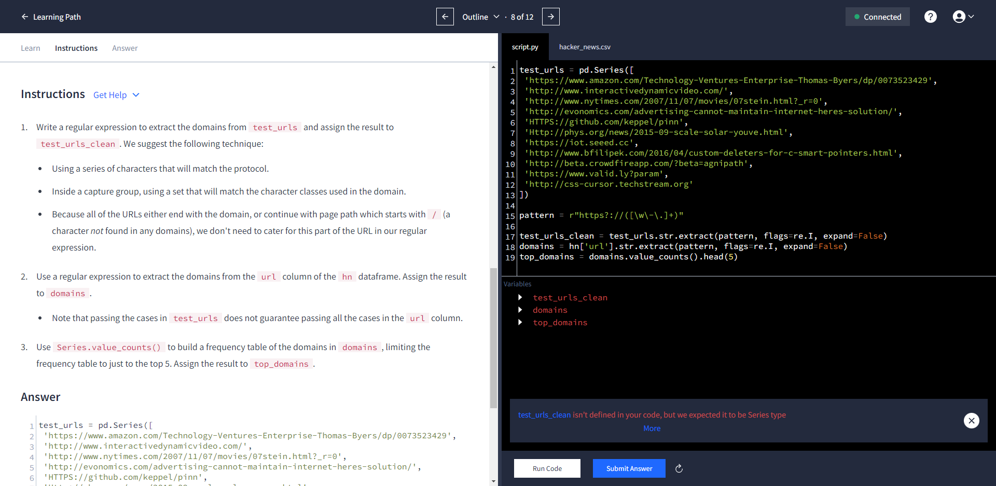

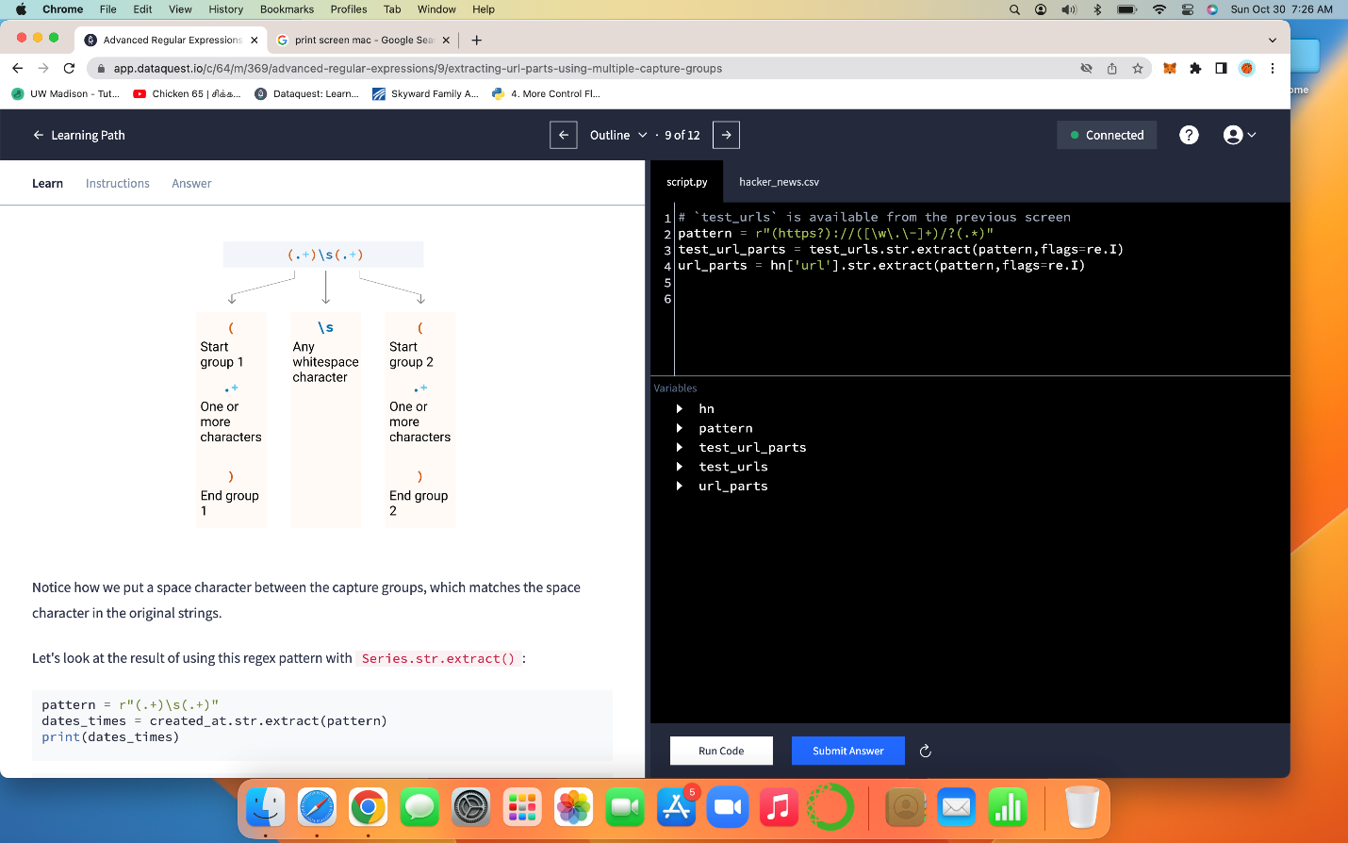

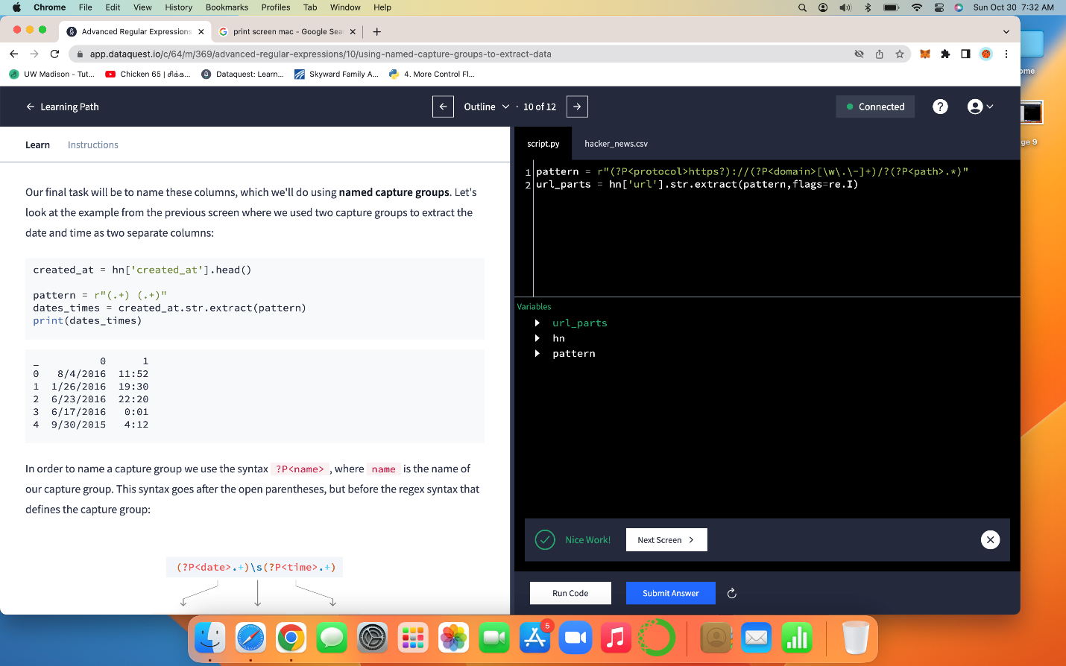

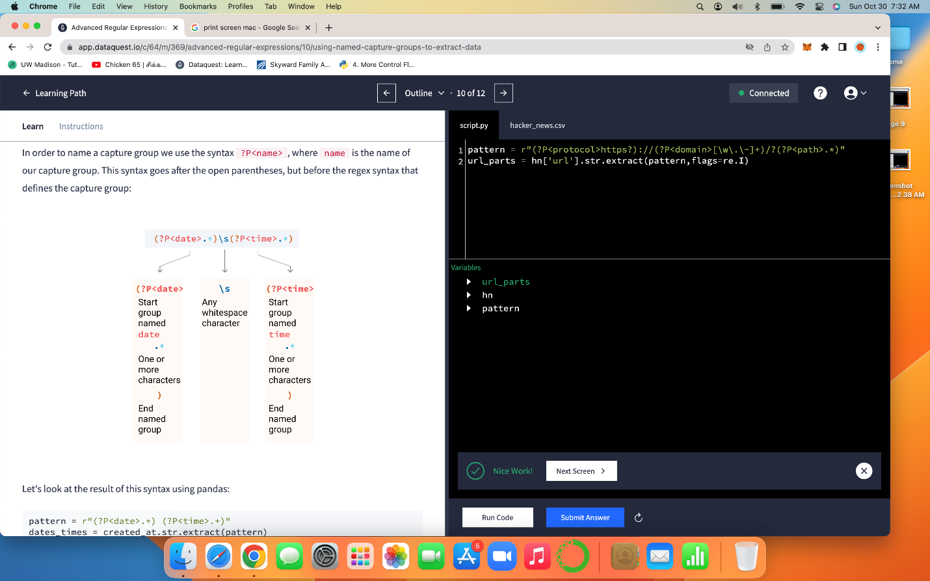

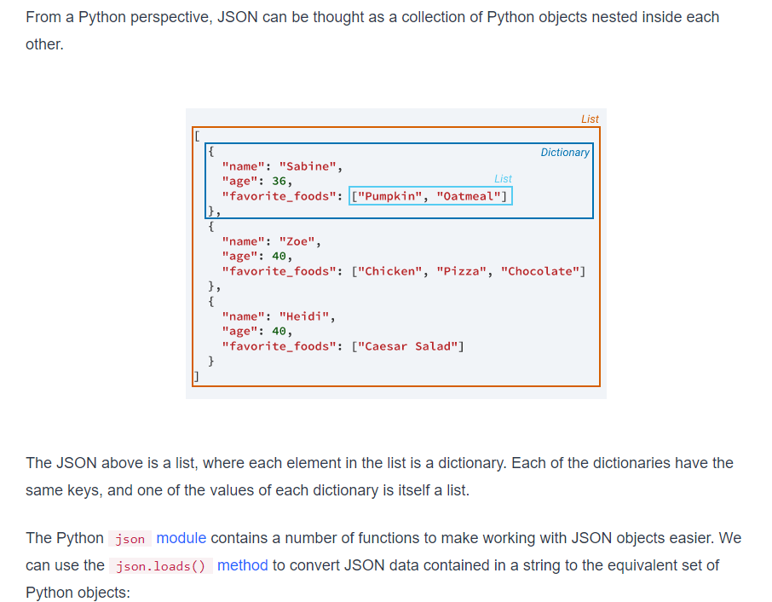



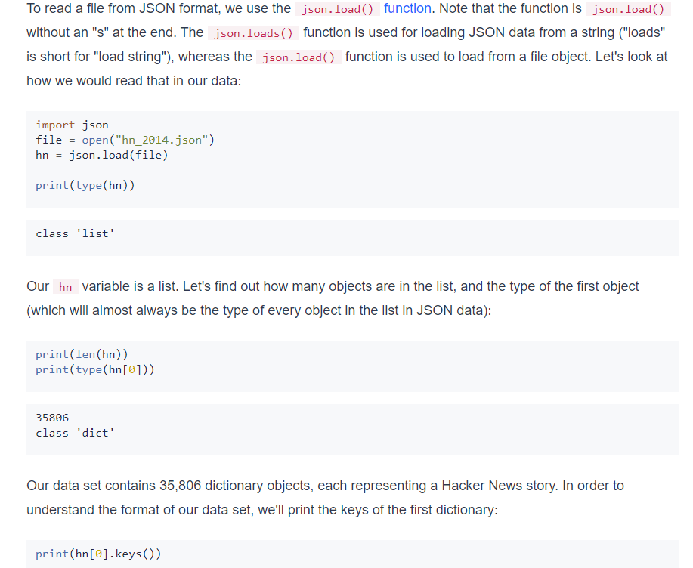

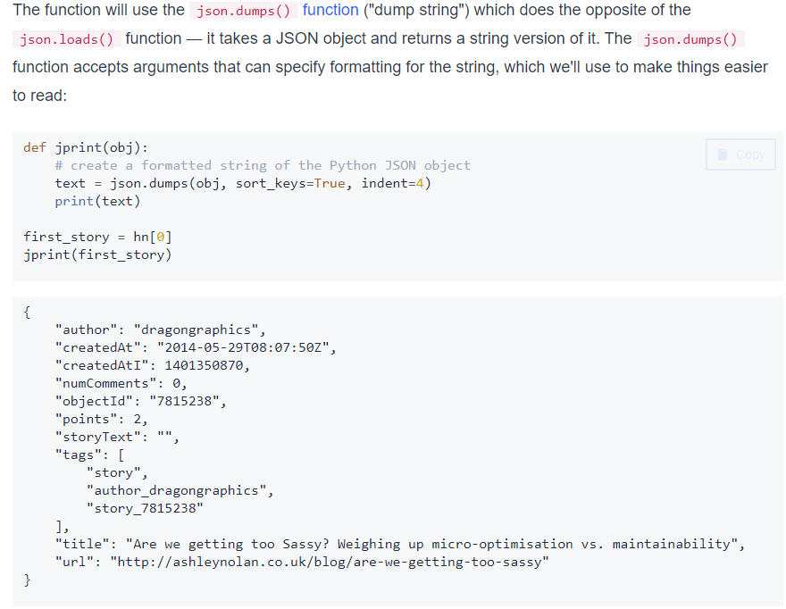

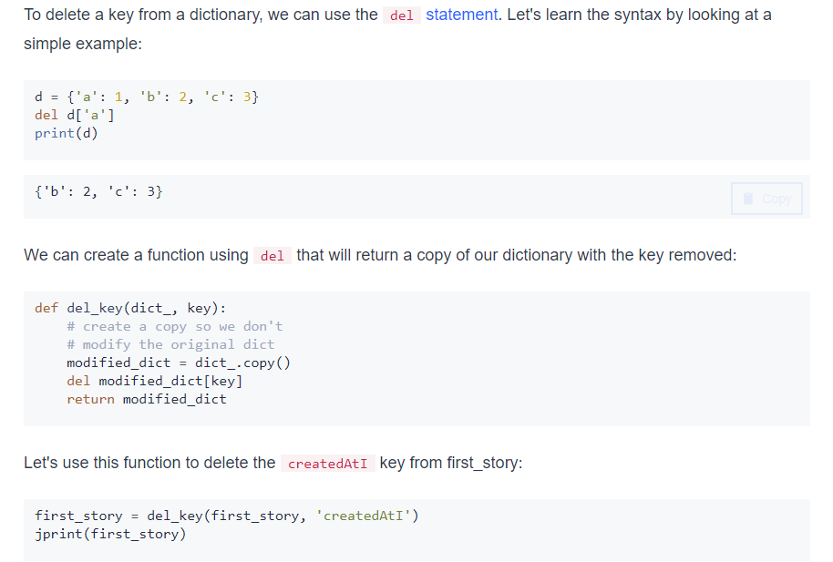

def del_key(dict_, key):

# create a copy so we don't

# modify the original dict

modified_dict = dict_.copy()

del modified_dict[key]

return modified_dict

hn_clean = []

for item in hn:

hn_clean.append(del_key(item,'createdAtI'))

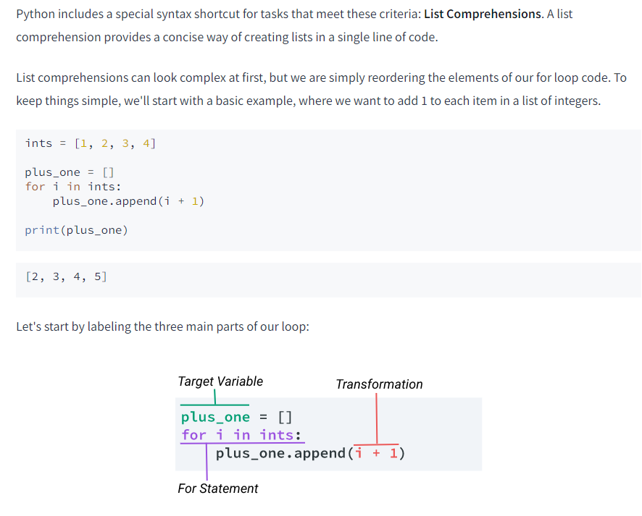



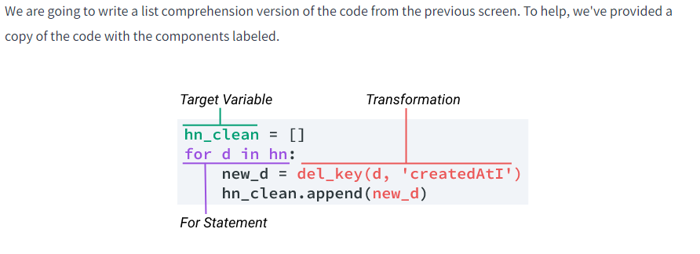

hn_clean = []

hn_clean = [del_key(item,"createdAtI") for item in hn]

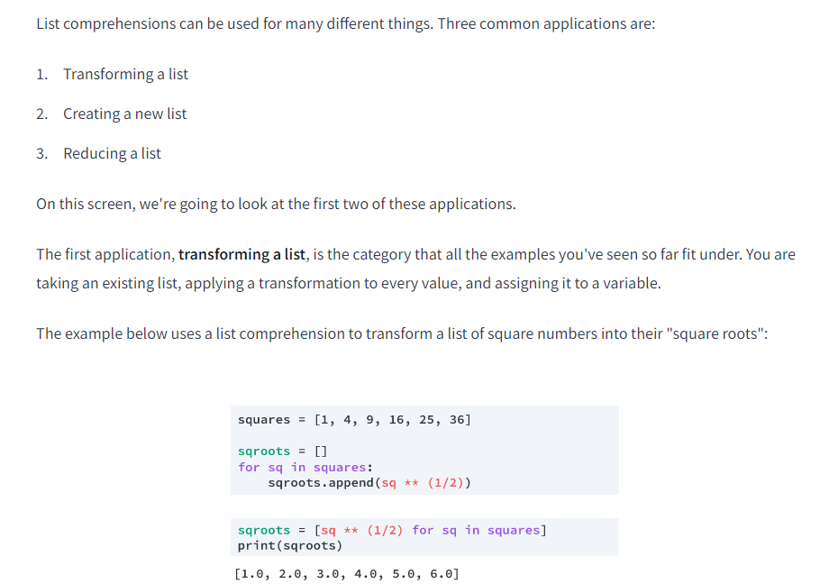

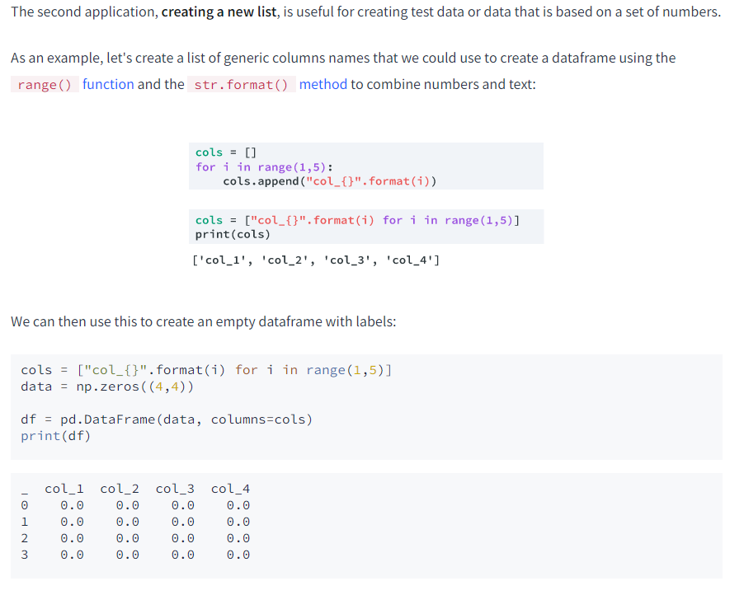

urls = [hn[item]['url'] for item in range(0,len(hn))]

urls = [hn['url'] for hn in hn_clean]

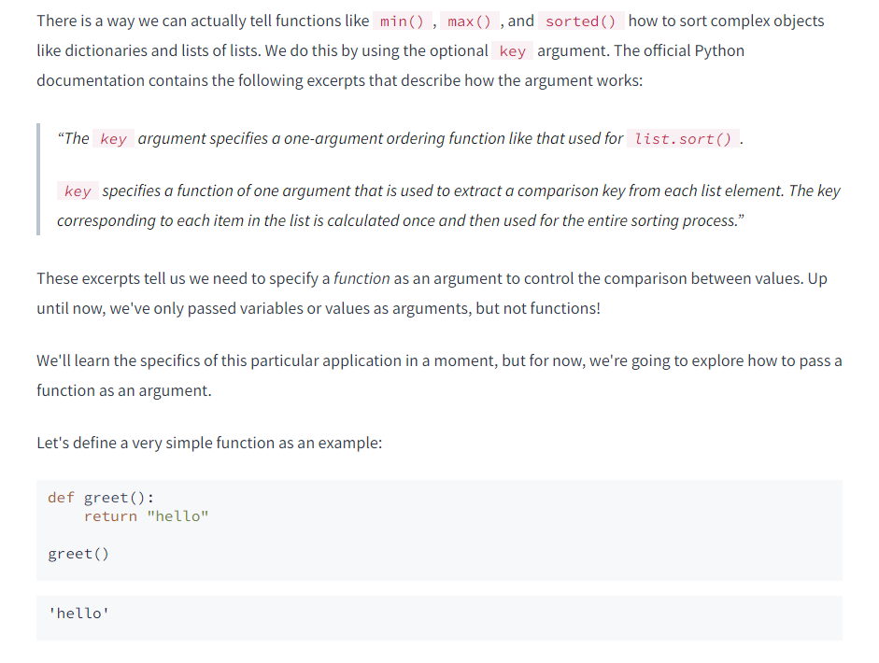

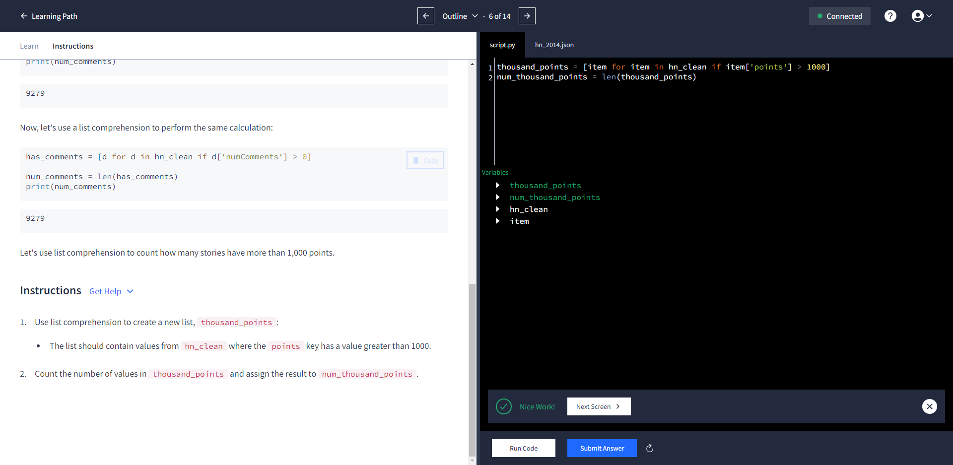





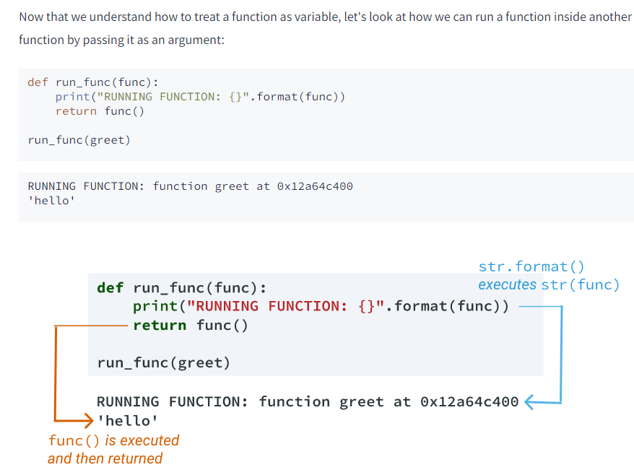

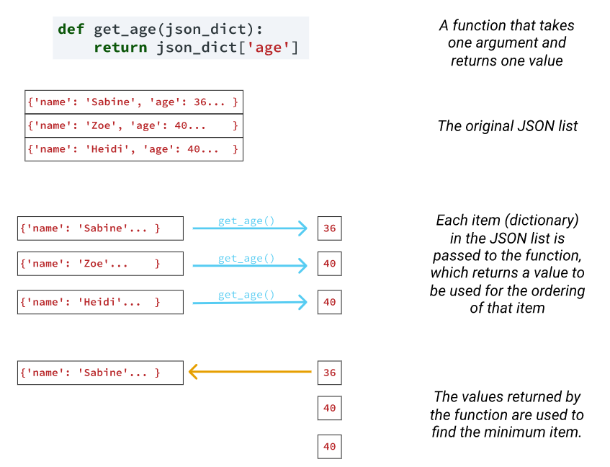

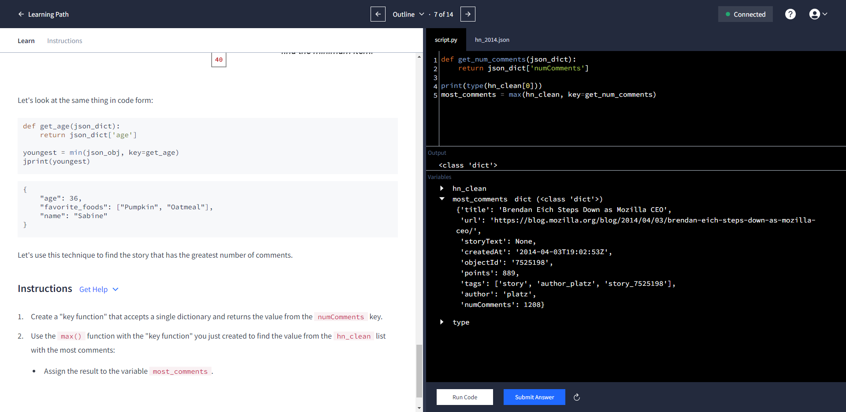

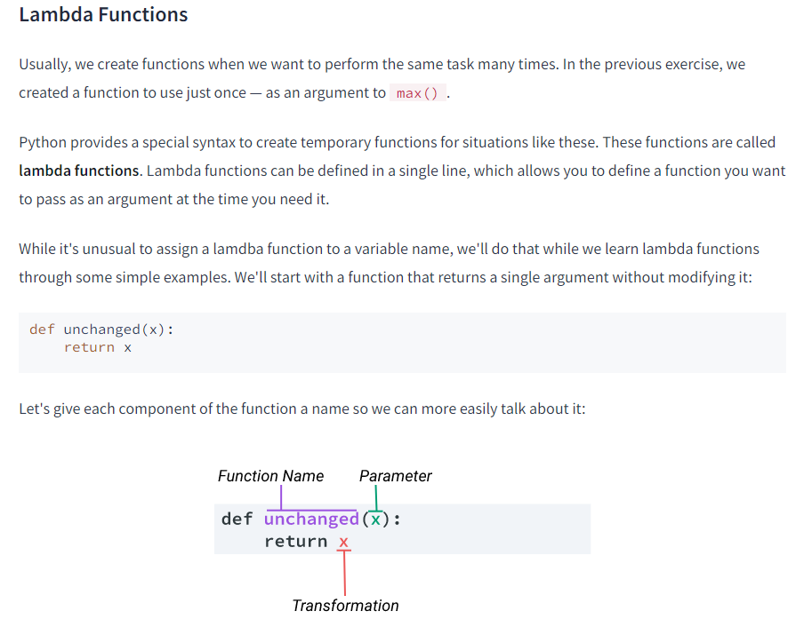

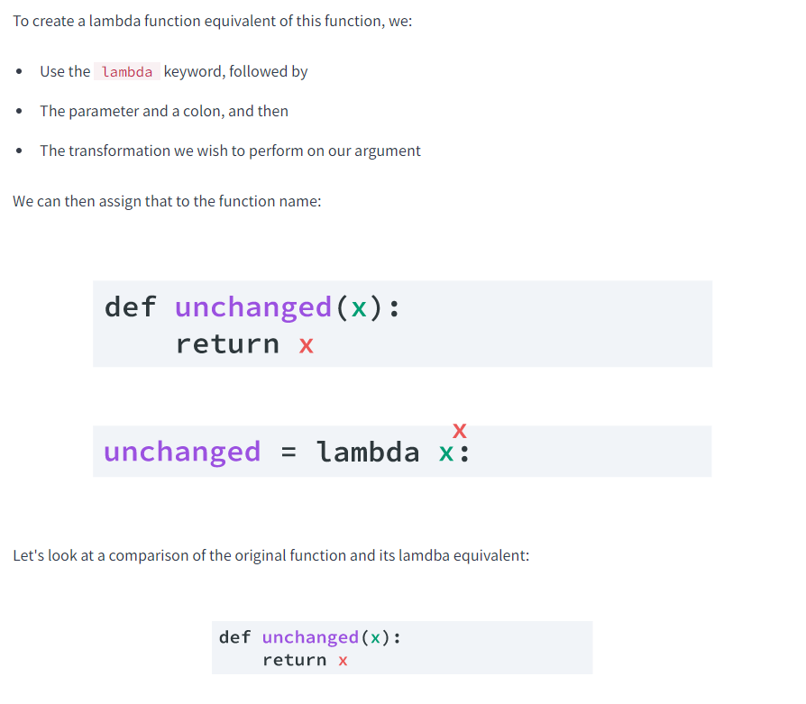

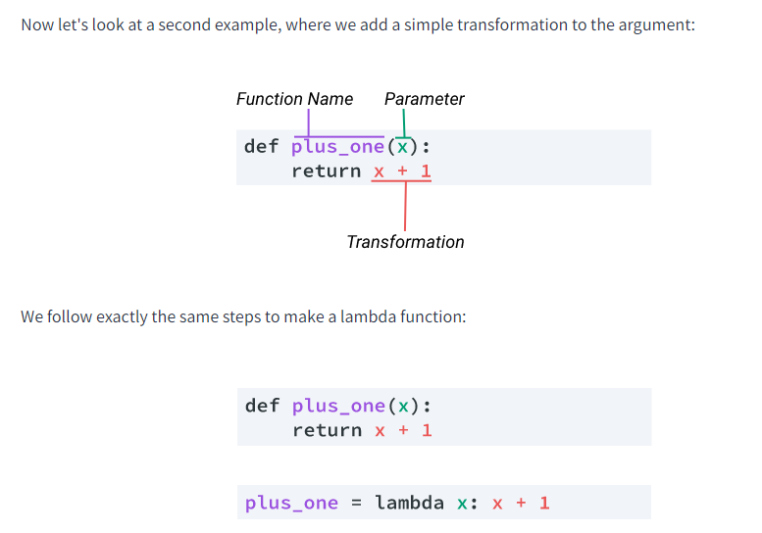

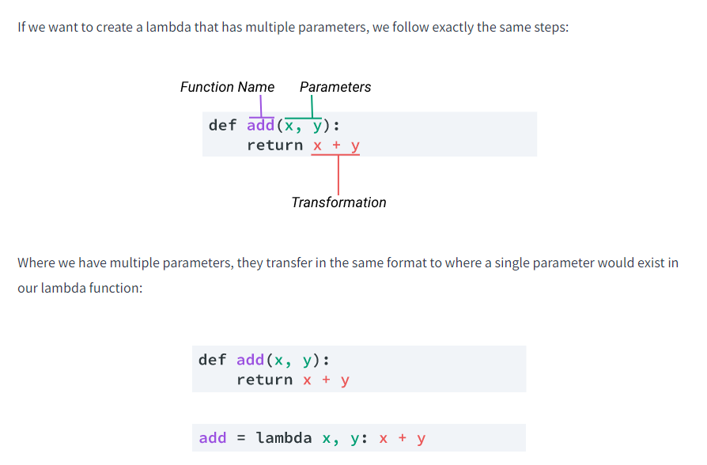

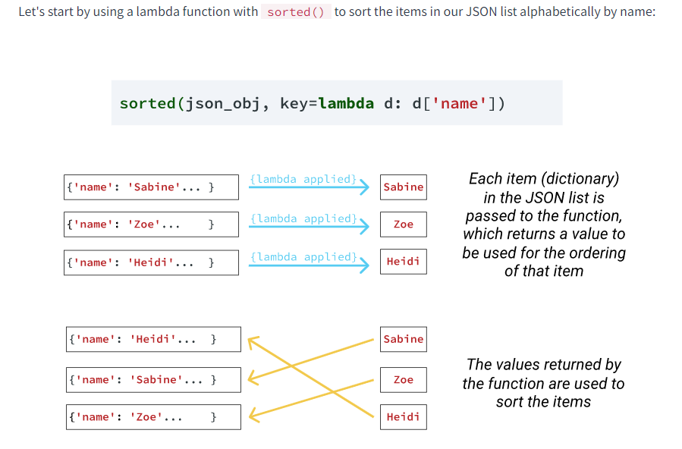

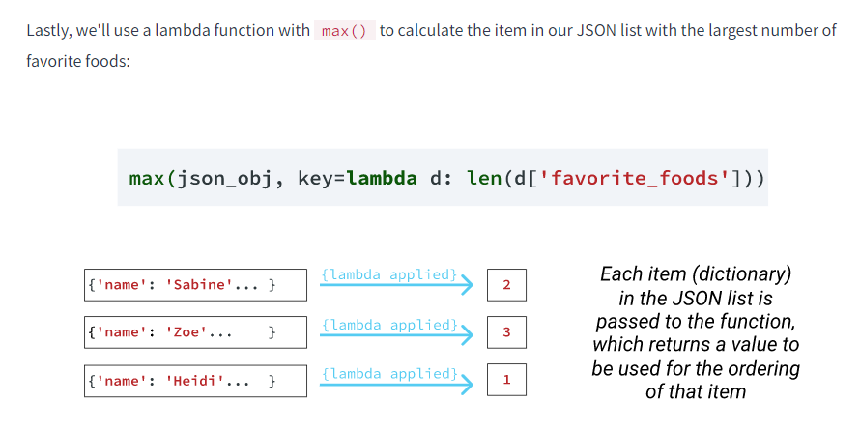

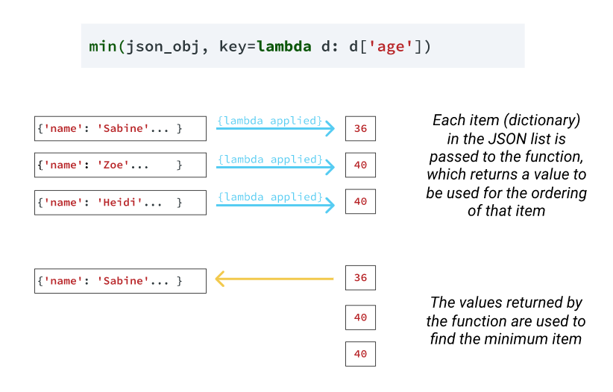

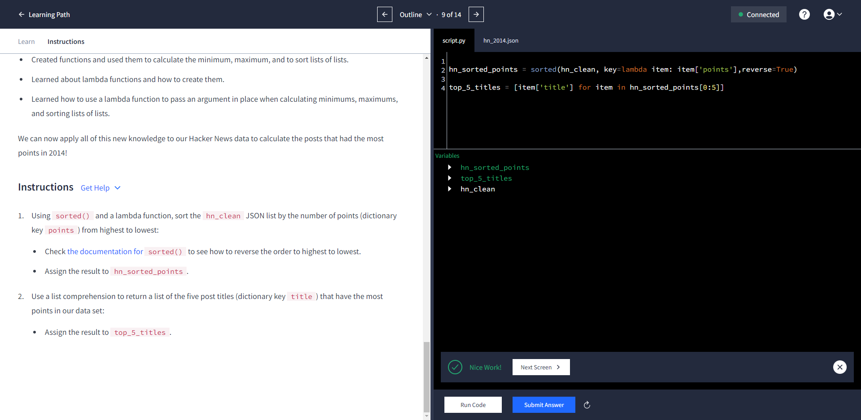

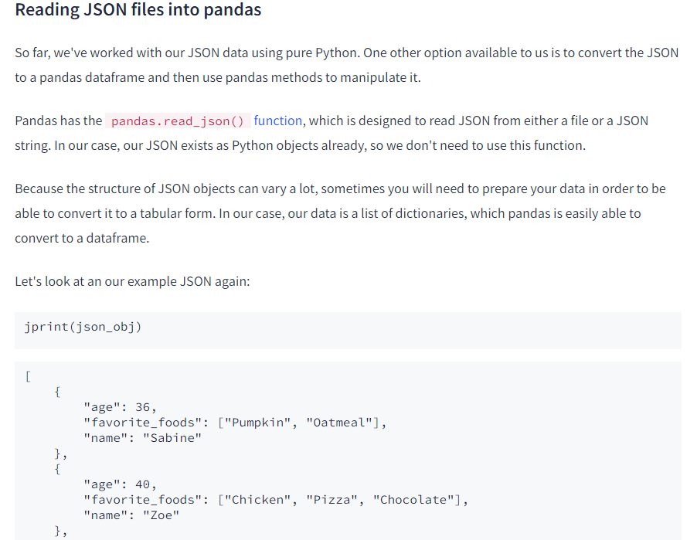

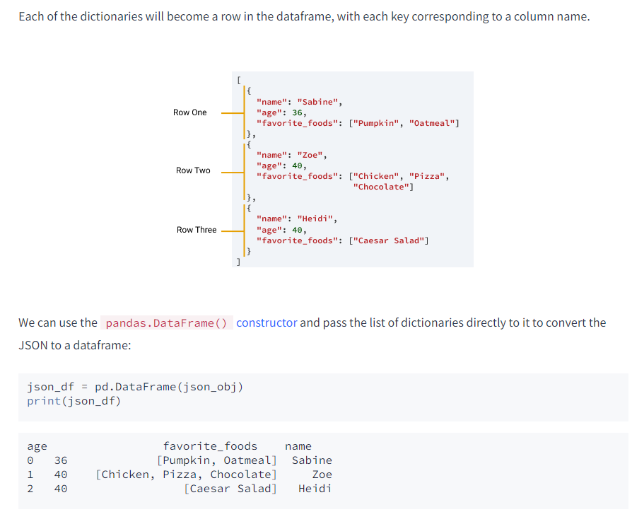

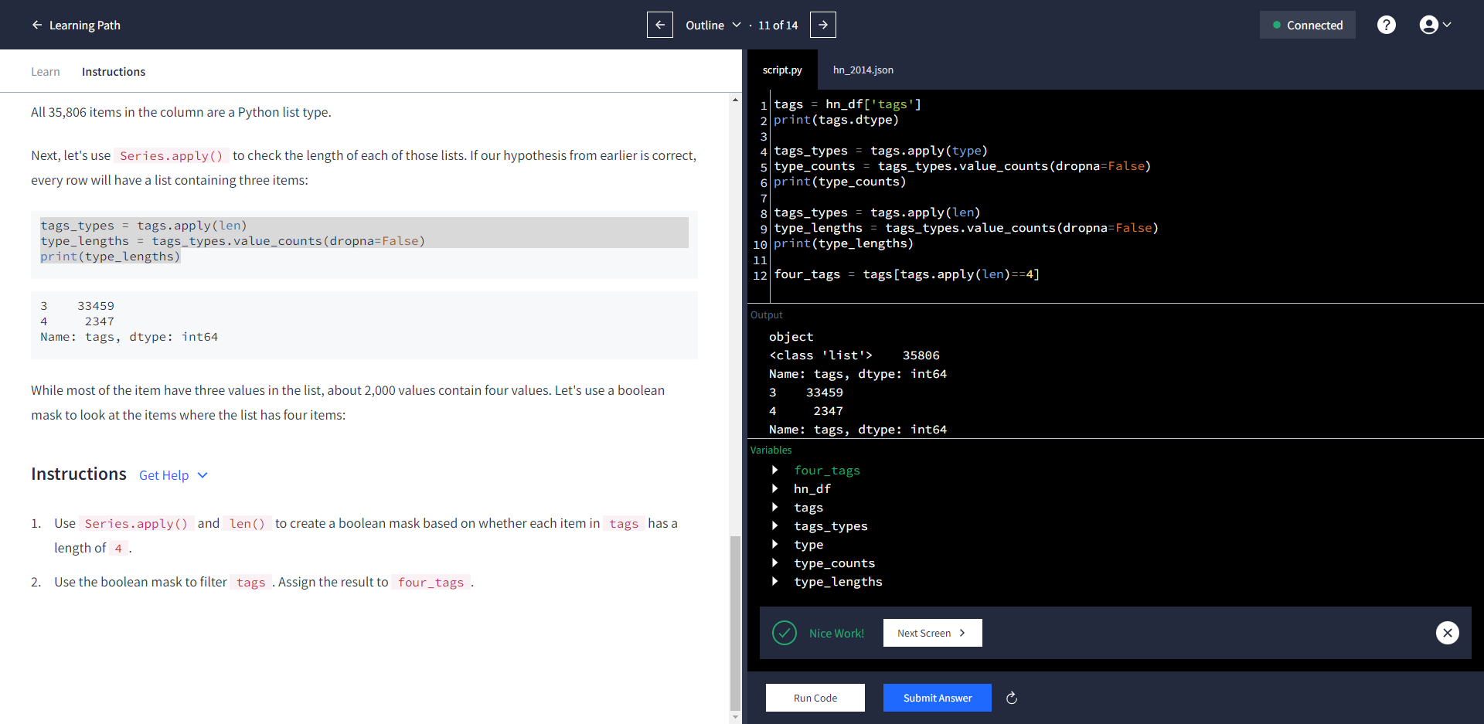

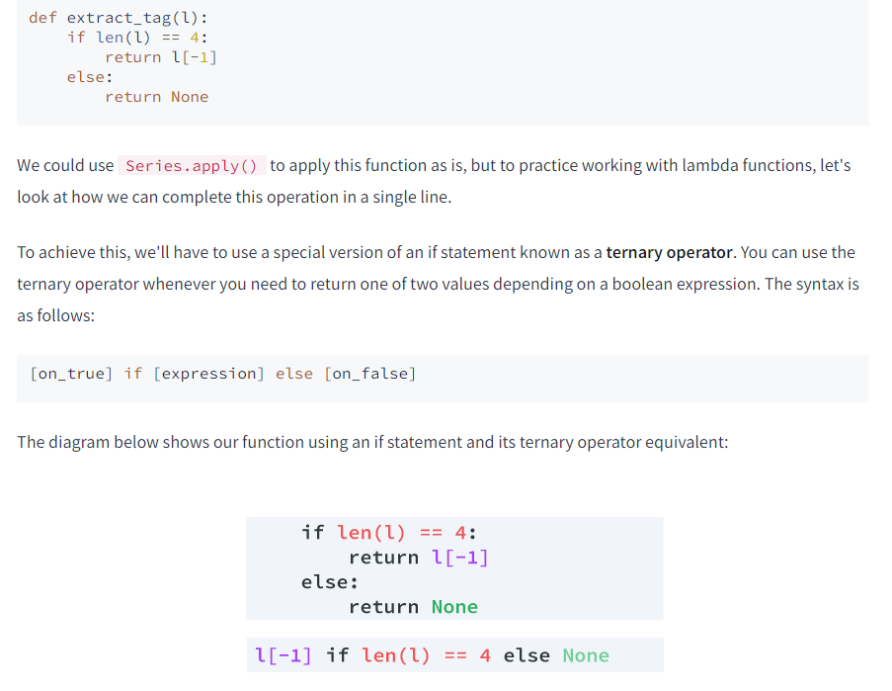

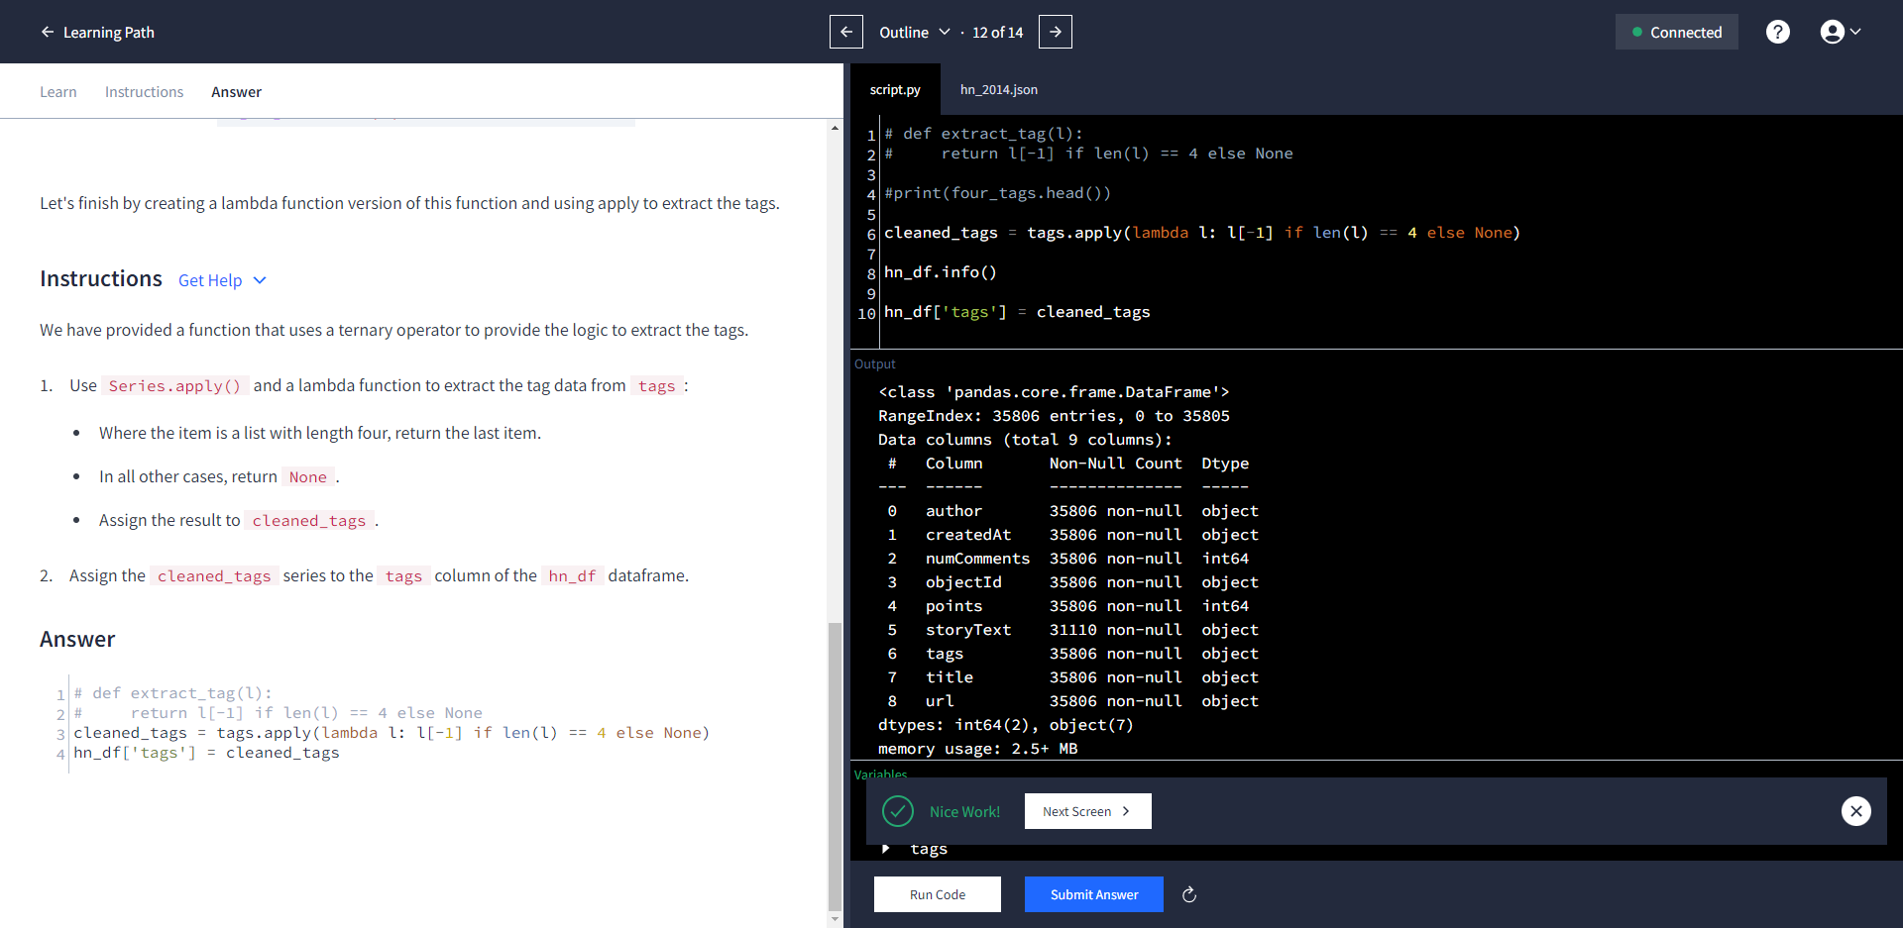

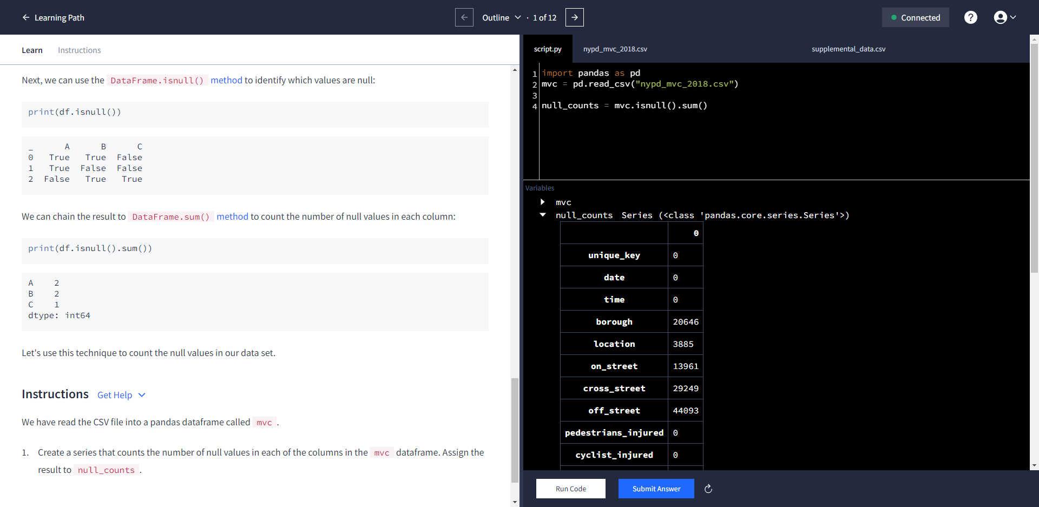

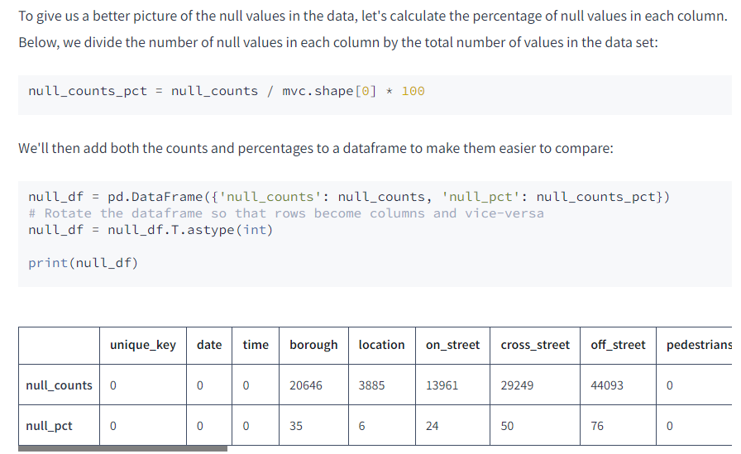

null_df = pd.DataFrame({'null_counts': null_counts, 'null_pct': null_counts_pct})

# Rotate the dataframe so that rows become columns and vice-versa

null_df = null_df.T.astype(int)

print(null_df)

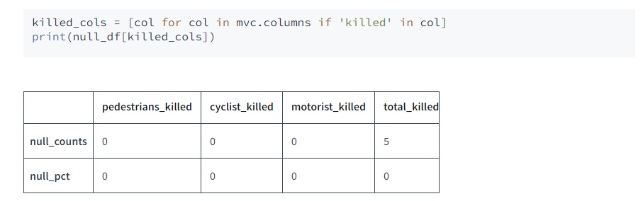

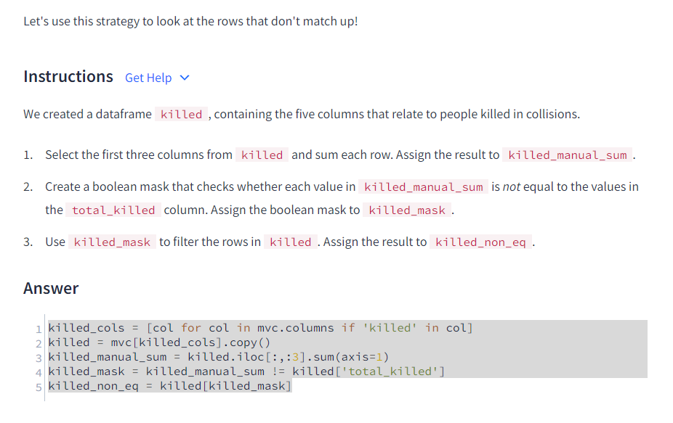

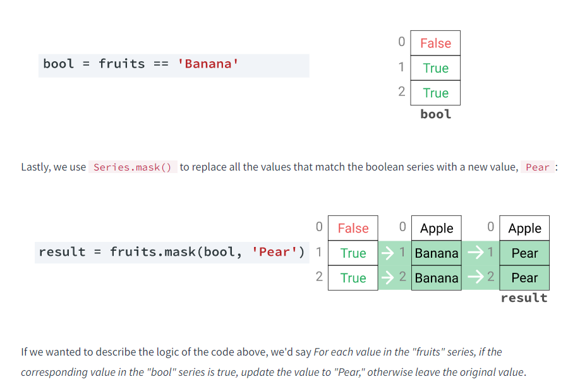



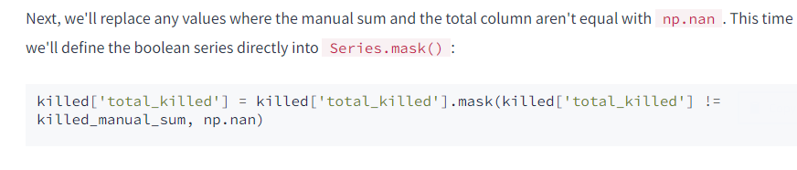

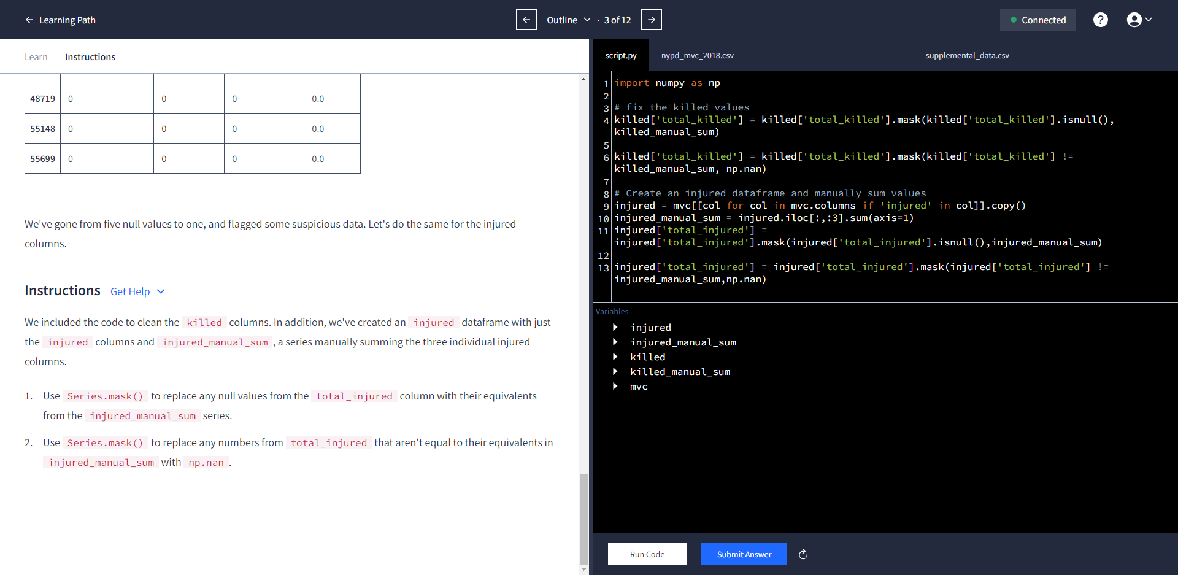

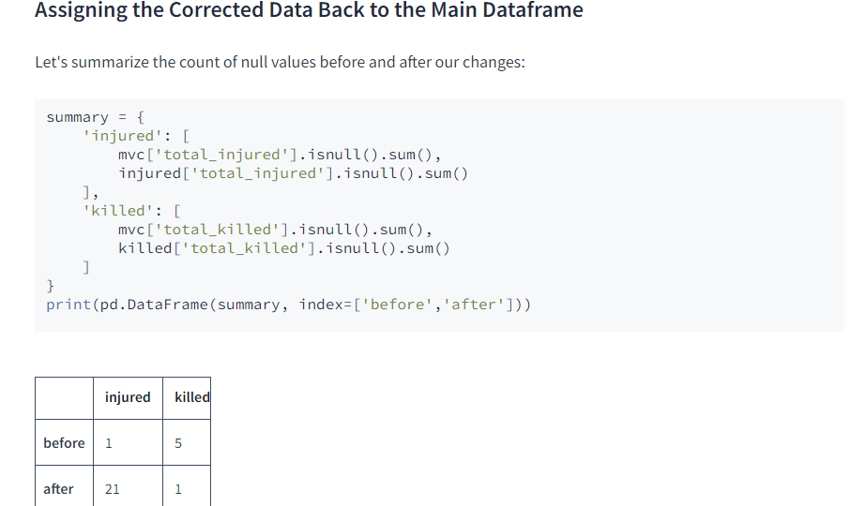

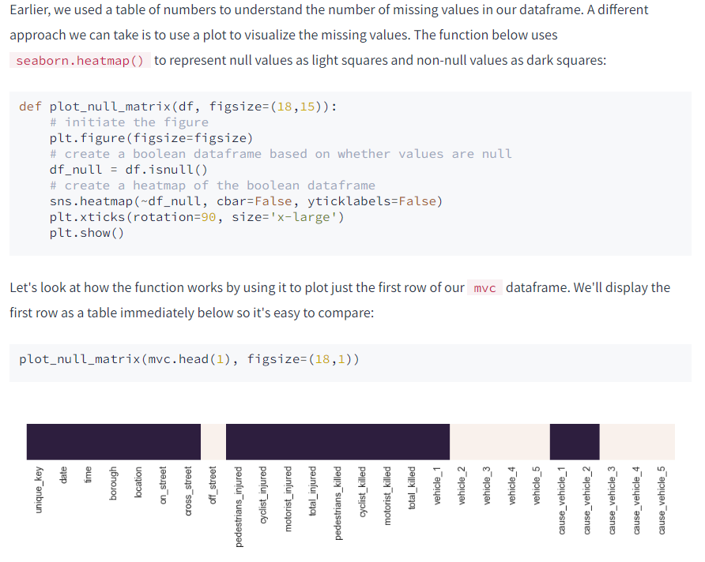



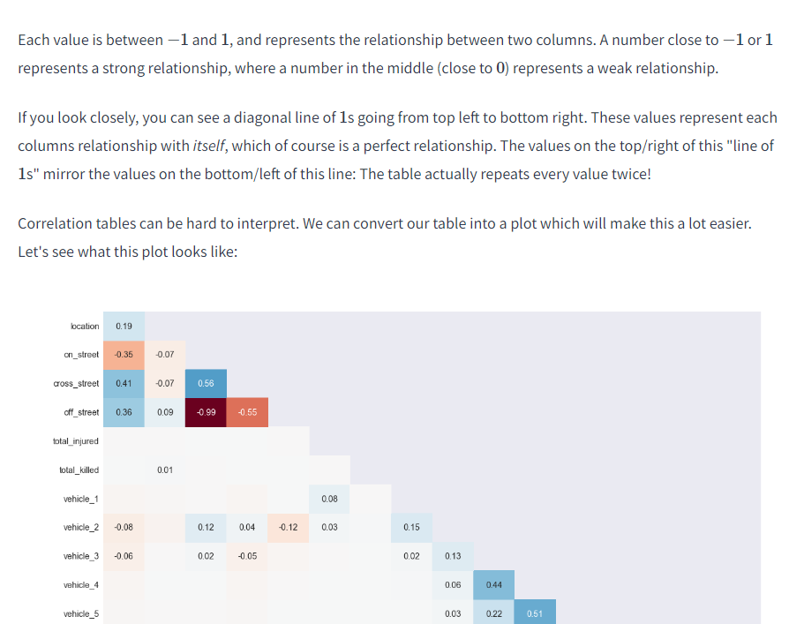

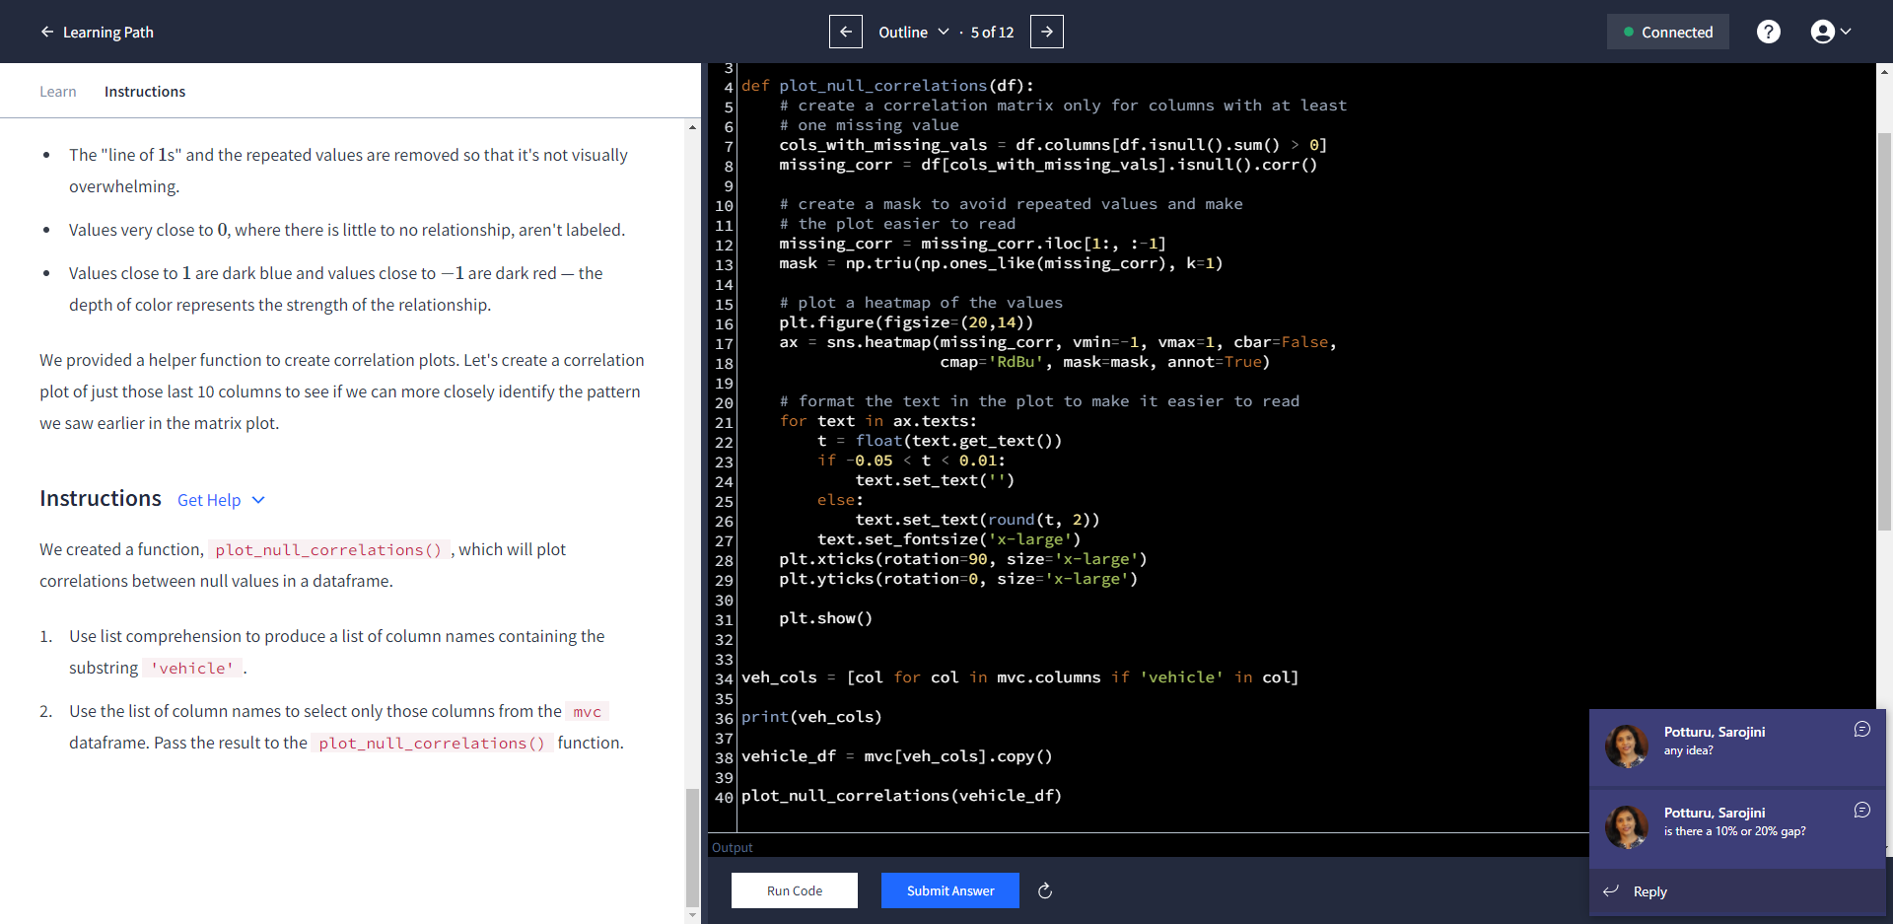

import matplotlib.pyplot as plt

import seaborn as sns

def plot_null_correlations(df):

# create a correlation matrix only for columns with at least

# one missing value

cols_with_missing_vals = df.columns[df.isnull().sum() > 0]

missing_corr = df[cols_with_missing_vals].isnull().corr()

# create a mask to avoid repeated values and make

# the plot easier to read

missing_corr = missing_corr.iloc[1:, :-1]

mask = np.triu(np.ones_like(missing_corr), k=1)

# plot a heatmap of the values

plt.figure(figsize=(20,14))

ax = sns.heatmap(missing_corr, vmin=-1, vmax=1, cbar=False,

cmap='RdBu', mask=mask, annot=True)

# format the text in the plot to make it easier to read

for text in ax.texts:

t = float(text.get_text())

if -0.05 < t < 0.01:

text.set_text('')

else:

text.set_text(round(t, 2))

text.set_fontsize('x-large')

plt.xticks(rotation=90, size='x-large')

plt.yticks(rotation=0, size='x-large')

plt.show()

col_labels = ['v_number', 'vehicle_missing', 'cause_missing']

vc_null_data = []

for v in range(1,6):

v_col = 'vehicle_{}'.format(v)

c_col = 'cause_vehicle_{}'.format(v)

v_null = (mvc[v_col].isnull() & mvc[c_col].notnull()).sum()

c_null = (mvc[v_col].notnull() & mvc[c_col].isnull()).sum()

print(v_null, ' ' , c_null)

vc_null_data.append([v,v_null,c_null])

vc_null_df = pd.DataFrame(vc_null_data,columns=col_labels)

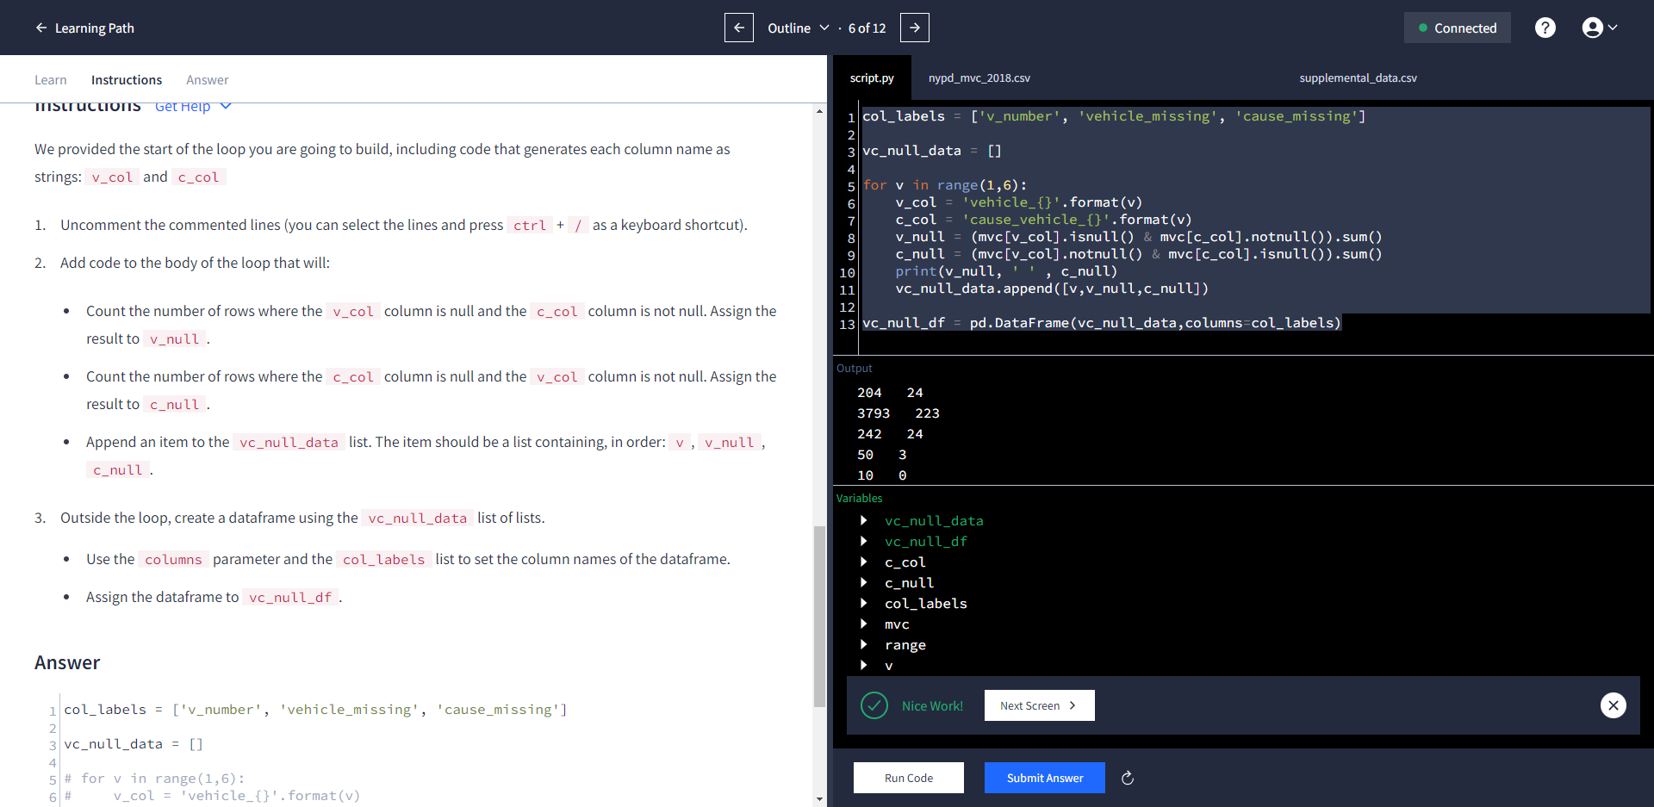

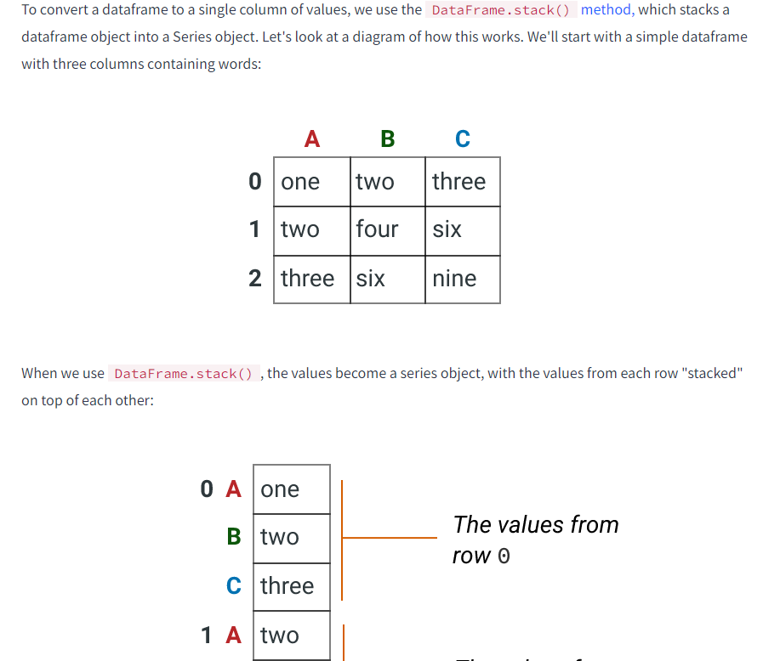

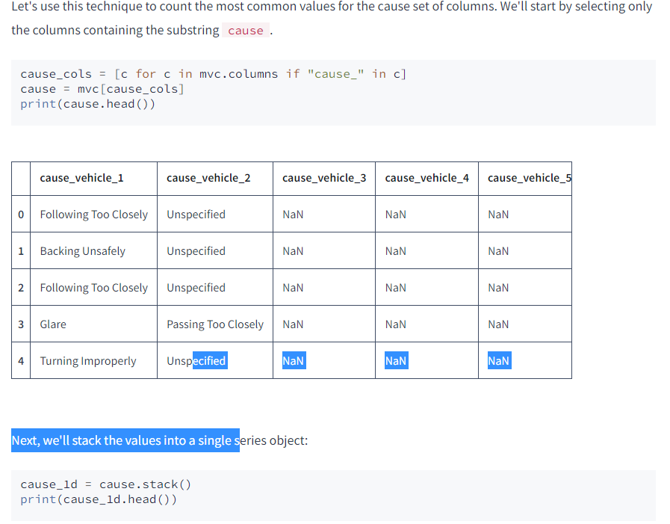

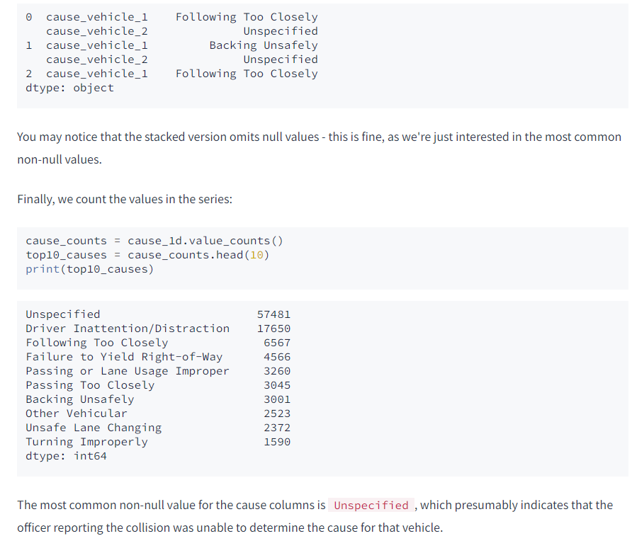

v_cols = [c for c in mvc.columns if c.startswith("vehicle")]

vehicle = mvc[v_cols]

vehicles_1d = vehicle.stack()

vehicles_counts = vehicles_1d.value_counts()

top10_vehicles = vehicles_counts.head(10)

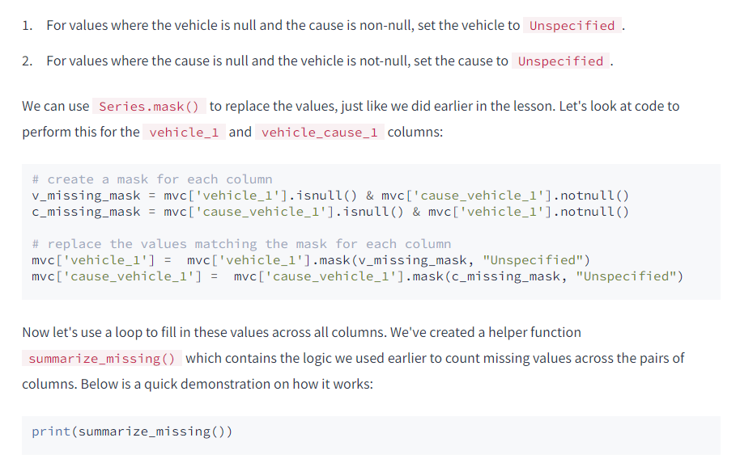

def summarize_missing():

v_missing_data = []

for v in range(1,6):

v_col = 'vehicle_{}'.format(v)

c_col = 'cause_vehicle_{}'.format(v)

v_missing = (mvc[v_col].isnull() & mvc[c_col].notnull()).sum()

c_missing = (mvc[c_col].isnull() & mvc[v_col].notnull()).sum()

v_missing_data.append([v, v_missing, c_missing])

col_labels = columns=["vehicle_number", "vehicle_missing", "cause_missing"]

return pd.DataFrame(v_missing_data, columns=col_labels)

summary_before = summarize_missing()

for v in range(1,6):

v_col = 'vehicle_{}'.format(v)

c_col = 'cause_vehicle_{}'.format(v)

v_missing = (mvc[v_col].isnull() & mvc[c_col].notnull())

c_missing = (mvc[c_col].isnull() & mvc[v_col].notnull())

mvc[v_col] = mvc[v_col].mask(v_missing, "Unspecified")

mvc[c_col] = mvc[c_col].mask(c_missing, "Unspecified")

summary_after = summarize_missing()

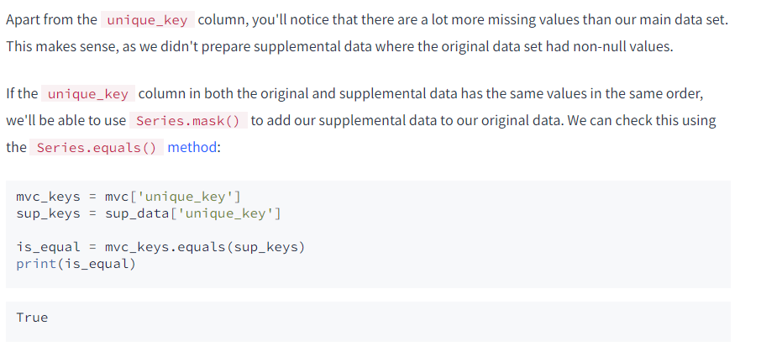

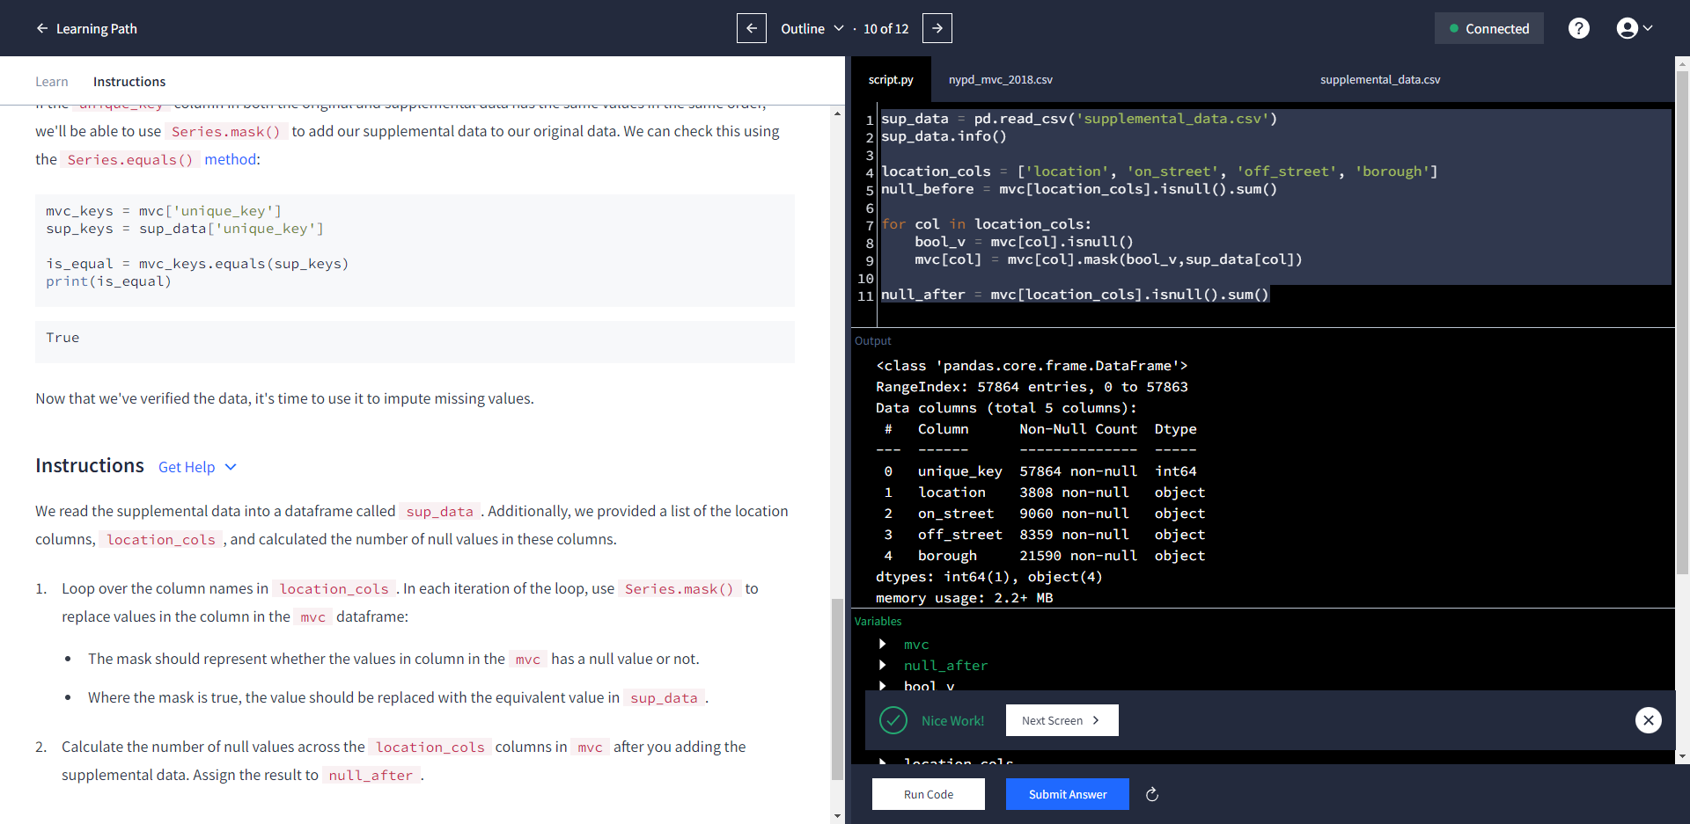

Here are two ways to find a good topic:

* Think about what sectors or angles you're really interested in, then find data sets relating to those sectors.
* Review several datasets and find one that seems interesting enough to explore.

Whichever approach you take, you can start your search at these sites:

* [Data.gov](https://www.data.gov/) - A directory of government data downloads
* [/r/datasets](https://reddit.com/r/datasets) - A subreddit that has hundreds of interesting datasets
* [Awesome datasets](https://github.com/caesar0301/awesome-public-datasets) - A list of datasets hosted on GitHub
* [rs.io](http://rs.io/100-interesting-data-sets-for-statistics/) - A great blog post with hundreds of interesting datasets

The same website has several related datasets covering demographic information and test scores. Here are the links to all of the datasets we'll be using:

* [SAT scores by school](https://data.cityofnewyork.us/Education/SAT-Results/f9bf-2cp4) - SAT scores for each high school in New York City
* [School attendance](https://data.cityofnewyork.us/Education/School-Attendance-and-Enrollment-Statistics-by-Dis/7z8d-msnt) - Attendance information for each school in New York City
* [Class size](https://data.cityofnewyork.us/Education/2010-2011-Class-Size-School-level-detail/urz7-pzb3) - Information on class size for each school
* [AP test results](https://data.cityofnewyork.us/Education/AP-College-Board-2010-School-Level-Results/itfs-ms3e) - Advanced Placement (AP) exam results for each high school (passing an optional AP exam in a particular subject can earn a student college credit in that subject)
* [Graduation outcomes](https://data.cityofnewyork.us/Education/Graduation-Outcomes-Classes-Of-2005-2010-School-Le/vh2h-md7a) - The percentage of students who graduated, and other outcome information
* [Demographics](https://data.cityofnewyork.us/Education/School-Demographics-and-Accountability-Snapshot-20/ihfw-zy9j) - Demographic information for each school
* [School survey](https://data.cityofnewyork.us/Education/NYC-School-Survey-2011/mnz3-dyi8) - Surveys of parents, teachers, and students at each school

All of these datasets are interrelated. We'll need to combine them into a single dataset before we can find correlations.

import pandas as pd

data_files = [

"ap_2010.csv",

"class_size.csv",

"demographics.csv",

"graduation.csv",

"hs_directory.csv",

"sat_results.csv"

]

data = {}

for item in data_files:

data[item.split('.')[0]] = pd.read_csv('schools/'+ item)

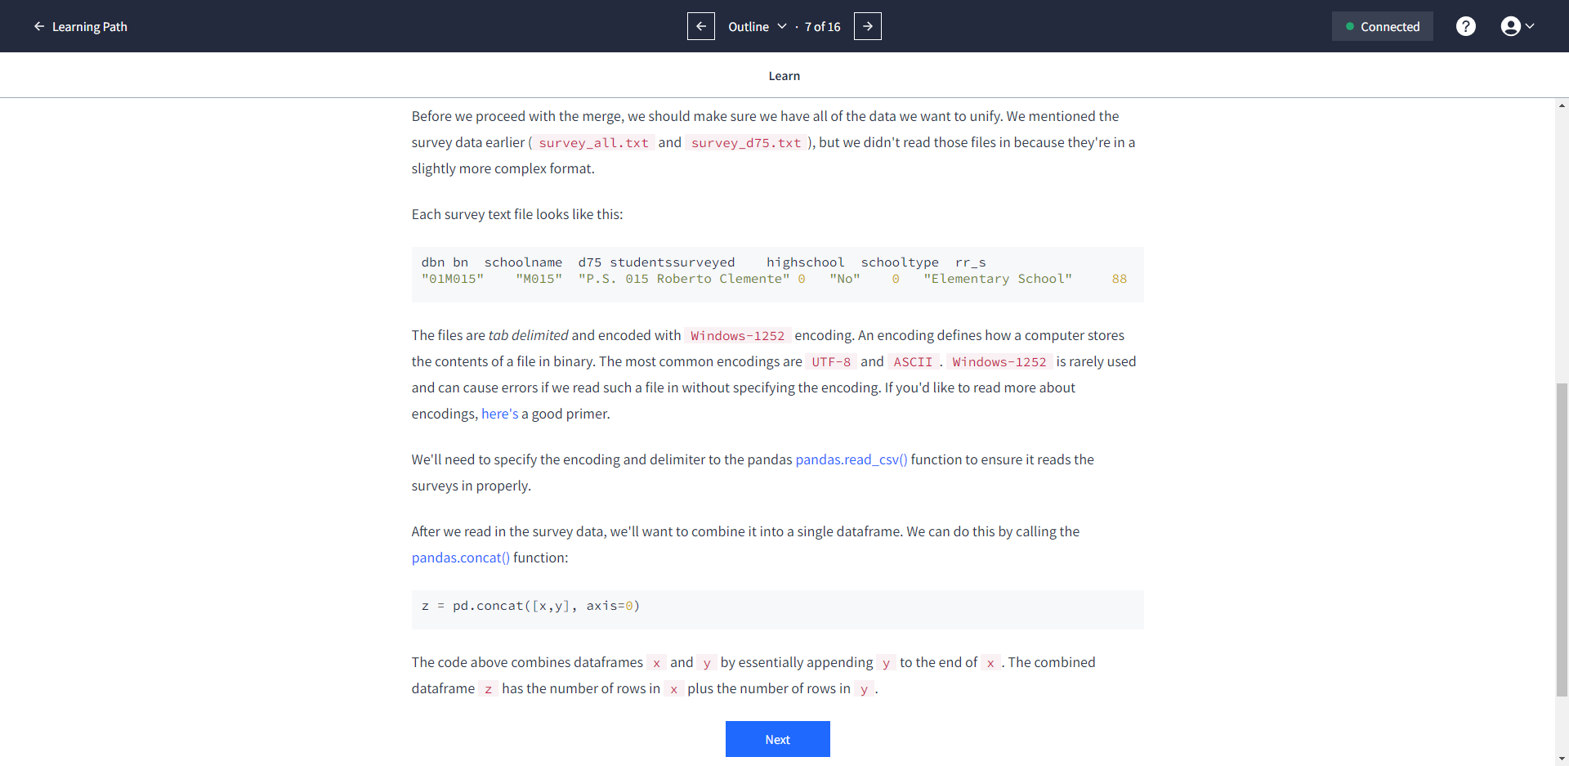

all_survey = pd.read_csv('schools/survey_all.txt',delimiter = "\t", encoding='windows-1252')

d75_survey = pd.read_csv('schools/survey_d75.txt',delimiter = "\t", encoding='windows-1252')

survey = pd.concat([all_survey,d75_survey])

print(all_survey.shape)

print(d75_survey.shape)

print(survey.shape)

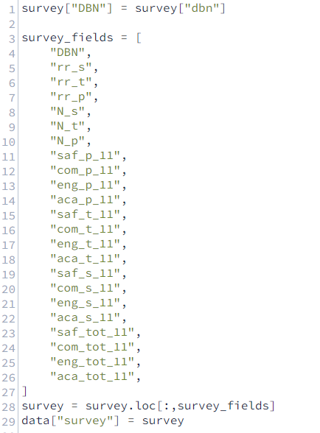

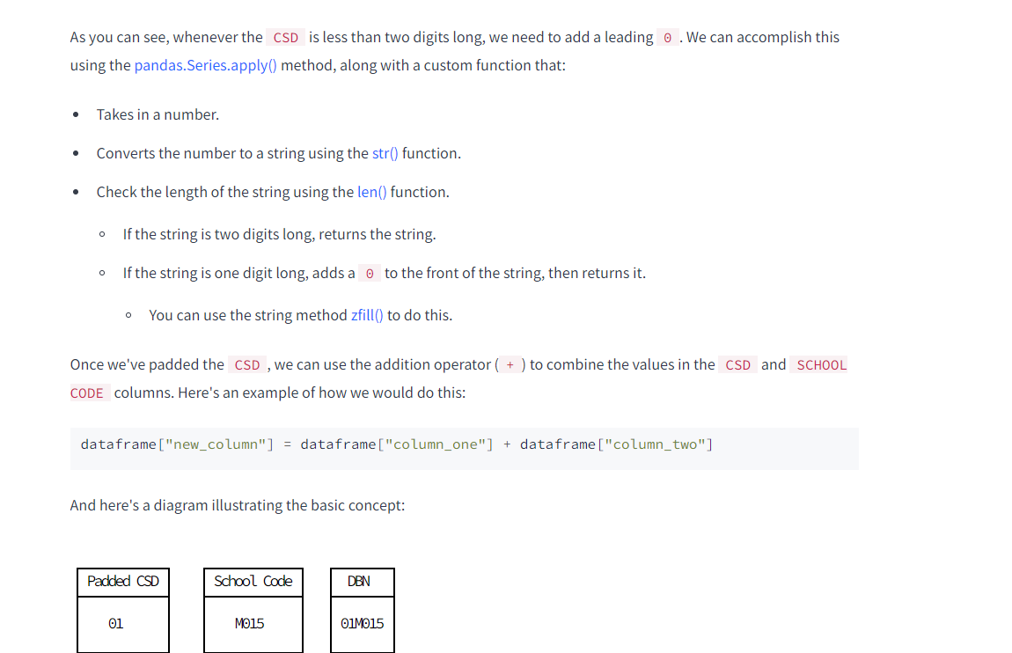

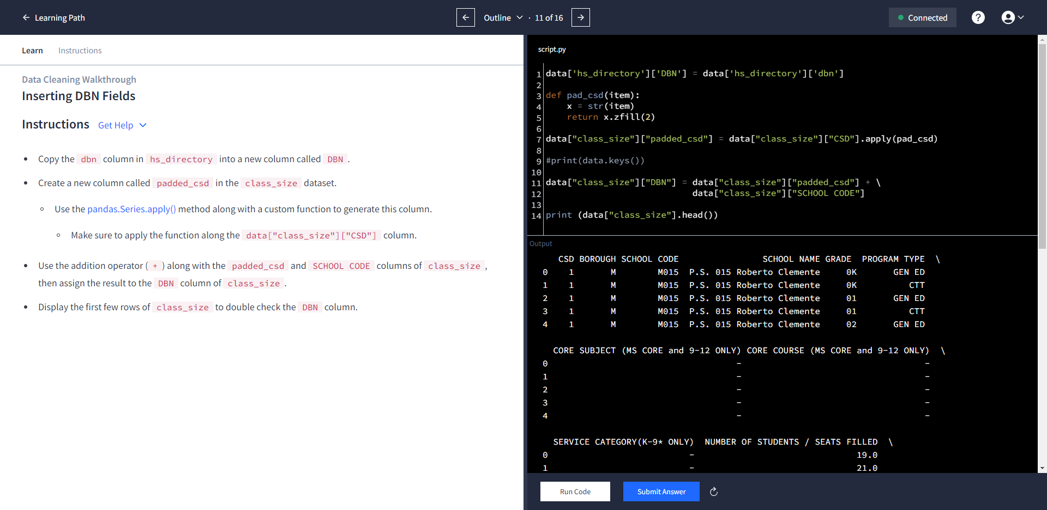

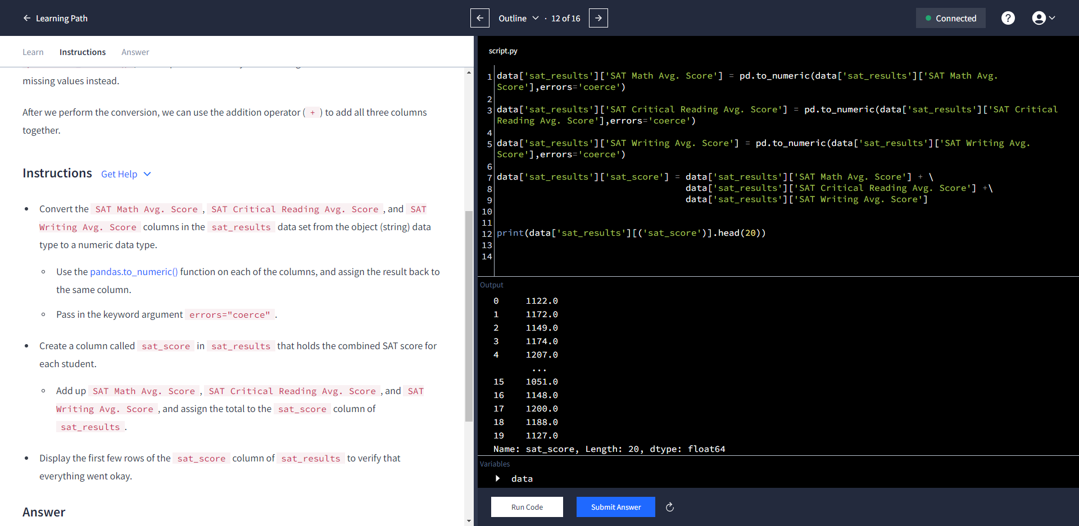

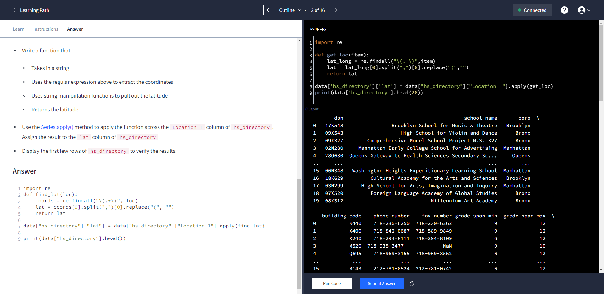

import re

def get_loc(item):

lat_long = re.findall("\(.+\)",item)

long = lat_long[0].split(",")[1].replace(")","")

return long

data['hs_directory']['lon'] = data["hs_directory"]["Location 1"].apply(get_loc)

data['hs_directory']['lon'] = pd.to_numeric(data['hs_directory']['lon'],errors='coerce')

data['hs_directory']['lat'] = pd.to_numeric(data['hs_directory']['lat'],errors='coerce')

print(data['hs_directory'].head(20))

* Create a new variable called class_size and assign the value of data["class_size"] to it.
* Filter class_size so the GRADE  column only contains the value 09-12. Note that the name of the GRADE  column has a space at the end; you'll generate an error if you don't include it.
* Filter class_size so that the PROGRAM TYPE column only contains the value GEN ED.
* Display the first five rows of class_size to verify.

class_size = data["class_size"]

class_size = class_size[class_size["GRADE "] == "09-12"]

class_size = class_size[class_size["PROGRAM TYPE"] == "GEN ED"]

print(data["class_size"].shape)

print(class_size.head())

print(class_size["CORE SUBJECT (MS CORE and 9-12 ONLY)"].unique())

import numpy

groupedbn = class_size.groupby('DBN')

class_size = groupedbn.agg(numpy.mean)

class_size.reset_index(inplace=True)

data["class_size"] = class_size

print(data["class_size"].head())

cols = ['AP Test Takers ', 'Total Exams Taken', 'Number of Exams with scores 3 4 or 5']

for c in cols:

data["ap_2010"][c] = pd.to_numeric(data["ap_2010"][c],errors='coerce')

for c in cols:

print(data["ap_2010"][c].dtypes)

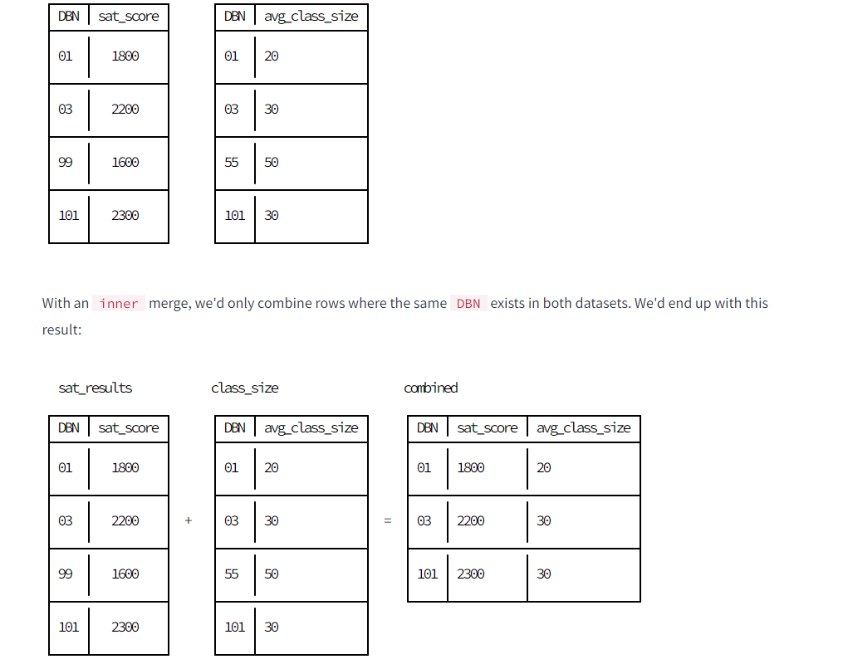

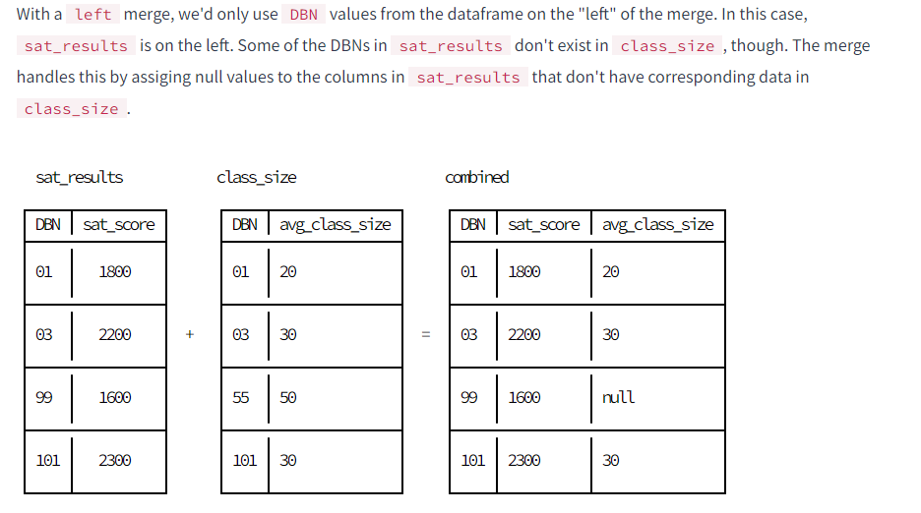

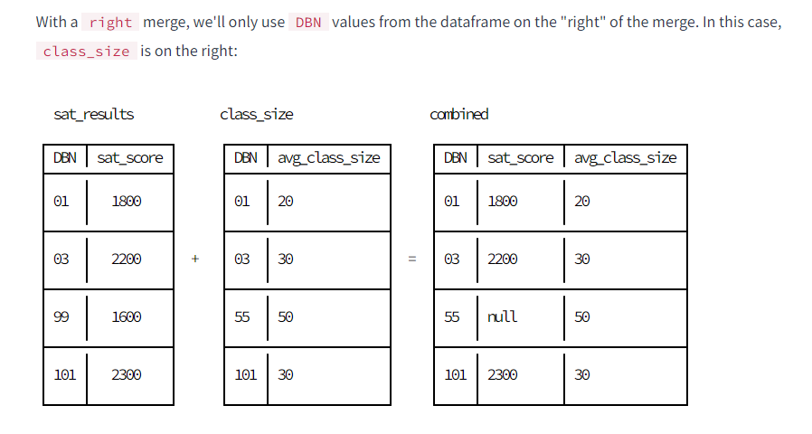

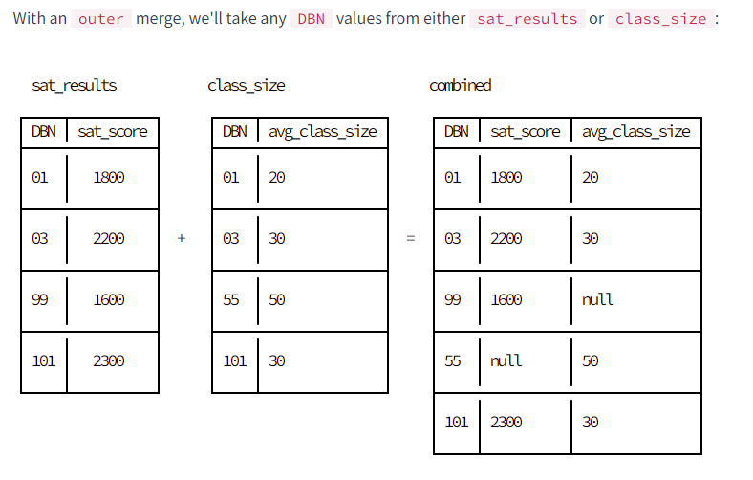

combined = pd.merge(combined,data["class_size"],on="DBN")

combined = pd.merge(combined,data["demographics"],on="DBN")

combined = pd.merge(combined,data["survey"],on="DBN")

combined = pd.merge(combined,data["hs_directory"],on="DBN")

print(combined.head())

print(combined.shape)

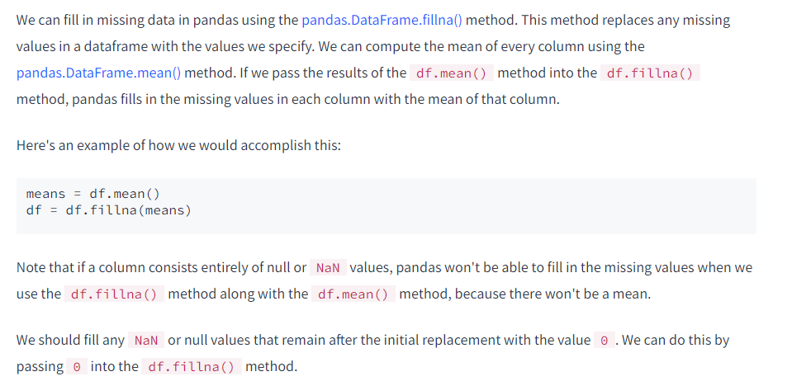

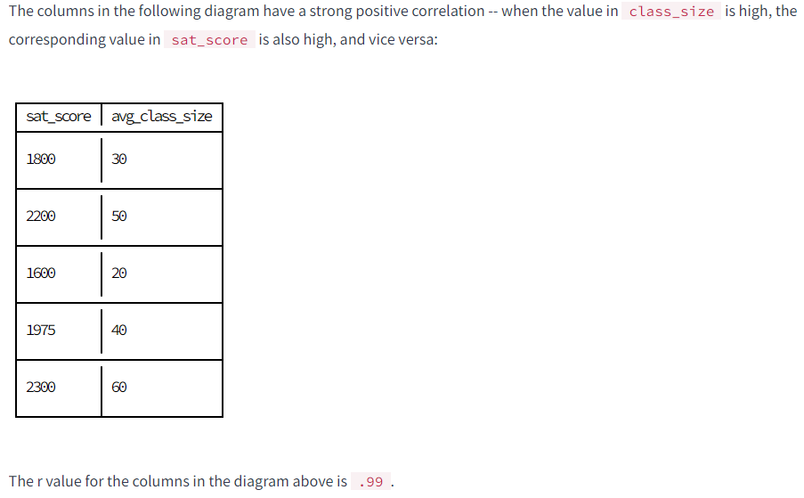

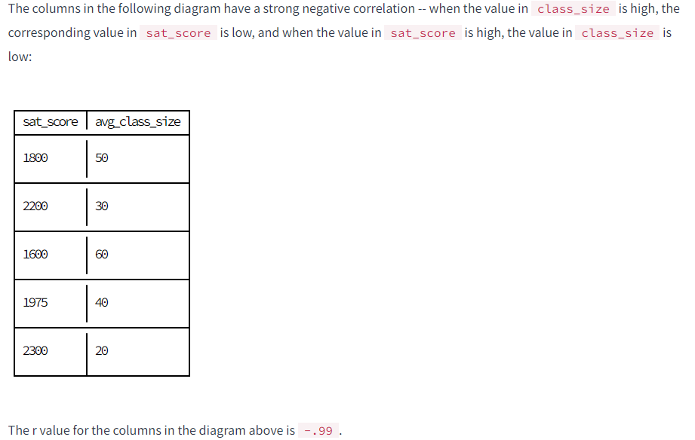

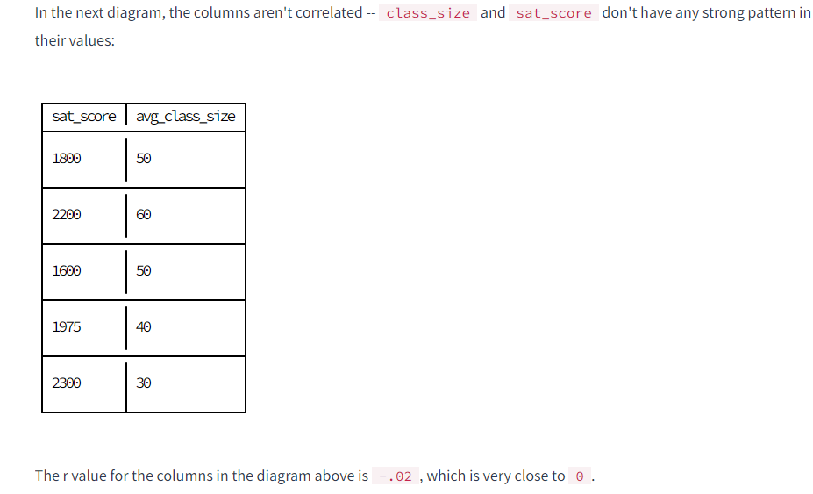

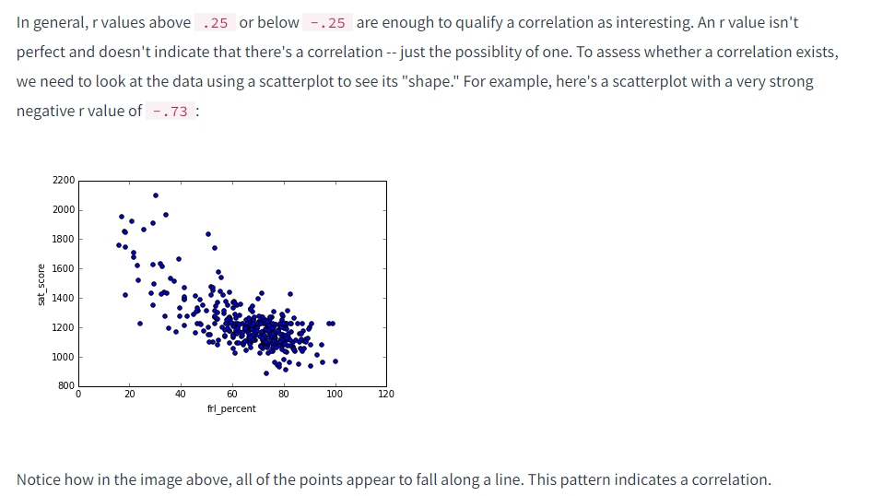

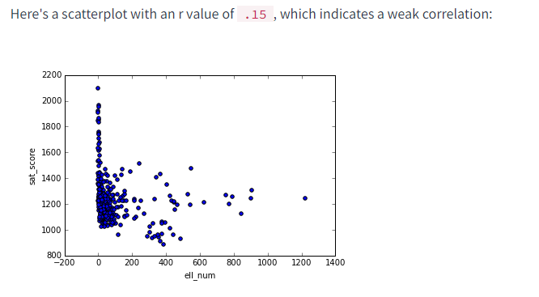

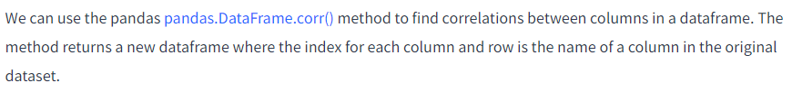

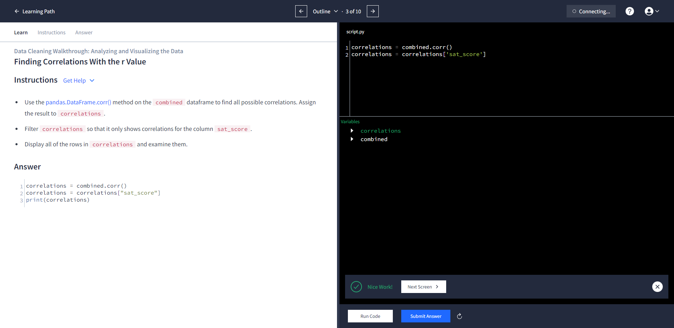

SAT Critical Reading Avg. Score 0.986820

SAT Math Avg. Score 0.972643

SAT Writing Avg. Score 0.987771

sat_score 1.000000

AP Test Takers 0.523140

Total Exams Taken 0.514333

Number of Exams with scores 3 4 or 5 0.463245

Total Cohort 0.325144

CSD 0.042948

NUMBER OF STUDENTS / SEATS FILLED 0.394626

NUMBER OF SECTIONS 0.362673

AVERAGE CLASS SIZE 0.381014

SIZE OF SMALLEST CLASS 0.249949

SIZE OF LARGEST CLASS 0.314434

SCHOOLWIDE PUPIL-TEACHER RATIO NaN

schoolyear NaN

fl_percent NaN

frl_percent -0.722225

total_enrollment 0.367857

ell_num -0.153778

ell_percent -0.398750

sped_num 0.034933

sped_percent -0.448170

asian_num 0.475445

asian_per 0.570730

black_num 0.027979

black_per -0.284139

hispanic_num 0.025744

hispanic_per -0.396985

white_num 0.449559

...

rr_p 0.047925

N_s 0.423463

N_t 0.291463

N_p 0.421530

saf_p_11 0.122913

com_p_11 -0.115073

eng_p_11 0.020254

aca_p_11 0.035155

saf_t_11 0.313810

com_t_11 0.082419

eng_t_10 NaN

aca_t_11 0.132348

saf_s_11 0.337639

com_s_11 0.187370

eng_s_11 0.213822

aca_s_11 0.339435

saf_tot_11 0.318753

com_tot_11 0.077310

eng_tot_11 0.100102

aca_tot_11 0.190966

grade_span_max NaN

expgrade_span_max NaN

zip -0.063977

total_students 0.407827

number_programs 0.117012

priority08 NaN

priority09 NaN

priority10 NaN

lat -0.121029

lon -0.132222

Name: sat_score, dtype: float64

| **sat_score** |
| --- |
| **SAT Critical Reading Avg. Score** | 0.986820 |
| **SAT Math Avg. Score** | 0.972643 |
| **SAT Writing Avg. Score** | 0.987771 |
| **sat_score** | 1.000000 |
| **AP Test Takers** | 0.523140 |
| **Total Exams Taken** | 0.514333 |
| **Number of Exams with scores 3 4 or 5** | 0.463245 |
| **Total Cohort** | 0.325144 |
| **CSD** | 0.042948 |
| **NUMBER OF STUDENTS / SEATS FILLED** | 0.394626 |
| **NUMBER OF SECTIONS** | 0.362673 |
| **AVERAGE CLASS SIZE** | 0.381014 |
| **SIZE OF SMALLEST CLASS** | 0.249949 |
| **SIZE OF LARGEST CLASS** | 0.314434 |
| **SCHOOLWIDE PUPIL-TEACHER RATIO** | NaN |
| **schoolyear** | NaN |
| **fl_percent** | NaN |
| **frl_percent** | -0.722225 |
| **total_enrollment** | 0.367857 |
| **ell_num** | -0.153778 |
| **ell_percent** | -0.398750 |
| **sped_num** | 0.034933 |
| **sped_percent** | -0.448170 |
| **asian_num** | 0.475445 |
| **asian_per** | 0.570730 |
| **black_num** | 0.027979 |
| **black_per** | -0.284139 |
| **hispanic_num** | 0.025744 |
| **hispanic_per** | -0.396985 |
| **white_num** | 0.449559 |
| **white_per** | 0.620718 |
| **male_num** | 0.325520 |
| **male_per** | -0.112062 |
| **female_num** | 0.388631 |
| **female_per** | 0.112108 |
| **rr_s** | 0.232199 |
| **rr_t** | -0.023386 |
| **rr_p** | 0.047925 |
| **N_s** | 0.423463 |
| **N_t** | 0.291463 |
| **N_p** | 0.421530 |
| **saf_p_11** | 0.122913 |
| **com_p_11** | -0.115073 |
| **eng_p_11** | 0.020254 |
| **aca_p_11** | 0.035155 |
| **saf_t_11** | 0.313810 |
| **com_t_11** | 0.082419 |
| **aca_t_11** | 0.132348 |
| **saf_s_11** | 0.337639 |
| **com_s_11** | 0.187370 |
| **eng_s_11** | 0.213822 |
| **aca_s_11** | 0.339435 |
| **saf_tot_11** | 0.318753 |
| **com_tot_11** | 0.077310 |
| **eng_tot_11** | 0.100102 |
| **aca_tot_11** | 0.190966 |
| **grade_span_max** | NaN |
| **expgrade_span_max** | NaN |
| **zip** | -0.063977 |
| **total_students** | 0.407827 |
| **number_programs** | 0.117012 |
| **priority08** | NaN |
| **priority09** | NaN |
| **priority10** | NaN |
| **lat** | -0.121029 |
| **lon** | -0.132222 |

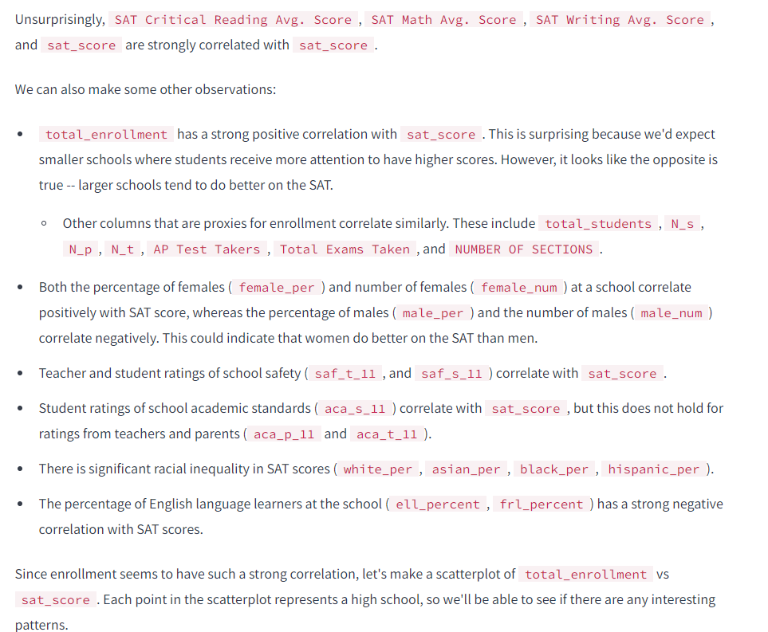

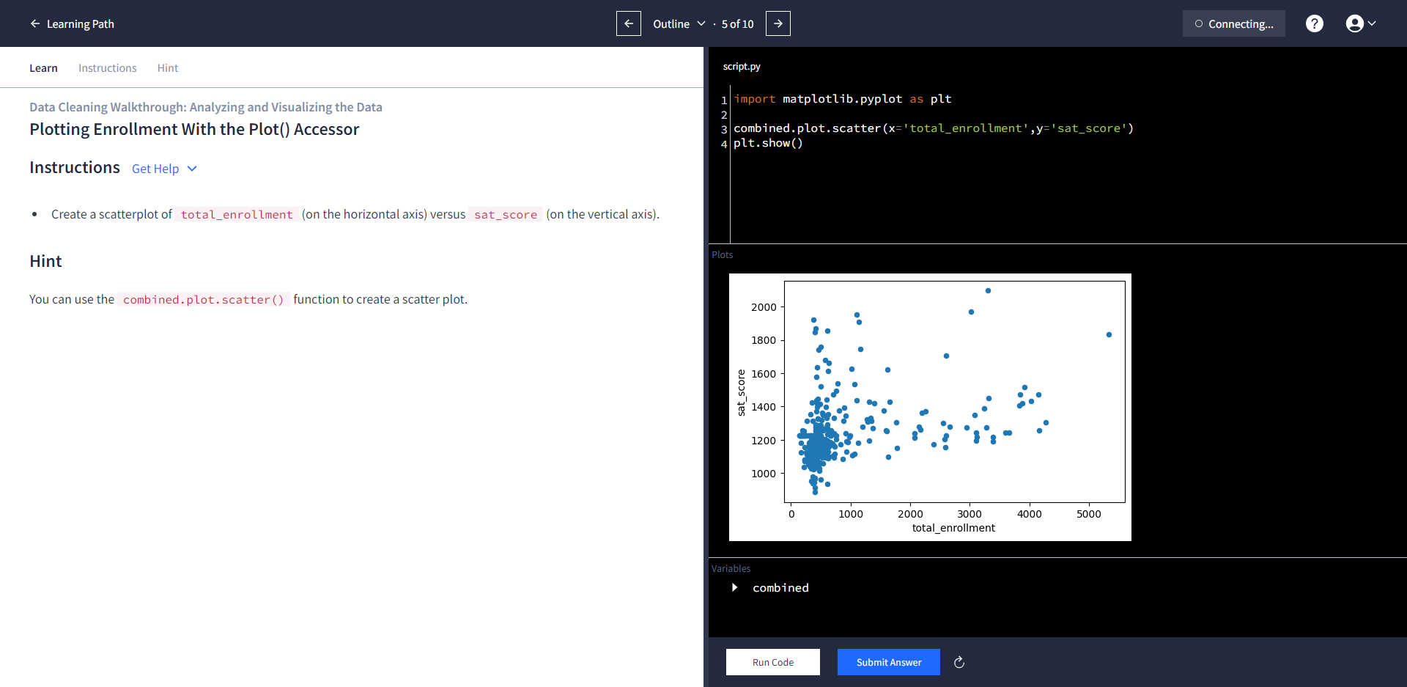

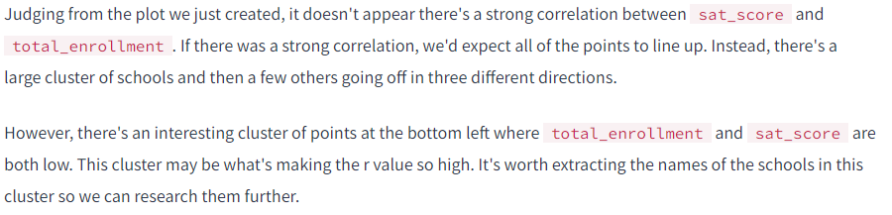

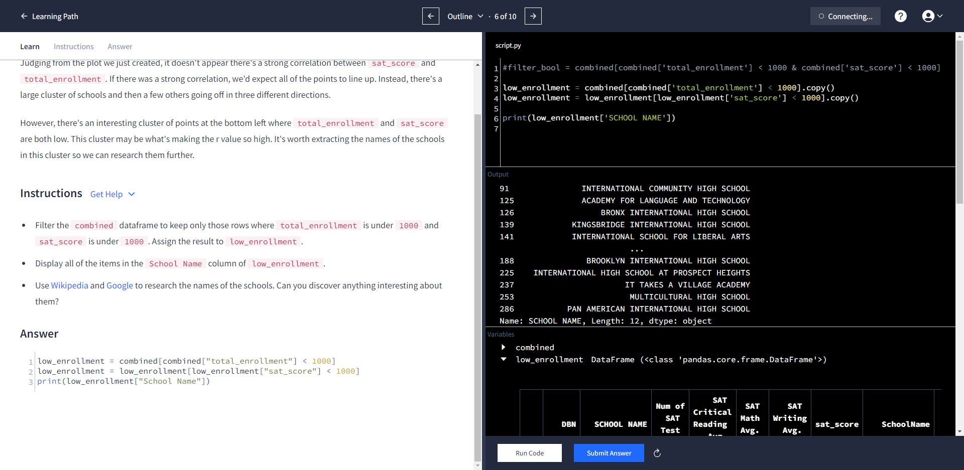

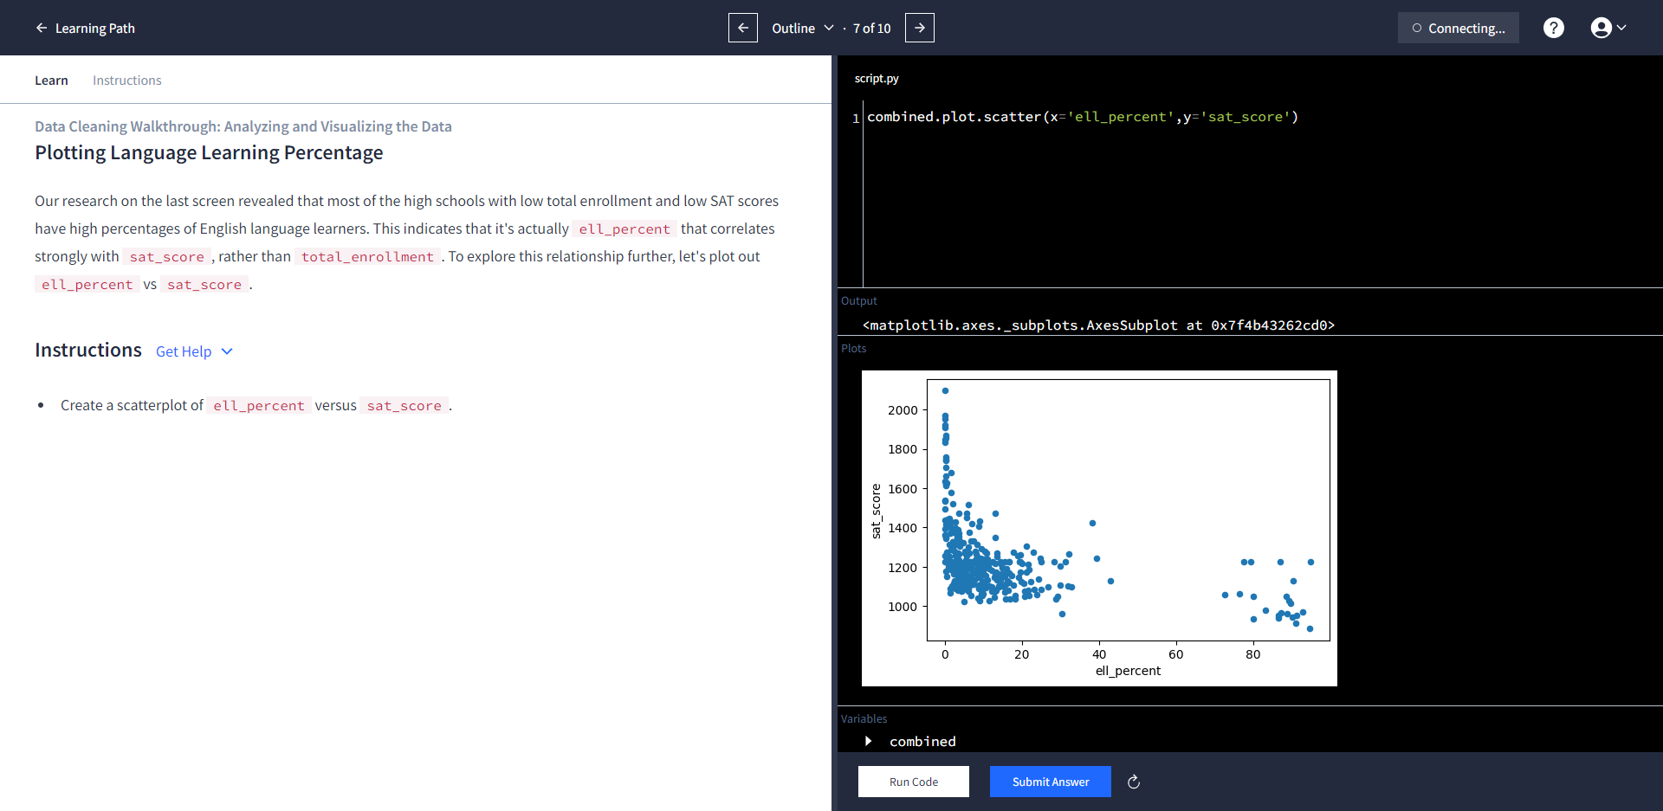

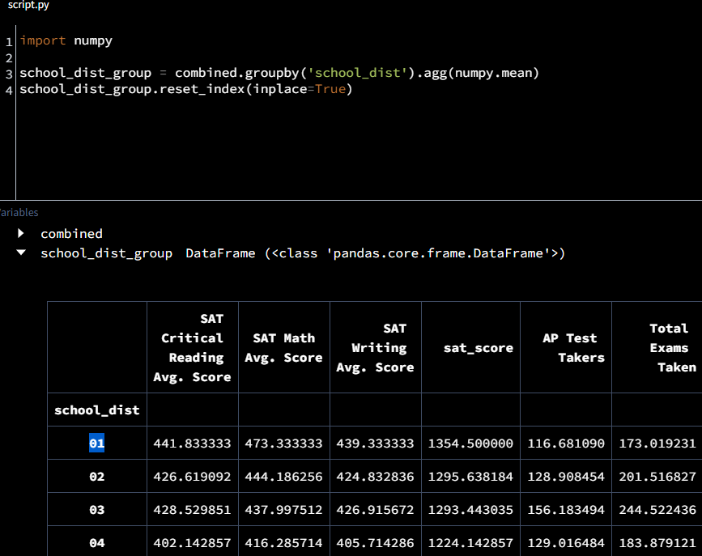

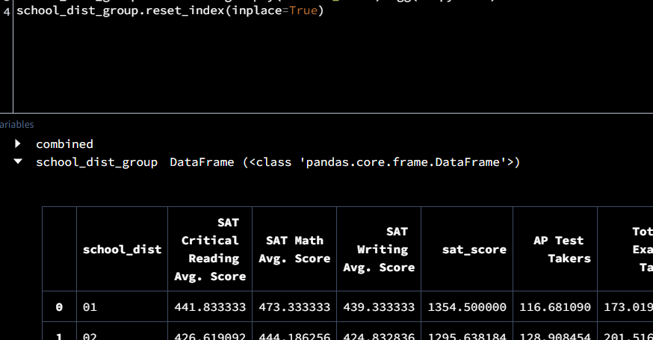

## Resources

* [R value](https://en.wikipedia.org/wiki/Pearson_product-moment_correlation_coefficient)
* [pandas.DataFrame.plot()](http://pandas.pydata.org/pandas-docs/stable/generated/pandas.DataFrame.plot.html)
* [Correlation](https://www.mathsisfun.com/data/correlation.html)
* [Guess the Correlation](http://guessthecorrelation.com/)

